

Documenting Student Activity and Feedback
A Guide for PEP Supervisors and Facilitators


As a nursing supervisor or facilitator in PEP, it is important to document your observations and evidence of student performance, feedback and development. This will support recall for completing assessments, enable a chronological picture of student’s progression and developing capability, and in extenuating circumstances provide additional evidence when a student’s performance in PEP is under review.
Documenting student learning and evidencing performance in practice does not have to be onerous. The key is recording brief, dot-point descriptions that capture specific student activity daily, where possible.
Supervisors and facilitators have different ways of documenting observations of student activity and the feedback provided, including using a word document as a repository of observed student activity, recording notes in their regular diary, or emailing observations and feedback to students directly. Whilst there is no prescribed documentation method, the following document has been useful in keeping track of how students are progressing in PEP.
If using other templates or methods, it is helpful to ensure that they contain the following elements:
- Student Name
- PEP Allocation (1-5)
- Date of observed activity
- Description of observed activity (dot points are fine)
- Indication that student feedback was provided
- Information pertaining to the observed activity / incident (if adverse and warranted) is referred to the appropriate level*.

*The Nursing Student Progression and Management pathway is a useful tool that provides guidance on whether further referral of student feedback is required to facilitate additional support measures. It has been attached to the end of these resources and can be accessed on the PEP Website www.utas.edu.au/health/professional-experience-placement/student-information/nursing/clinical-facilitators.

Facility: | Unit: | Facilitator/Supervisor Name:
PEP Supervisor / Facilitator Diary School of Nursing
Nursing Practice PEP (1-5) ☐ 1 ☐ 2 ☐ 3 ☐ 4 ☐ 5

Student Name: ___________________________________________________________

Date | Brief description of observed student activity | Demonstrated strengths, knowledge, skills, attitudes, or approach | Areas for focus or improvement | Student Feedback Provided  Y / N | Further Referral Required  Y / N

Student Name: __________________________________________________________

Further Notes:

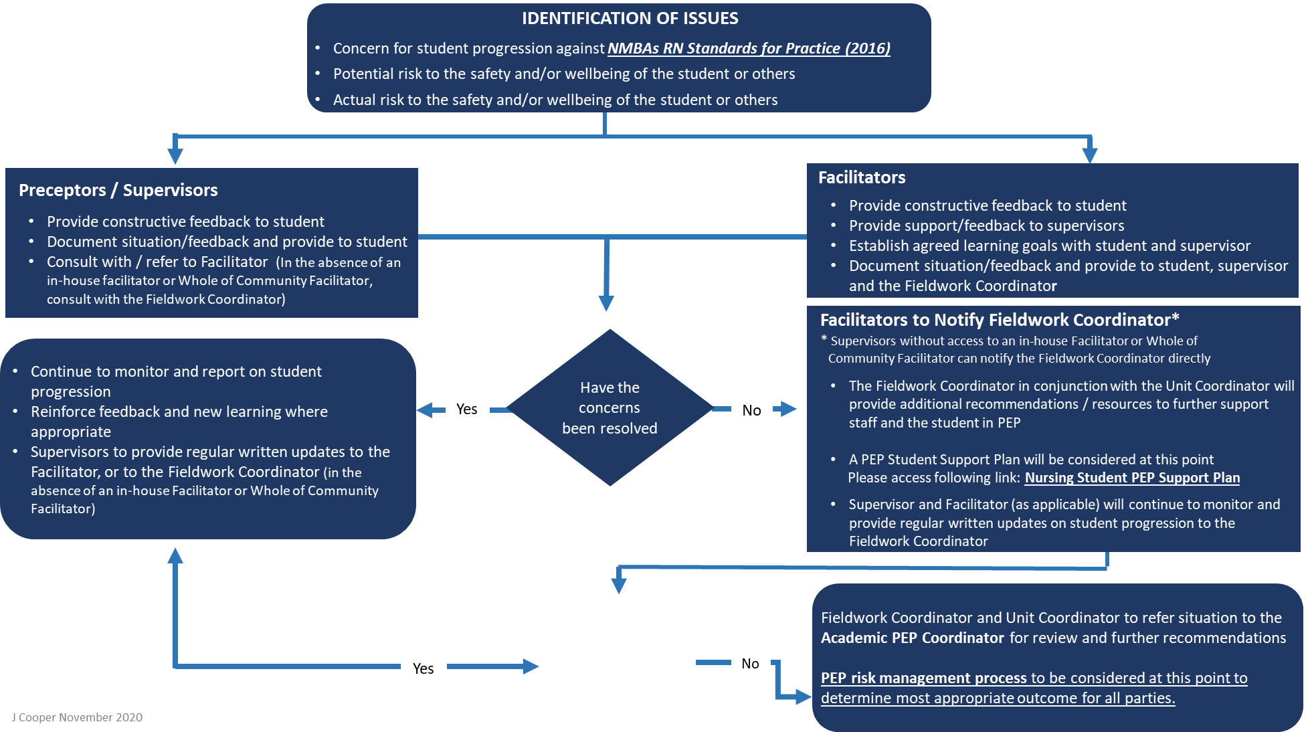

Nursing Student
Progression Management Pathway - During PEP

