

Closed Circuit Television

Specification Guidelines

February 2018

CONTENTS

1.0 INTRODUCTION 1
2.0 BACKGROUND 1
3.0 SPECIFICATION REQUIREMENTS 1
4.0 CAMERA SELECTION 2
5.0 CAMERA PERFORMANCE AND MOUNTING 6
6.0 STORAGE 14
7.0 VIDEO MANAGEMENT SYSTEM 14
8.0 CONFIGURATION 14
9.0 WORKS EXECUTION 18
10.0 TESTING AND COMMISSIONING 19
11.0 PRACTICAL COMPLETION (HANDOVER) 23
12.0 RECORD OF WORK (AS INSTALLED/BUILT) 23
13.0 WARRANTIES 23
14.0 CAMERA SCHEDULE EXAMPLE 25
15.0 ANALYTICS SCHEDULE 25

INTRODUCTION
This guideline is intended to inform a performance based specification of CCTV cameras and systems for the University of Tasmania. Each project’s CCTV requirements are unique and will require input from the University to ensure its requirements are firstly determined and then met. The text and images within this guideline may be used explicitly for this purpose.

BACKGROUND
The University is increasing its use of security technology, in particular CCTV to provide more automated security intelligence.

For this, high quality video and surveillance is required as an essential foundation.

The degree of variability for each project or works can be reasonable, primarily due to the wide and evolving range of CCTV cameras and their ability meet the surveillance requirement.

The current Video Management System (VMS) used by the University is Geutebruck. All systems installed will extend, or be part of, this enterprise wide system. As such all hardware must be compatible or agreement obtained from Geutebruck to create compatibility prior to installation.

As a simplified means of explaining the system, refer to the below diagram.


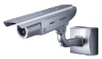
IP Camera
IP Camera

University Data Network, Security VLAN

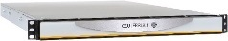

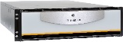

Geutebruck
Management Server
(Centrally hosted)
Geutebruck
Recorder
(Local)

EXISTING SYSTEMS
A reasonable degree of existing cameras are analogue and have been IP enabled through the use of IP encoders. If you are unable to determine if an existing camera is analogue or digital, specify for a new digital camera.

SPECIFICATION REQUIREMENTS
CCTV works specifications must cover at minimum:

- Camera performance & functionality;
- Storage performance & functionality;
- VMS works;
- Software configuration;
- Works execution; and
- Commissioning / testing.

A camera schedule must also be developed and provided with the specification.

It is recommended to number all scheduled cameras and incorporate reference on
co-ordinated reflected ceiling plans.

CCTV design software packages can greatly assist the process of design, and selection of cameras. Such packages are available from JVSG.

http://www.jvsg.com/software/ip-video-system-design-tool/

Alternatively, 3D modelling software with appropriate camera models, plugins or extensions can be used such as Trimble Sketchup with an Axis camera extension.

http://www.sketchup.com/ and https://www.axis.com/au/en/tools/axis-camera-extension

Proposed CCTV systems should be modelled in a 3D design program and presented to the University to demonstrate the outcomes for each device at its intended location. The modelling should be based on the selected camera model, lens, mounting height and horizontal field of view (HFOV) that will be delivered.

CAMERA SELECTION
The contractor shall select and use only cameras, including accessories and lensing that fulfil the requirements specified within this section.

Compliance with performance aspects of the requirements will be based on the replay of recorded images through various times of the day and night as further specified.

The contractor is to obtain samples of all their selected or proposed camera types and undertake testing prior to final selection and installation.

If the requirements / outcomes are failed to be met, as determined by the University within the defects liability period, the contractor must replace, free of charge, any systems or equipment under their scope including but not limited to cameras, lensing or accessories required to ensure the system complies with the required outcomes.

All cameras selected must be compatible with the University’s Geutebruck VMS unless guarantee is obtained from Geutebruck to incorporate compatibility prior to works being undertaken.

Cameras shall only be of the following manufacture unless otherwise authorised by the University’s Security Technical Officer:

- Axis
- Panasonic
- Pelco
- Sony

All cameras used shall provide as a minimum:

- Imaging of target areas without automatic gain control increasing graininess or noise within the viewed image;
- Images of moving targets free of motion blur, smear or ghosting;
- 1080 horizontal lines of resolution at 12.5 frames per second during motion periods;
- Use a fully conformant Onvif Profile S specification;
- Motion detection recording on Geutebruck recording appliances;
- True wide or high dynamic response suitable for the application;
- Progressive scanning;
- Automatic black level to enhance the contrast by removing veiling glare from the picture;
- A “lens wizard” during lens back focus setup to allow focusing at maximum iris opening to ensure the object of interest within the field of view always remains in focus.
- Through-the-lens automatic tracking white balance.

Internal Cameras
Cameras used internally for the surveillance of the internal building must have some resistance against tampering.

Cameras located nearby or providing surveillance of areas with glazing or daylight shall have high dynamic range. Other cameras located in areas with only artificial lighting that is not subject to rapid significant changes in illumination may have standard dynamic range.

Cameras providing surveillance of corridors, hall ways or the like, if greater than 4:3 (1.33:1) aspect ratio image shall utilise a 90 degree mode to increase coverage.

If cameras are covering entry / exit points or areas that provide access between levels, resolution outcomes (Detail Resolution) of either Identification or Recognition shall apply.

External Cameras
Cameras used externally for the surveillance of the external building or site must be vandal and weather resistant. External cameras are to provide minimum performance levels where there is no appreciable light source. Graininess in picture is deemed not acceptable.

External cameras must have low light capability for night-time operation and exceptional backlight compensation for daytime operation. Low light cameras utilising technologies which compromise quality or resolution outcomes for scenes containing motion shall not be accepted. SensUP or similar technologies affecting these outcomes will not be accepted.

Cameras shall provide selectable on/off backlight compensation with back light compensation and wide/high dynamic range operating at the same time.

Dynamic Range and Response, Low Lighting Examples
The following are example images to demonstrate the unacceptable and acceptable outcome of a cameras dynamic range and response, and low lighting conditions.

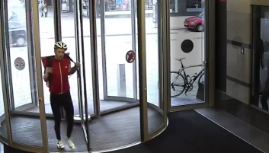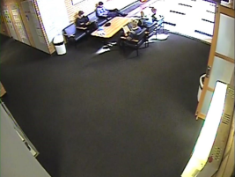
Acceptable
Not Acceptable

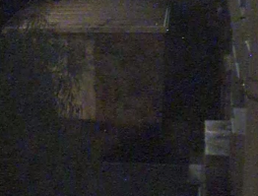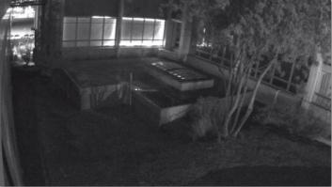
Acceptable at 0.1 Lux illumination
Not Acceptable

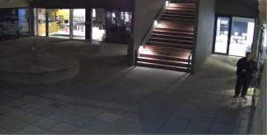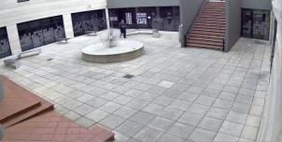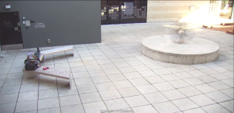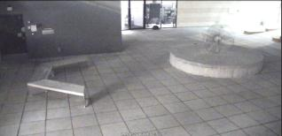
Acceptable at 0.1 Lux illumination
Not Acceptable
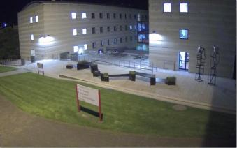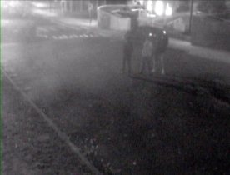
Acceptable
Not Acceptable

Detail Resolution
The following Detail Resolutions in Pixels per Meter (PPM) must be achieved when scheduled at all hours. In the event there is insufficient lighting available to provide these outcomes, supplementary lighting, including infrared shall be fitted to maintain compliance.

Identification
Cameras scheduled as being required to provide identification use imaging are required to deliver 303 PPM imaging of the target area (entry / exit door, counter, chokepoint or other identified).

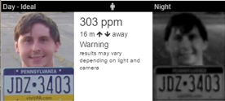

Recognition
Cameras scheduled as being required to provide recognition use imaging are required to deliver 160 PPM imaging of the target area (waiting room, reception area, general circulation).

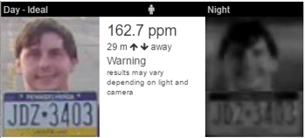

Observation
Cameras scheduled as being required to provide observation use imaging are required to deliver 100 PPM imaging of the target area (vehicular / personnel traffic flows).

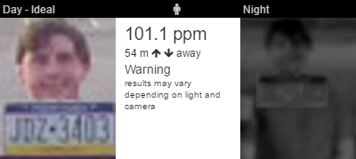

Detection
Cameras scheduled as being required to provide detection use imaging are required to deliver 62 PPM imaging of the target area (general internal / external).

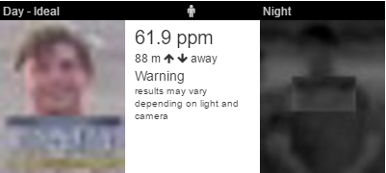

Integral Infrared Illumination and IR Cameras
Cameras incorporating inbuilt infrared illumination shall not demonstrate any reflection from the IR light blocks within the lens or picture. The cameras IR shall provide images free of graininess or artefacts within the target area through times of low or no light.
IR cameras shall also utilise adaptive power technologies that removes blooming / hotspots within the images.

Full Body Cameras
Full body cameras shall allow the use of C or CS Mount type lenses and shall accept fixed iris lenses, manual iris lenses, DC auto-iris lenses, and video-iris lenses. For ease of installation, the camera shall auto detect the type of lens used and optimize performance accordingly.

Fully body cameras fitted externally onto buildings where mounted below 3.5M AFFL shall be enclosed in a protective housing.

CAMERA PERFORMANCE AND MOUNTING
Cameras are to be mounted in locations that provide access for maintenance and servicing, and shall be mounted at a height to provide clear images of the target area.

Cameras shall be mounted and adjusted so they have no direct view of any light source, nor have any ceiling or luminaires in the cameras view wherever practical. Placement shall take into account the arc of the sun throughout summer, autumn, winter and spring as well as reflectivity changes off surfaces during the seasons.

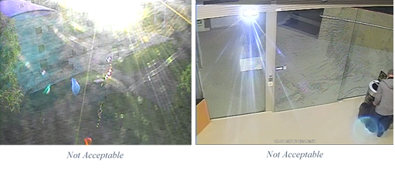

External Cameras
Cameras fitted externally on structures and freestanding poles shall not be mounted at such a level that allows ease of access from persons standing on the ground or on nearby fixed / movable objects.

External Cameras shall be rated at (Ingress Protection) IP 66 minimum unless they may be subject to pressure cleaning whereby they are required to be rated at IP 68.

External cameras shall be rated to meet or exceed the IK10 impact protection standard.

All cabling entering camera housings shall be enclosed in PVC clad flexible steel conduit with suitable terminations.

The camera mounting bracket or pole shall safely support the weight of the camera and any other attached devices. It shall also be designed to take into account the windage (drag) of the camera and other attached devices at the locations rated maximum wind loading and be designed to minimise any pole deflection affecting camera and imaging performance outcomes.

Camera Performance
Camera suitability and performance shall be tested against the reproduced image which has been recorded.
These reviews shall be completed at various hours throughout the day including dusk, dawn, harsh light times (midday, in the case of traffic cams headlights and spotlights) and low light hours. The assessment of images suitable for identification where required will be based on low light performance outcomes. Shown below are issues associated with performance outcomes, including examples of unacceptable and acceptable results.

Dynamic Range
Dynamic range refers to the CCTV cameras ability to interpret and display images in varying light conditions.
The higher the dynamic range, the better the cameras ability to cater for variances within lighting conditions including highlight and low light aspects.
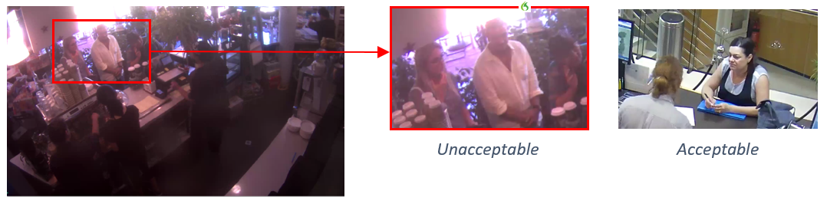
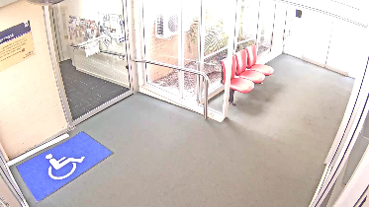
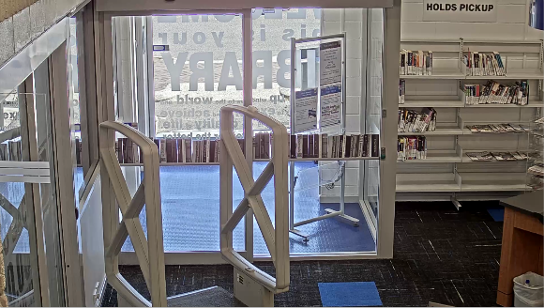
Unacceptable
Acceptable

Note:
It is important to understand that manufacturer data sheets and supporting documentation only relate to the capability of the camera and not to the functional outcomes that is achieved by the device once installed. This is due to the varying environmental and site conditions in which the cameras are installed and subsequently required to operate. As such a proper testing regime is essential prior to the purchase and installation of any equipment.

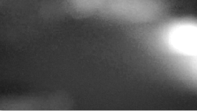
Focus
Unacceptable
Camera Lenses have not been focused correctly to produce a crisp image. Cameras may also be in-focus throughout the day but go out of focus at night.
This is a result of poor installation practices whereby the cameras have not been configured for the (1) available scene lighting, (2) back-focused correctly, or (3) configured to operate with the optics associated with a dome camera’s bubble.
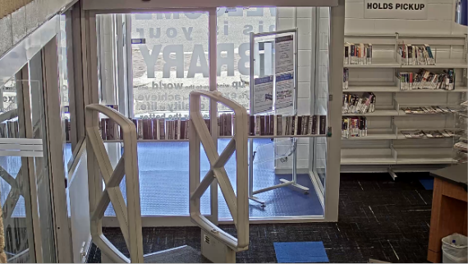
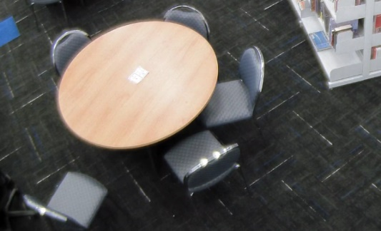
Unacceptable
Acceptable

Exposure

Overexposed or Flaring

Images can be described as overexposed when the amount of light allowed entering through the lens is greater than intended, which results in a brighter photo image.

The correct selection, installation and commissioning processes associated with close circuit television infrastructure will correct this issue.

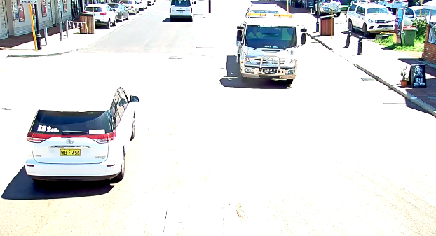
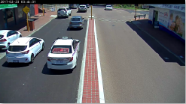
Unacceptable
Acceptable

Underexposed
Underexposed refers to the amount of allowed light through the cameras lens is not sufficient to produce acceptable images and will be darker than the overexposed or correctly exposed picture.

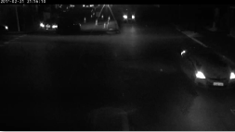
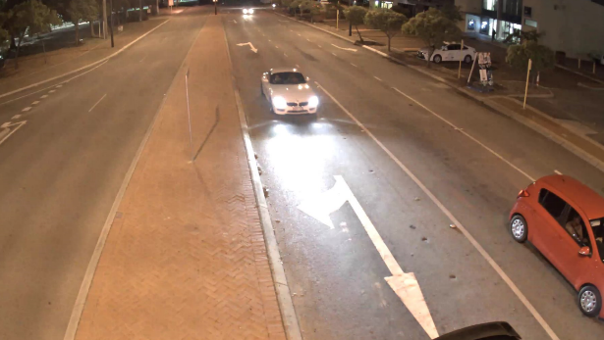
The correct selection, installation and commissioning processes associated with close circuit television infrastructure will correct this issue.
Unacceptable
Acceptable

Graininess and Noise

The Graininess is caused by the automatic gain control within the camera trying to compensate for low light conditions it cannot handle. As the camera amplifies the picture to try and get a good image it also amplifies the noise (graininess).

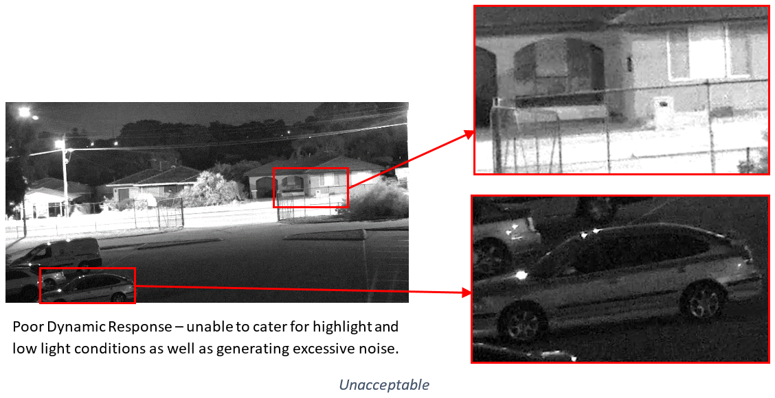
Owing to the way images are compressed within modern CCTV systems, in systems containing
Hi-Definition cameras, this noise can result in the storage required increasing by up to 900% (above daytime storage levels) in low light conditions (when nothing is happening).

Smear
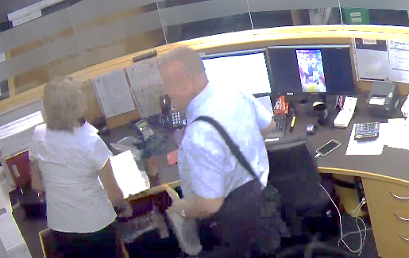
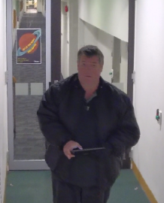
Incorrect camera selection or configuration combined with motion and lighting may cause loss of resolution in moving targets.
Unacceptable

Known as motion smearing and occurs when the camera amplifies noise which degrades the image.

License Number Plate Capture
Cameras designated to capture number plates shall complete this function regardless of the speed of the vehicle and lighting condition of the scene
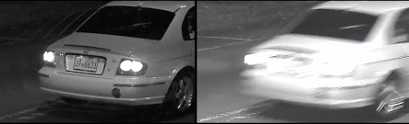
Acceptable Unacceptable

Slow Shutter Speed & the Inability to Capture Moving Targets at Night Time
Whilst most camera images look good through the day (insert), it is during lowlight or harsh light conditions when the failings of the camera and its ability to produce acceptable imaging is demonstrated.

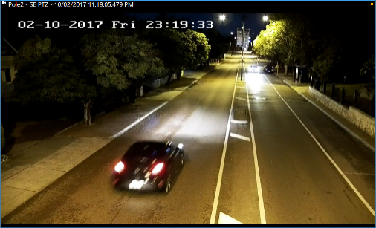
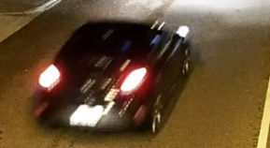
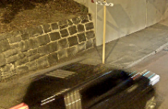
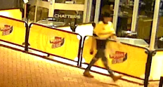
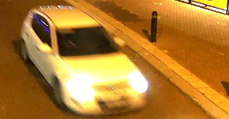
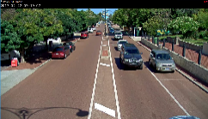
Camera manufacturers frequently used techniques which involve extending the time that the shutter remains open to enable the camera to produce images in low light conditions. The resultant effect is that background remains crisp and in focus, whilst moving targets become nothing more than a blur. This renders the camera unsuitable for producing night-time images where any detail is required on a moving target to provide identification or trying to resolve what has happened.
Unacceptable

Lack of Resolution
Simply put, resolution refers to the number of pixels on the target. The greater the amount of pixels on a subject, the greater the ability to define detail (in a perfect world).

The problem is that the clarity of the image may be affected by other conditions as such resolution or detail on target may be caused by (main ones):
- Poor dynamic range (1) – Edge Detail being compromised due to light,
- Lens Selection (2) – trying to cover too much in one picture.

- Poor Dynamic Range

- Lens Selection - Same Camera/ Different Lens Adjustment
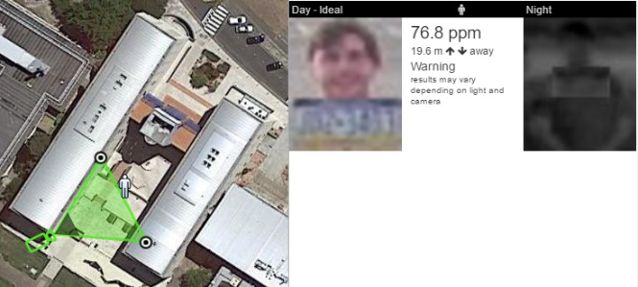
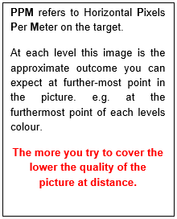
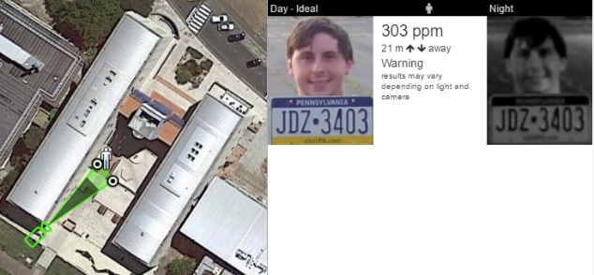
Note: Cameras and imaging devices produce differing results depending on the amount of light available.

When installing CCTV systems, the outcomes related for the imaging device should be based on night-time or harsh light reproduction and not solely on daytime imaging.
Resolution Required for ID by ANZPAA Guidelines
The wider the cameras view, the less detail is captured

Incorrect Positioning and Adjustment

Entries
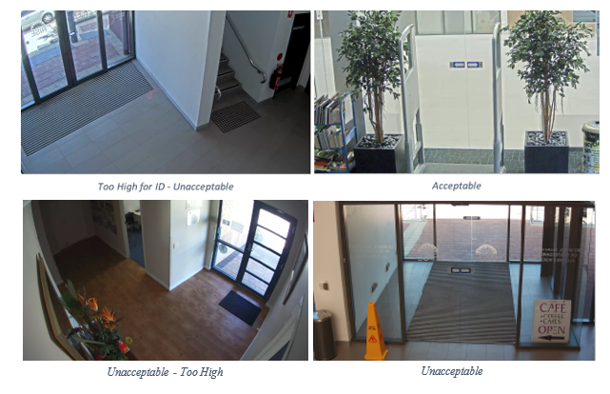The position of scheduled identification cameras shall be such that the camera is no more than 15° above the horizontal plane of 1.8 m target height. When entry cameras are too high all you will see is heads or hats.
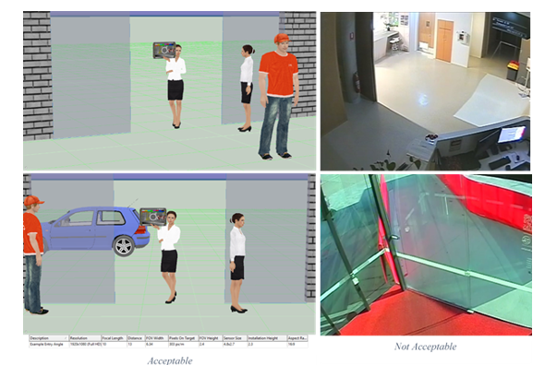

Mounting Height
Mounting heights of CCTV infrastructure should be low enough as to provide recognition or Identification of an event.
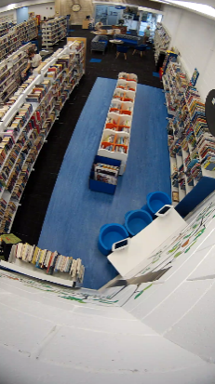
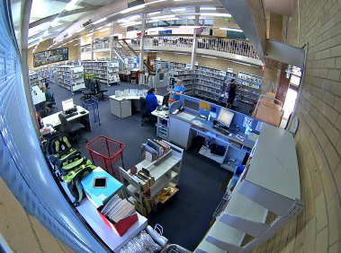
Unacceptable - Too High
Field of view too wide, looking at walls and lights
Views looking at Walls or Lights provide no benefit except to reduce resolution on the target and in the case of lighting, may affect the cameras ability to produce acceptable pictures.

Looking at Sky or Lights
Looking at Lights or the sky is unproductive. Apart from wasting the possible additional surveillance of a target or area, the cameras also have to cater for the flair and dynamic range of lighting as well as darker scenes away from the lights.

Unless there is a special requirement, it is bad practice to set cameras up in this way. These cameras will be rejected.

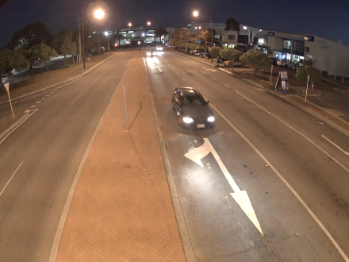
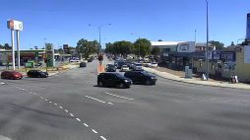
Unacceptable - Sky filling 50% of the image
Looking at sky and street lights

Alignment
Although not technically incorrect, straightening of images wherever possible ensures a better viewing experience. Cameras will be aligned to produce straight images.

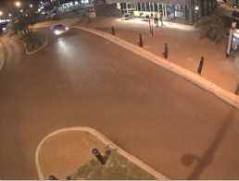
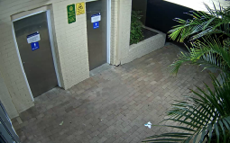
Image not straight
Image not straight

Environmental Conditions

Landscaping and Obstructions
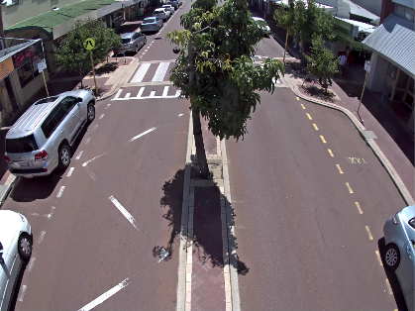
Installation of CCTV infrastructure should take in to account the environment in which it is being installed.

Landscaping presents ongoing challengers to the ongoing effectiveness of any imaging system. Remedial maintenance programs should be put in place to ensure ongoing outcomes or the cameras should be relocated to a different location

Cameras will not be positioned where they may be affected by vegetation or other obstructions

STORAGE
All storage solutions shall be Geutebruck and typically located within a University ITS (central IT & comms) rack. If not located within an ITS rack, it shall be within a secure room or cupboard with 0.5 hour UPS and ventilation/cooling to maintain manufacturer recommended optimal conditions.

Liaise with the rack supplier and installer, providing details of space, power and cooling requirements.

The storage shall be dimensioned based on, for every camera stream as follows.

Resolution: 1080P
Quality: Medium
Scene Activity: Low at 16 hours, Medium at 4 hours, High at 4 Hours
Scene Detail: Medium
Frame Rate, No Motion: 3 IPS
Frame Rate, Motion: 12.5 IPS
Retention: 31 days minimum

A minimum overhead of 20% (spare capacity) shall be included for each storage appliance.

The storage appliance shall use RAID 6 for the storage of video.

VIDEO MANAGEMENT SYSTEM
The University’s Geutebruck Video Management System (VMS) and Gallagher Command Centre Alarm Access Control System (AACS) shall be updated to incorporate the installed CCTV system (e.g. cameras and storage).

This includes but is not limited to:

- Required Additional Licences
- Camera Streams
- Storage Devices
- Alarms and events
- Gallagher Command Centre (the AACS) Integration
- New or updated Maps
- Edge device and server analytics

CONFIGURATION
For the purposes of configuration, testing, and commissioning a test area / site / division / group, which is hidden from all users other than the contractor and administrator shall be utilised.

A workstation shall be made available by the University for VMS and AACS work upon request. Contractor supplied mobile computers may be used but only through VPN access.

Contractors requiring VMS and AACS access must apply for a Non University Member Account (NUMA). Email a completed Access to Services Form, ICT Services and Facilities Use Agreement, and copy of photo identification such as a drivers licence to the University Security Technical Officer.

For a copy of the required form and agreement refer to the below website:

http://www.utas.edu.au/it/communication-technologies/utas-user-accounts/network-access-for-roles-other-than-staff-or-student/applying-for-a-new-numa-account

IP Addresses
All IP addresses shall be determined and provided by the University’s Security Technical Officer. The contractor must submit a request for them accompanied with an IP device schedule with MAC address, required ports, switch, and switch port number, recorded for each IP device.

Device Passwords
Default passwords for all IP devices shall be changed to custom ones as nominated or approved by the University’s Security Technical Officer.

Storage
Each camera stream at minimum shall be configured to record at;

Resolution: 1080P
Quality: Medium
Frame Rate, No Motion: 3 IPS
Frame Rate, Motion: 12.5 IPS

Unless otherwise directed or determined during testing and commissioning.

Analytics
Setup and configure the further specified and scheduled analytics.

Scene Validation (SV)
All camera streams are to have automatic Scene Validation enabled.

Activity Detection (AD)
Configure AD for specific cameras as detailed in the analytics schedule.

Video Motion Detection (VMD)
Configure VMD for specific cameras as detailed in the analytics schedule.

Video Motion Detection Extra Class (VMX)
Configure VMX for specific cameras as detailed in the analytics schedule.

Automatic Number Plate Recognition (ANPR)
All ANPR data shall be configured and integrated to stream into the AACS as an event as detailed in the analytics schedule.

People Counting
Camera or server analytics producing people counting or traffic numbers shall be configured to email daily xml or csv files in a format specified by the University with time stamped counts to a University specified email address.

Failover
Configure all camera streams to failover to the central failover recorder in the event of the cameras primary recorder failing.

Maps
Update the VMS maps to incorporate the installed CCTV system. Styles, fonts, colours and the like shall match the existing unless otherwise directed.

Base or background images must be vector based, either PDF or html 5 compliant scalable vector graphics (SVG).

All graphic links shall darken 50% from their colour upon mouse hover over.

All naming of sites, buildings and rooms is to be as per SISfm, the University’s mapping system. Refer: https://sisfm.admin.utas.edu.au/sisfm-enquiry/utas
Site, building and room codes, as per SISfm must be used where specified.

Add any new sites to the Tasmania state map and provide a graphic link shaped to represent the site’s boundary to the site map. The site name shall appear on mouse hover over.

Where a site has one building, the ground (entry) floor map of that building may be used as the site map.

The site map must show all buildings on the site and external cameras. Each building must have its building code shown in the centre of its graphic.

Each building with a CCTV system shall have a graphic link shaped to represent the outline of the building to the ground floor map of that building (a building level map). The building name shall appear on mouse hover over.

Each site level map shall have a rectangular graphic link on the top left hand side linking to the state map link and shall include the text State within the rectangle.

Each building level map shall have a set of rectangular graphic links on the top left hand side linking to the building’s level maps in descending order of lowest to highest and with a site map link as the first. Each graphic link shall including the building level map name it represents and the site map link shall include the text Site.

The ground floor building level maps must show external cameras if attached to that building.

Building level maps must show room numbers.

Camera Identification and Grouping
All naming of sites, buildings and rooms is to be as per SISfm, the University’s mapping system. Refer: https://sisfm.admin.utas.edu.au/sisfm-enquiry/utas

Site, building and room codes, as per SISfm must be used where specified.

All cameras are to be named as per the camera schedule descriptions and grouped by site, building, level, and camera group type for filtering as tabled. Where cameras are internal the room number following a capital R shall be added to the front of the camera name. Where cameras are external and not covering a single building or any building they shall not have a building or level.

Standard camera group types shall be formed and used as applicable by applying the following convention (examples):

Site Group: Sandy Bay, Hobart City etc
Site: Domain Campus, Centre for the Arts etc
Camera Group: AX24 – Building Y, AX19 – Uni Centre etc

Standard camera naming shall be formed and used as applicable by applying the following convention (examples):

First term: Site and Building Code
Second term: Room Number (if internal, blank if not)
Third term: Room/location Description
Fourth term: PTZ (blank if not a PTZ camera)
Fifth term: ANPR, PCOUNT etc (blank if not a dedicated analytic function)

Example:

Camera Naming | Site Group | Site | Camera Group
ML01 R120 Bike Store Exit | Hobart City | Melville St | ML01 – Melville St Accomm
SB BA22 Life Sciences Entrance PTZ | Sandy Bay | Sandy Bay Campus | BA22 – Life Sciences
NH AJ21 Brooks Carpark 13 | Newnham | Newnham Campus | AJ21 – Building T40B

The Global Camera Number for each camera shall be an extension of the existing within the following ranges as applicable:

Area | Range
Hobart City | 1 - 999
Sandy Bay Campus | 1000 - 1999
Southern Regional | 2000 – 2999
Inveresk | 3000 - 3999
Newnham | 4000 - 4999
Northern Regional | 5000 - 5999
North West | 6000 - 6999

AACS Maps Integration
All cameras are to be viewable on the AACS by Security and System Administrator users.

Update existing and create new maps as required in-line with the existing and as specified for VMS Maps excluding the State maps and vector based background requirements.

AACS Alarm Integration
In consultation with the University Security Technical Officer and as scheduled or further specified, alarms in the AACS that are in view of a camera are to place that camera into full motion record frame rate and show recorded and live video within the AACS for that alarm. PTZ cameras are to also pan and zoom to a defined pre-set. As a minimum, forced door and access denied alarms shall be integrated.

Any alarms from lost or tampered camera streams (e.g. lost camera communications, failed Scene Validation) and Analytics are to generate an alarm within the AACS.

Alarms acknowledged or processed with the AACS shall be automatically acknowledged or processed with the VMS.

AACS Event Integration
In consultation with the University Security Technical Officer and as scheduled or further specified, integrate VMS alarms or events as events within the AACS.

Users
Set up new or add to existing user groups as specified below.

Organisational Unit User
Setup a user group named as advised by the University. Restrict access to all parts of the VMS down to maps, alarm/event processing, viewing, and retrieval of video for the Organisational Unit’s area advised by the University.

Local Security User
Setup a user group for security guards or officers who require access to some of the sites or buildings as advised by the University and all operational functions.

Central Security User
These are monitoring operators that require access to all sites and operational functions within the VMS.

Tenant User
Setup a user group named as advised by the University. Restrict access to all parts of the VMS down to maps, alarm/event processing, viewing, and retrieval of video to the tenancy area advised by the University.

WORKS EXECUTION

General
Execute all works in accordance with this specification, associated drawings and in compliance with applicable Australian Standards, including but not limited to:

AS 1939 | Classification of degrees of protection provided by enclosures of electrical equipment
AS 3548 | Electromagnetic interference, limits and methods of measurement of information technology equipment
AS 4806.1 | CCTV Part 1 – Management and Operation
AS 4806.2 | CCTV Part 2 – Application Guidelines
AS 4806.3 | CCTV Part 3 – PAL signal timings and levels
AS 4806.4 | CCTV Part 4 – Remote video monitoring code of practice
AS 4552 | Electromagnetic compatibility
AS 60529 | Degrees of protection provided by enclosures (IP code)
AS/ACIF S009 | Installation requirements for customer cabling (Wiring rules)
AS/NZS 2053 | Conduits and fittings for electrical installations – All parts and amendments
AS/NZS 3000 | Electrical installation – SAA Wiring Rules

Where the requirements of this document exceed the requirements recommended in Australian Standards, The requirements of this document shall be implemented.

Interruption of Existing Services
Prior to interruption and isolating of any existing services notify University Security. All interruptions shall be kept to absolute minimum and works may have to be rescheduled by agreement with the University Security to avoid unsatisfactory disruption.

All interrupted services shall be reinstated and fully operational before leaving site at the end of each day, unless otherwise approved.

Supports and Conduit
Provide all necessary cabling support including brackets, hangars, conduit and fixings. Details of exposed supports are to be confirmed with the Architect prior to installation.

All wiring is preferred to be concealed. Where concealment is not possible due to structural elements or reasonable chasing in masonry/brick surfaces and surface mounted conduit is to be used it shall be painted to match the colour of the surface it runs on unless it is within a service area such as a node or plant room.

Electromagnetic Compatibility
Cable route installed, equipment and appliances provided are not to cause interference with any radio or other electronic transmitting or receiving equipment in the same locality. Cable route, equipment or appliances that cause interference shall be relocated or replaced at nil cost.

Cable Termination & Labelling
All terminations at a terminal strip shall utilise Starfix terminations or approved equivalent. Bare wire or solder wire connection shall not be accepted.
Cables shall be installed in such a manner to maintain the cable twist to the termination point.
All cabling shall be labelled using the Brady wire wrap system or an equivalent approved permanent labelling system allowing for replacement following cable re-termination. Labels shall be applied within 150mm of any termination point and shall not be concealed within cable duct or similar.

Sealing of Penetrations
Ensure that all conduit, wiring and penetrations through acoustic elements are sealed such that the required acoustic rating of the element is maintained. Penetrations through external walls shall be sealed with neutral cure silicon. Penetrations requiring waterproofing shall be effectively sealed and complete.

Fire and Smoke Stopping
Ensure that all conduit, wiring and penetrations through fire rated elements are protected by fire stop collars or fire resistant packing such that the required fire rating of the element is maintained.

Penetrations through smoke walls shall be effectively sealed to maintain the smoke rating of the wall.

Disposal of Waste
The work sites and locations are to be kept clean at all times. Remove from the sites and work areas all refuse, including food scraps, paper, packaging, wire stripping’s from undertaking the contract works.

Data (Ethernet) Cabling, Termination and General Installation
All data works are to comply with the Universities Telecommunications Cabling standard. A copy is available from the website below:

http://www.utas.edu.au/it/communication-technologies/standards

Panduit certification is required. All cameras shall be connected via terminated jacks within their enclosures. No camera shall be connected via wall or ceiling mounted outlets.

Making Good
Where existing services are removed or new installed the effected surfaces shall be made good or reinstated to the satisfaction of the Architect, typically by patching and painting.

TESTING AND COMMISSIONING
For the purposes of configuration, testing, and commissioning a test area / site / division / group, which is hidden from all users other than the Contractor and System Administrator shall be utilised.

Camera Testing
All cameras shall be upgraded to the latest VMS compatible firmware prior to testing.

Cameras to be tested are to be placed side-by-side with the same field of view (FoV) and connected to the same Video Management System (VMS) which has been configured similarly for all cameras (recording resolution, frame rate, quantitative/compression settings, date time stamping and motion areas) undergoing testing.

The test site/division within the VMS, specifically set up for testing if devices shall be used as is segregated from all but the Admin and Installer users.

Minimum shutter speeds shall be manually configured in the camera to 1/30s to eliminate differences between manufacturers slow shutter adjustment under low light.

Settings within each camera are to be optimised for the scene in which it is to be tested. In the event that the camera is to be used in bright, backlight and low light environments, the optimal setting for this camera is to be configured to perform for each scene/role. Records shall be kept of each set of configuration parameters to allow later deployment.

During setup, attention should be paid to the camera performance to identify any abnormalities. In the event that the image quality is substandard, recheck settings and if required contact the manufacturer or manufacturer’s representative for clarification.

The cameras are to be subsequently tested in each scene for which they are to be utilised. This includes use of resolution test charts to confirm the required Detail Resolutions will be achieved.

For example an entry exit camera would be tested in low light, harsh light and strong backlight conditions. This would ideally happen on site or in a location that would duplicate actual site conditions.

Nominal test lighting conditions and times to be used:

- Illumination Levels (target area) – 0.1 Lux, 0.5 Lux, 1 Lux, 5 Lux, 10 Lux
- Review of Recorded Site Imaging – 1 AM, 5 AM, 6 AM, 12 noon, 1 PM, 5 PM, 7 PM.

Pan, Tilt and Zoom Cameras shall be tested to verify:

- Maximum Pan and Tilt rotation angles and any intermediate pre-stops within them.
- Blind spots created where PTZ units do not provide full 360° rotation.
- Rotational speed meets requirements for tracking objects, inclusive of speed of calling between pre-set positions.
- The effects of induced vibration into the PTZ mechanism and how it affects home position. This is especially important when the testing PTZ is being mounted on poles as low-level vibration within poles may cause home positions to move affecting all pre-set positioning programmed within the camera head.

Still images from comparable cameras should be collated side-by-side to provide a direct and simple comparison.

Images from Camera Testing are to be recorded on the video management system and then reviewed following the completion of the testing. It is strongly recommended to include the University’s Security Technical Officer in the review of results.

It is recommended to compare and score cameras for the scene performance in relevant areas as per the following criteria:

- Bandwidth utilisation – bright light/low light
- Quantisation/Compression
- Detail Resolution performance with appropriate resolution test charts
- Image Quality for each scene in both still and motion conditions. Aspects to be considered include:
  - Colour
  - Saturation
  - Graininess and the effects of automatic gain control as light levels decrease
  - Smear and Motion Blur
  - Ability to handle lighting extremes such as headlights or dusk/dawn sunlight environment looking directly at camera
  - Optical correctness of dome covering camera lens
  - Effect of altering camera shutter and frame rates in low light situations while using camera motion detection
  - LNPR cameras furthermore shall be tested utilising vehicles fitted with various types of number plates and spotlights
- The imaging devices ability to trigger motion events on the Video Management System
- Ease of Use, firmware upgrade
- Mounting and Mounting Options – type and cost
- Ease of setup/maintenance of cameras especially PTZ’s on mounting brackets. This includes installation times of each unit tested
- Availability and cost
- Support

Commissioning
Undertake and complete the works and actions within the Commissioning Check List. Record completion within the check list including any relevant comments. Submit the completed Commissioning Check List to the Engineer and University Security Technical Officer for acceptance of Commissioning. If Commissioning is not accepted undertake the works or actions as directed by the Engineer or University Security Technical Officer to achieve acceptance.

Commissioning Check List

ITEM | YES/NA | COMMENTS / WHY NA?
CAMERAS
Completed Camera Testing for each installed camera
Submitted Camera Selection criteria compliant image for cameras taken at 1 AM
Submitted Camera Selection criteria compliant image for cameras taken at 5 AM
Submitted Camera Selection criteria compliant image for cameras taken at 6 AM
Submitted Camera Selection criteria compliant image for cameras taken at 12 PM
Submitted Camera Selection criteria compliant image for cameras taken at 1 PM
Submitted Camera Selection criteria compliant image for cameras taken at 5 PM
Submitted Camera Selection criteria compliant image for cameras taken at 7 PM
Submitted licence plate cameras test images daylight and night time conditions with vehicles having low beam, high beam and spotlights
VMS
All maps are updated or added to reflect the works and installation
Zooming in / out and panning of maps does not distort, lag or fail
All map links darken upon hover over
All map links navigate to the correct maps
All cameras shown on maps have live footage on hover/selection (not currently active)
Locate on map function works for all cameras on maps
All required new user groups have been created or existing have been updated/modified
AACS INTEGRATION
All maps are updated or added to reflect the works and installation
PTZ control of PTZ cameras functions smoothly including pre-sets
AACS alarms show associated recorded video and live video from the VMS
VMS alarms for lost or tampered camera streams occur within the VMS for all cameras
AACS acknowledged or processed VMS alarms, acknowledge or process within the VMS
STORAGE
Appliance health is within the manufacturers recommended ranges or limits
All camera streams are recording at the minimum frame rates and quality or greater
Average storage bitrate is within anticipated levels
Storage level checked after 7 days
Storage level checked at 31 days
ANALTYICS
Scene Validation is enabled and configured for all cameras
AD / VMD / VMX analytics are configured as scheduled or directed and not producing false or nuisance alarms
FAIL OVER
All camera streams are configured to fail over to the central failover recorder

PRACTICAL COMPLETION (HANDOVER)
Notify the University Security Technical Officer upon completion of works in a building or site.

RECORD OF WORK (AS INSTALLED/BUILT)
Complete and submit electronic copies of relevant maintainable asset forms available from:

http://www.utas.edu.au/commercial-services-development/building-works/contractors-and-consultants

Submit a copy of the completed Commissioning Check List.

WARRANTIES
Make good any defects caused by faulty workmanship and/or materials during the Defects Liability Period upon notice to do so.

Warrant to carry out regular inspections specified. Make any necessary adjustments during these inspections.

Time Warranties for Workmanship and Materials
The time warranties for the work commence at the agreed date of Practical Completion given for the completion of the whole building project.

Warrant the whole of the installation for a period of twelve (12) months from the date of Practical Completion. Where ongoing defects in workmanship or materials are evident throughout the initial 12 month period and have not been rectified to the universities satisfaction, the initial defects liability shall be extended as required.

In the event of inclusion of equipment normally covered by a lesser time warranty, allow for and include the cost of extending such warranty to that specified for the whole installation.

Defects Liability
A Defects Liability Period of twelve (12) calendar months from the date of Practical Completion will apply. This clause applies irrespective of the fact that such part or parts may have been previously accepted.

During the Defects Liability period:

Supply electronic record of works undertaken consisting of:

- Replace or make good any part or parts which may prove faulty in design, workmanship or material; and

- Renew or modify any items of equipment and/or group of items and/or complete system that do not comply with the operating conditions and performance specified during the period of twelve (12) months after the date of Practical Completion; and

- Include for all labour and all incidental costs for the removal and replacement of defective parts or components; and

- Perform the required works as instructed in writing within seven (7) days of such notices; and

- Test all replaced items and show that the system operations as designed.

Failure to rectify defects found during the Defect Liability period will result in the University engaging others to finish the required works. The costs of these works will be deducted from payments owning or billed.

Equipment Warranties
CCTV Equipment and associated systems shall carry a 36-month manufacturer’s warranty that shall take effect from commissioning of the system, device or associated equipment.

Warrant that the performance of all items of equipment used in the works are not less than those specified when operating under the specified conditions and that such equipment can be installed with adequate clearances for operation and maintenance.

Replace any items of equipment, not meeting the requirements, at no cost to the University.

Replacement and/or repair of equipment during the Defects Liability period may result in the Defects Liability period being extended for the respective item(s).

CAMERA SCHEDULE EXAMPLE
The following schedule is an example of the expected detail within a camera schedule. Level included in Camera Description for scheduling purposes only. Level to not be included in Camera Description for configuration as level to be included in grouping configuration.

Camera ID | Camera Description | Nominal Install Height (m) | Target Distance (m) | Target Width (m) | Target Height (m) | Required Detail Resolution | Nominal Pixels On Target | Focal Length (mm) | Corridor Mode | Nominal Manufacturer | Nominal Model | AACS Alarm
1 | Street Entry External | 3 | 17.5 | 6.7 | 3.01 | Recognition | 161 px/m | 8 | Yes | Axis | P3225-LVE

ANALYTICS SCHEDULE
The following schedule is an example of the expected detail within an analytics schedule.

Camera ID | Description | Analytic | Analytic Function | Analytic Functional Description
1 | Street Entry External | VMX | Loiter Alarm | Generate alarm when person sized objects have entered the target area and not left within 15 minutes

