

Maintainable Asset Forms

Commercial Services and Development

Revision 1.0

http://www.utas.edu.au/commercial-services-development/building-works/contractors-and-consultants

This document has been produced for use and reference by all persons and parties involved with undertaking built environment works for the University of Tasmania (e.g. Contractors, Consultants, Project Managers, Facilities Managers, Works / Maintenance Officers).

All effort has been made to simplify or streamline the instructions within this manual. Feedback on its content and assets covered is appreciated and should be directed to Infrastructure Planning and Compliance or provided to the University staff managing the works being undertaken.

Document change log

Version | Date | Revision
1.0 | 09/05/2016 | Supersedes Maintainable Assets – Description Hierarchy

Contents

Introduction 1
Asset Forms 2
General Instructions 2
Asset Relocation / Storage / Inactive Form 4
Asset Demolition / Disposal Form (External Use Only) 5
Asset Type Nomination Form 6
Building Asset Forms 1
Civil Asset Forms 19
Communications Asset Forms 26
Electrical Asset Forms 27
Fire Asset Forms 49
Hydraulic Asset Forms 69
Gas Asset Forms 115
Mechanical Asset Forms 130
Security Asset Forms 214
Vertical Transportation Asset Forms 219
Research Asset Forms 226

Introduction

Record of physical infrastructure is important for numerous reasons including legal ones such as the requirement for Form 56 Annual Maintenance Statements, regulatory body requirements and contractually binding commitments.

The legally required maintenance for a building is often stipulated by the Form 46 Schedule of Prescribed Features and Measures issued by a Building Surveyor. In addition to this other acts and regulatory body requirements may apply such as gas and electricity codes. These forms are aimed at ensuring sufficient information and data is provided for meeting these legal requirements and also satisfying University’s policies, frameworks, guidelines and procedures for its facilities and asset management incorporating the built environment.

The University of Tasmania has a reasonable history and many records. The quality of work performed and its record will be viewed, reviewed and used by many University staff and other parties such as Architects, Engineers, Builders, Plumbers, Electricians and HVAC Technicians. Accordingly past work and its record are a factor in future work.

Asset Forms

General Instructions
This section details what to put in asset non-specific data fields on the asset data forms.

Project No. / WR No.
Every issued item of work will have a project number or work request number (WR). Ask the University staff organising the works for this number if you do not know it.

Site / Building / Room
Location codes are to be used for the identification of University space. These can easily be found on any provided plans or from UTAS SISfm Enquiry at the below website:

https://sisfm.admin.utas.edu.au/SISfm-Enquiry/utas/

Names can be provided however space is limited on the asset data forms making the use of the Universities location codes easier. The University staff organising the works can provide the location codes upon request or explain how to find them in UTAS SISfm Enquiry. Most small works or projects should contain them as part of the works request or project documentation from the University or its consultants.

Identifier
The identifier is what you, the installer use as an identifier for that asset. The asset must be physically labelled with the same identifier and it must also be present on any as-installed material referencing the asset such as drawings, schematics, head end graphics, and building handbook.

ARV Cost
This is the known or approximate Asset Replacement Value cost consisting of the supply and installation cost of the asset.

OH&S Notes
These are to provide warning or information useful to persons required to work on the asset so they can pre-prepare as best as possible prior to assessing and commencing the work. Examples are;

- Ladder required for access
- EWP required for access
- Noise protection required
- Harness required
- Manhole in far corner of room
- Physical containment area (PC1, PC2, etc.)
- Quarantined containment area (QC1, QC2, etc.)
- Located in confined space

Warranty End Date
This date when the manufacturer’s warranty will expire starting from the warranty commencement date. For lifetime warranties enter 99/99/9999. For items with more than one warranty period enter the longest one noting the shorter one and its coverage in the warranty coverage notes.

Warranty Coverage
The warranty coverage are notes that refers to what the warranty covers or applies for. Generally, use the manufacturer’s brief wording.

Asset Life
This is the estimated duration in years of when asset will need replacing either due to total failure or reaching a point of no longer being economic to maintain. A default value for the type of asset is provided in brackets however this should be varied depending on the installation, e.g. corrosive environment, exposed to the weather, AC unit subjected to short cycling.

University Use Fields
For reference only, University use fields are explained below

Class = Asset Class = eq_class
Group = Asset Category/Group = eq_group
Cat = Asset Group/Type = eq_type
Cat Type = Category Type = category_id

BC (default value) = Budget Centre = dp_id
Cond. = Condition rating, default excellent for new assets = condition
Crit.. = Criticality rating, default provided for asset type = criticality
FMC = Asset FM Contract Category = eq_fmcat
Asset No. = Asset number to be completed when generated

Asset Relocation / Storage / Inactive Form

Project No. / WR No. |  |  |  | Date of Change | / /
Asset Number |  |  |  | Contractor
Identifier |  |  |  | Relocation | Yes / No
New Site |  |  |  | Storage | Yes / No
New Building |  |  |  | Inactive | Yes / No
New Room
General Notes

Notes:

If no change in Site, Building or Room then leave as blank.

Relocation means an asset that has been taken out of service and put back into service in another location.

Storage means an asset that has been taken out of service and stored.

Inactive means a decommissioned asset that has remained in its service location but is no longer in service. E.g. A ceiling mounted heater disconnected.

Asset Demolition / Disposal Form (External Use Only)

Project No. / WR No. |  |  |  | Date of Disposal | / /
Asset Number |  |  |  | Contractor
Identifier |  |  |  | Disposal Method | Waste / Scrap / Possession
General Notes

Notes:

For external use only (non-University Staff) when an asset is being disposed of by a contractor for the University.

Waste means sent to landfill

Scrap means salvaged, recycled or melted down

Possession means asset has been retained by contractor

Asset Type Nomination Form

Generally, the University has created its asset database in-line with legislated Form 46 and other Worksafe maintenance requirements.

Accordingly some assets of reasonable value (over $5,000) may not be captured with the forms in this manual or would be better classified with an asset type of their own for direct assignment of maintenance schedules/programs. If this is the case please fill out the below for the University’s consideration.

Definition:

Project No. / WR No. |  |  |  | Install Date | / /
Identifier |  |  |  | ARV Cost (ex GST)
Site |  |  |  | Manufacturer
Building |  |  |  | Model
Room |  |  |  | Serial No.
Installer |  |  |  | Warranty End Date | / /
Warranty Coverage
OH&S Notes
General Notes

Sub assets:

Components:

Attributes:

Building Asset Forms

Refer to Asset Forms General Instructions section before completing these forms.

Building Façade 2
External Windows 3
Window Louvre - External 4
Gutters & Downpipes 5
Metal Roof Decking 6
Membrane Roof Coatings 7
Fall Arrest Device – Anchor Points 8
Fall Arrest Device – Static Line 9
Fall Arrest Device – Ladder Anchor 10
Safety Access Walkway 11
Floor Finishes 12
Ceilings 13
Internal Walls 14
Stairwell 15
Balconies 16
Balustrades and Barriers 17

Building Façade

The façade of a building including, cladding and, parapet.

One asset per building.

If undertaking significant works for an existing buildings asset provide value of works on asset form otherwise an asset form for the existing building is not required.

Project No. / WR No. |  |  |  | Install Date | / /
Identifier |  |  |  | ARV Cost (ex GST)
Site |  |  |  | Manufacturer
Building |  |  |  | Warranty End Date | / /
Installer
Warranty Coverage
OH&S Notes
General Notes
Form Filled Out By

Attributes:
Asset Life (60)
Fire Rated* | Yes / No
*If has fired rated elements or parts

University Use:
Class / Group / Cat / Cat Type |  |  |  | BUILDING / BFAB / BUILDING FABRIC / EW
BC (775) |  | Cond. | EXCL |  | Crit. | C3 | FMC | N/A | Asset No.

External Windows

The external windows of a building, excluding glazed louvres

One asset per building.

If undertaking significant works for an existing buildings asset provide value of works on asset form otherwise an asset form for the existing building is not required.

Project No. / WR No. |  |  |  | Install Date | / /
Identifier |  |  |  | ARV Cost (ex GST)
Site |  |  |  | Manufacturer
Building |  |  |  | Warranty End Date | / /
Installer
Warranty Coverage
OH&S Notes
General Notes
Form Filled Out By

Attributes:
Asset Life (60)
Fire Rated* | Yes / No
*If has fired rated elements or parts

University Use:
Class / Group / Cat / Cat Type |  |  |  | BUILDING / BFAB / BUILDING FABRIC / WW
BC (775) |  | Cond. | EXCL |  | Crit. | C3 | FMC | N/A | Asset No.

Window Louvre - External

A louvered window, manual or electrically controlled.

Project No. / WR No. |  |  |  | Install Date | / /
Identifier |  |  |  | ARV Cost (ex GST)
Site |  |  |  | Manufacturer
Building |  |  |  | Warranty End Date | / /
Installer |  |  |  | Room
Warranty Coverage
OH&S Notes
General Notes

Attributes:
Asset Life (60)
Fire Rated* | Yes / No
*If has fired rated elements or parts

University Use:
Class / Group / Cat / Cat Type |  |  |  | BUILDING / BFAB / BUILDING FABRIC / WW
BC (775) |  | Cond. | EXCL |  | Crit. | C3 | FMC | N/A | Asset No.

Gutters & Downpipes

Guttering and downpipes, ending at the ground. Includes flashings.

One asset per building.

If undertaking significant works for an existing buildings asset provide value of works on asset form otherwise an asset form for the existing building is not required.

Project No. / WR No. |  |  |  | Install Date | / /
Identifier |  |  |  | ARV Cost (ex GST)
Site |  |  |  | Manufacturer
Building |  |  |  | Warranty End Date | / /
Installer
Warranty Coverage
OH&S Notes
General Notes

Attributes:
Asset Life (20)

University Use:
Class / Group / Cat / Cat Type |  |  |  | BUILDING / BFAB / BUILDING FABRIC / -
BC (775) |  | Cond. | EXCL |  | Crit. | C3 | FMC | N/A | Asset No.

Metal Roof Decking

Metal roofing.

One asset per building.

If undertaking significant works for an existing buildings asset provide value of works on asset form otherwise an asset form for the existing building is not required.

Project No. / WR No. |  |  |  | Install Date | / /
Identifier |  |  |  | ARV Cost (ex GST)
Site |  |  |  | Manufacturer
Building |  |  |  | Warranty End Date | / /
Installer
Warranty Coverage
OH&S Notes
General Notes

Attributes:
Asset Life (45)

University Use:
Class / Group / Cat / Cat Type |  |  |  | BUILDING / BFAB / BUILDING FABRIC / RF
BC (775) |  | Cond. | EXCL |  | Crit. | C3 | FMC | N/A | Asset No.

Membrane Roof Coatings

All membrane types of roof coatings or sealing.

One asset per building.

If undertaking significant works for an existing buildings asset provide value of works on asset form otherwise an asset form for the existing building is not required.

Project No. / WR No. |  |  |  | Install Date | / /
Identifier |  |  |  | ARV Cost (ex GST)
Site |  |  |  | Manufacturer
Building |  |  |  | Warranty End Date | / /
Installer
Warranty Coverage
OH&S Notes
General Notes

Attributes:
Asset Life (20)

University Use:
Class / Group / Cat / Cat Type |  |  |  | BUILDING / BFAB / BUILDING FABRIC / RF
BC (775) |  | Cond. | EXCL |  | Crit. | C3 | FMC | N/A | Asset No.

Fall Arrest Device – Anchor Points

Definition:

Fall arrest device, anchor point type. One asset per building. Quantity to be provided in notes.

Project No. / WR No. |  |  |  | Install Date | / /
Identifier |  |  |  | ARV Cost (ex GST)
Site |  |  |  | Manufacturer
Building |  |  |  | Model
Room* |  |  |  | Serial No.
Installer |  |  |  | Warranty End Date | / /
Warranty Coverage
OH&S Notes
General Notes |  | Quantity?

*Room first anchor point is above, below or outside of.

Attributes:
Asset Life (10)

University Use:
Class / Group / Cat / Cat Type |  |  |  | BUILDING / BFAB / BUILDING FABRIC / -
BC (775) |  | Cond. | EXCL |  | Crit. | C4 | FMC | SAFESTAT | Asset No.

Fall Arrest Device – Static Line

Definition:

Fall arrest device, Static Line type

Project No. / WR No. |  |  |  | Install Date | / /
Identifier |  |  |  | ARV Cost (ex GST)
Site |  |  |  | Manufacturer
Building |  |  |  | Model
Room* |  |  |  | Serial No.
Installer |  |  |  | Warranty End Date | / /
Warranty Coverage
OH&S Notes
General Notes

*Room it is above, below or outside of.

Attributes:
Asset Life (10)

University Use:
Class / Group / Cat / Cat Type |  |  |  | BUILDING / BFAB / BUILDING FABRIC / -
BC (775) |  | Cond. | EXCL |  | Crit. | C4 | FMC | SAFESTAT | Asset No.

Fall Arrest Device – Ladder Anchor

Definition:

Fall arrest device, ladder anchor

Project No. / WR No. |  |  |  | Install Date | / /
Identifier |  |  |  | ARV Cost (ex GST)
Site |  |  |  | Manufacturer
Building |  |  |  | Model
Room* |  |  |  | Serial No.
Installer |  |  |  | Warranty End Date | / /
Warranty Coverage
OH&S Notes
General Notes

*Room it is above, below or outside of.

Component:
Quantity
Access Strop

Attributes:
Asset Life (10)

University Use:
Class / Group / Cat / Cat Type |  |  |  | BUILDING / BFAB / BUILDING FABRIC / -
BC (775) |  | Cond. | EXCL |  | Crit. | C4 | FMC | SAFESTAT | Asset No.

Safety Access Walkway

Definition:

Walkway located generally on roofs for safer paths of travel to equipment. One asset per building. Quantity to be provided in notes.

Project No. / WR No. |  |  |  | Install Date | / /
Identifier |  |  |  | ARV Cost (ex GST)
Site |  |  |  | Manufacturer
Building |  |  |  | Model
Room* |  |  |  | Serial No.
Installer |  |  |  | Warranty End Date | / /
Warranty Coverage
OH&S Notes
General Notes |  | Length:

*Room first walkway part is above, below or outside of.

Attributes:
Asset Life (20)

University Use:
Class / Group / Cat / Cat Type |  |  |  | BUILDING / BFAB / BUILDING FABRIC / -
BC (775) |  | Cond. | EXCL |  | Crit. | C4 | FMC | SAFESTAT | Asset No.

Floor Finishes

Floor coverings and finishes.

One asset per building.

If undertaking significant works for an existing buildings asset provide value of works on asset form otherwise an asset form for the existing building is not required.

Project No. / WR No. |  |  |  | Install Date | / /
Identifier |  |  |  | ARV Cost (ex GST)
Site |  |  |  | Manufacturer
Building |  |  |  | Warranty End Date | / /
Installer
Warranty Coverage
OH&S Notes
General Notes

Attributes:
Asset Life (15)

University Use:
Class / Group / Cat / Cat Type |  |  |  | BUILDING / BFAB / BUILDING FABRIC / FF
BC (775) |  | Cond. | EXCL |  | Crit. | C3 | FMC | N/A | Asset No.

Ceilings

Plaster, acoustic, tiled, timber. All false or suspended ceilings.

One asset per building.

If undertaking significant works for an existing buildings asset provide value of works on asset form otherwise an asset form for the existing building is not required.

Project No. / WR No. |  |  |  | Install Date | / /
Identifier |  |  |  | ARV Cost (ex GST)
Site |  |  |  | Manufacturer
Building |  |  |  | Installer
Warranty Coverage
OH&S Notes
General Notes

Attributes:
Asset Life (30)
Fire Rated* | Yes / No
*If has fired rated elements or parts

University Use:
Class / Group / Cat / Cat Type |  |  |  | BUILDING / BFAB / BUILDING FABRIC / CF
BC (775) |  | Cond. | EXCL |  | Crit. | C3 | FMC | N/A | Asset No.

Internal Walls

All internal walls and their finishes.

One asset per building.

If undertaking significant works for an existing buildings asset provide value of works on asset form otherwise an asset form for the existing building is not required.

Project No. / WR No. |  |  |  | Install Date | / /
Identifier |  |  |  | ARV Cost (ex GST)
Site |  |  |  | Manufacturer
Building |  |  |  | Installer
Warranty Coverage
OH&S Notes
General Notes

Attributes:
Asset Life (50)
Fire Rated* | Yes / No
*If has fired rated elements or parts

University Use:
Class / Group / Cat / Cat Type |  |  |  | BUILDING / BFAB / BUILDING FABRIC / CF
BC (775) |  | Cond. | EXCL |  | Crit. | C3 | FMC | N/A | Asset No.

Stairwell

Stairwell.

One asset per stairwell.

If undertaking significant works for an existing buildings asset provide value of works on asset form otherwise an asset form for the existing building is not required.

Project No. / WR No. |  |  |  | Install Date | / /
Identifier |  |  |  | ARV Cost (ex GST)
Site |  |  |  | Manufacturer
Building |  |  |  | Warranty End Date | / /
Installer |  |  |  | Room
Warranty Coverage
OH&S Notes
General Notes

Attributes:
Asset Life (50)
Fire Isolated | Yes / No

University Use:
Class / Group / Cat / Cat Type |  |  |  | BUILDING / BFAB / BUILDING FABRIC / SC
BC (775) |  | Cond. | EXCL |  | Crit. | C3 | FMC | N/A | Asset No.

Balconies

Balconies.

One asset per building.

If undertaking significant works for an existing buildings asset provide value of works on asset form otherwise an asset form for the existing building is not required.

Project No. / WR No. |  |  |  | Install Date | / /
Identifier |  |  |  | ARV Cost (ex GST)
Site |  |  |  | Manufacturer
Building |  |  |  | Installer
Warranty Coverage
OH&S Notes
General Notes

Attributes:
Asset Life (50)

University Use:
Class / Group / Cat / Cat Type |  |  |  | BUILDING / BFAB / BUILDING FABRIC / -
BC (775) |  | Cond. | EXCL |  | Crit. | C3 | FMC | N/A | Asset No.

Balustrades and Barriers

Balustrades and barriers as required by the NCC.

One asset per building.

If undertaking significant works for an existing buildings asset provide value of works on asset form otherwise an asset form for the existing building is not required.

Project No. / WR No. |  |  |  | Install Date | / /
Identifier |  |  |  | ARV Cost (ex GST)
Site |  |  |  | Manufacturer
Building |  |  |  | Warranty End Date | / /
Installer |  |  |  | Room
Warranty Coverage
OH&S Notes
General Notes

Attributes:
Asset Life (50)

University Use:
Class / Group / Cat / Cat Type |  |  |  | BUILDING / BFAB / BUILDING FABRIC / -
BC (775) |  | Cond. | EXCL |  | Crit. | C3 | FMC | N/A | Asset No.

Structural Elements

The structural elements of the building. Columns, beams, trusses, loadbearing walls, foundations etc.

One asset per building.

If undertaking significant works for an existing buildings asset provide value of works on asset form otherwise an asset form for the existing building is not required.

Project No. / WR No. |  |  |  | Install Date | / /
Identifier |  |  |  | ARV Cost (ex GST)
Site |  |  |  | Manufacturer
Building |  |  |  | Warranty End Date | / /
Installer
Warranty Coverage
OH&S Notes
General Notes

Attributes:

Asset Life (60)
Fire Rated* | Yes / No
*If has fired rated elements or parts

University Use:
Class / Group / Cat / Cat Type |  |  |  | BUILDING / BFAB / STRUCTURE / -
BC (775) |  | Cond. | EXCL |  | Crit. | C3 | FMC | N/A | Asset No.

Civil Asset Forms

Refer to Asset Forms General Instructions section before completing these forms.

Boom Gate - Electric 20
Bollard - Electric 21
Parking Meter 22
Diesel Tank 23
Petrol Tank 24
LPG Tank 25

Boom Gate - Electric

An electronically controlled vehicle barrier

Project No. / WR No. |  |  |  | Install Date | / /
Identifier |  |  |  | ARV Cost (ex GST)
Site |  |  |  | Manufacturer
Installer |  |  |  | Warranty End Date | / /
Warranty Coverage
OH&S Notes
General Notes

Attributes:
Asset Life (15)

Class / Group / Cat / Cat Type |  |  |  | BUILDING / BUILD / CIVIL INFRASTRUCTURE / -
BC (775) |  | Cond. | EXCL |  | Crit. | C3 | FMC | N/A | Asset No.

Bollard - Electric

An electronically controlled vehicular barrier bollard

Project No. / WR No. |  |  |  | Install Date | / /
Identifier |  |  |  | ARV Cost (ex GST)
Site |  |  |  | Manufacturer
Installer |  |  |  | Warranty End Date | / /
Warranty Coverage
OH&S Notes
General Notes

Attributes:
Asset Life (15)

Class / Group / Cat / Cat Type |  |  |  | BUILDING / BUILD / CIVIL INFRASTRUCTURE / -
BC (775) |  | Cond. | EXCL |  | Crit. | C3 | FMC | N/A | Asset No.

Parking Meter

Parking meters, voucher machines, etc.

Project No. / WR No. |  |  |  | Install Date | / /
Identifier |  |  |  | ARV Cost (ex GST)
Site |  |  |  | Manufacturer
Installer |  |  |  | Warranty End Date | / /
Warranty Coverage
OH&S Notes
General Notes

Attributes:
Asset Life (15)

Class / Group / Cat / Cat Type |  |  |  | BUILDING / BUILD / CIVIL INFRASTRUCTURE / -
BC (775) |  | Cond. | EXCL |  | Crit. | C3 | FMC | N/A | Asset No.

Diesel Tank

Definition:
Above or below ground diesel tank

Project No. / WR No. |  |  |  | Install Date | / /
Identifier |  |  |  | ARV ARV Cost (ex GST)
Site |  |  |  | Manufacturer
Building |  |  |  | Model
Installer |  |  |  | Serial No
 |  |  |  | Warranty End Date | / /
Warranty Coverage
OH&S Notes
General Notes

Attributes:
Capacity (L)
Asset Life (20)

Class / Group / Cat / Cat Type |  |  |  | BUILDING / BUILD / CIVIL INFRASTRUCTURE / -
BC (775) |  | Cond. | EXCL |  | Crit. | C3 | FMC | N/A | Asset No.

Petrol Tank

Definition:
Above or below ground petrol tank

Project No. / WR No. |  |  |  | Install Date | / /
Identifier |  |  |  | ARV Cost (ex GST)
Site |  |  |  | Manufacturer
Building |  |  |  | Model
Installer |  |  |  | Serial No
 |  |  |  | Warranty End Date | / /
Warranty Coverage
OH&S Notes
General Notes

Attributes:
Capacity (L)
Asset Life (20)

Class / Group / Cat / Cat Type |  |  |  | BUILDING / BUILD / CIVIL INFRASTRUCTURE / -
BC (775) |  | Cond. | EXCL |  | Crit. | C3 | FMC | N/A | Asset No.

LPG Tank

Definition:
An above ground LPG tank.

Project No. / WR No. |  |  |  | Install Date | / /
Identifier |  |  |  | ARV Cost (ex GST)
Site |  |  |  | Manufacturer
Building |  |  |  | Model
Installer |  |  |  | Serial No
 |  |  |  | Warranty End Date | / /
Warranty Coverage
OH&S Notes
General Notes

Attributes:
Capacity (L)
Asset Life (20)

Class / Group / Cat / Cat Type |  |  |  | BUILDING / BUILD / CIVIL INFRASTRUCTURE / -
BC (775) |  | Cond. | EXCL |  | Crit. | C3 | FMC | N/A | Asset No.

Communications Asset Forms
Comprising of telecommunications, data, fibre optic and copper reticulation, audio visual systems.

Refer to University of Tasmania ITS requirements website below for further details.

http://www.utas.edu.au/it/communication-technologies/standards

Electrical Asset Forms

Refer to Asset Forms General Instructions section before completing these forms.

High Voltage Reticulation 28
Power Pole 29
Transformer – Pole Mounted 30
Substation - Kiosk 31
Substation – Pad Mount 32
Substation – In Building 33
Generator - Diesel 34
Generator - Solar 35
Generator – Solar-inverter 36
UPS System 37
Switchboard – In Substation 38
Switchboard - Main 39
Switchboard - Distribution 40
Power Factor Correction Unit 41
Lightning Protection System 42
Surge Protection Unit 43
General Power Reticulation 44
General Lighting Reticulation 45
Emergency Lighting & Fire Exit Signs 46
Automatic Door Control Assembly 47
Automatic External Defibrillator 48

High Voltage Reticulation

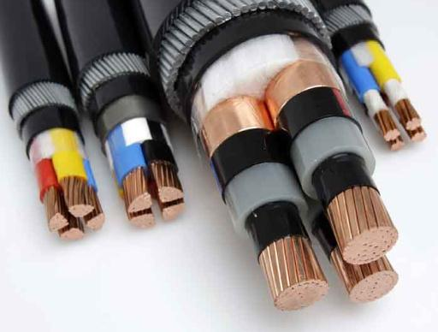

Definition:
Cable network used to reticulate High Voltage around a site. One asset per site.
If undertaking significant works for an existing site asset provide value of works on asset form otherwise an asset form for the existing site is not required.

Project No. / WR No. |  |  |  | Install Date | / /
Identifier |  |  |  | ARV Cost (ex GST)
Site |  |  |  | Installer
OH&S Notes
General Notes
Form Filled Out By

Attributes:
Asset Life (50)

University Use:
Class / Group / Cat / Cat Type |  |  |  | PLANT & EQUIP / ELECEQ / HIGH VOLTAGE SYSTEM / -
BC (775) |  | Cond. | EXCL |  | Crit. | C5 | FMC | N/A | Asset No.

Power Pole

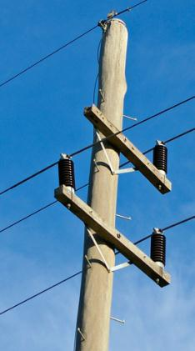

Definition:
A vertical pole supporting suspended power or communications cables

Project No. / WR No. |  |  |  | Install Date | / /
Identifier |  |  |  | ARV Cost (ex GST)
Site |  |  |  | Manufacturer
Installer |  |  |  | Warranty End Date | / /
Warranty Coverage
OH&S Notes
General Notes
Form Filled Out By

Attributes:

Height (m) |  | Material | Steel/Wood/Concrete
Asset Life (15)

University Use:
Class / Group / Cat / Cat Type |  |  |  | PLANT & EQUIP / ELECEQ/ HIGH VOLTAGE SYSTEMS / -
BC (775) |  | Cond. | EXCL |  | Crit. | C5 | FMC | ELECHV | Asset No.

Transformer – Pole Mounted

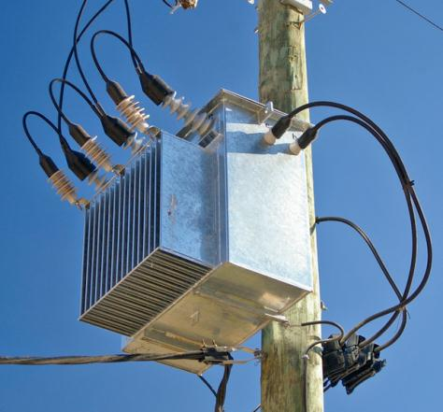

Definition:
A high voltage power transformer mounted on a power pole

Project No. / WR No. |  |  |  | Install Date | / /
Identifier |  |  |  | ARV Cost (ex GST)
Site |  |  |  | Manufacturer
Model |  |  |  | Serial No.
Installer |  |  |  | Warranty End Date | / /
Warranty Coverage
OH&S Notes
General Notes
Form Filled Out By

Attributes:

Rating (kVA) |  | Voltage (kV)
Asset Life (30)

University Use:
Class / Group / Cat / Cat Type |  |  |  | PLANT & EQUIP / ELECEQ/ HIGH VOLTAGE SYSTEMS / -
BC (775) |  | Cond. | EXCL |  | Crit. | C5 | FMC | ELECHV | Asset No.

Substation - Kiosk

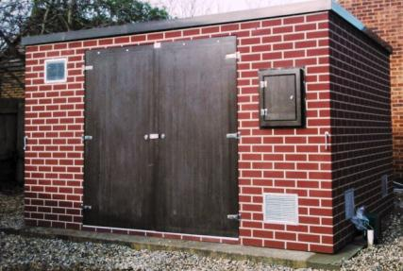

Definition:
A substation that is installed in a purpose built enclosure that is not a prefabricated part of the substation.

Project No. / WR No. |  |  |  | Install Date | / /
Identifier |  |  |  | ARV Cost (ex GST)
Site |  |  |  | Manufacturer
Installer |  |  |  | Warranty End Date* | / /
Warranty Coverage*
OH&S Notes
General Notes
Form Filled Out By
*As applies to components.

Components:
 | Make/Model | Quantity
Transformer
Switchgear

Attributes:
Rating (kVA) |  | Voltage (kV)
Asset Life (30) |  | SF6 Gas (kg)

University Use:
Class / Group / Cat / Cat Type |  |  |  | PLANT & EQUIP / ELECEQ/ HIGH VOLTAGE SYSTEMS / -
BC (775) |  | Cond. | EXCL |  | Crit. | C5 | FMC | ELECHV | Asset No.

Substation – Pad Mount

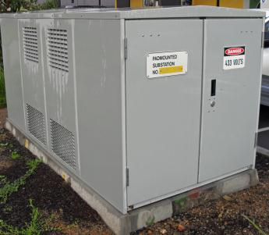

Definition:
A prefabricated all in one substation.

Project No. / WR No. |  |  |  | Install Date | / /
Identifier |  |  |  | ARV Cost (ex GST)
Site |  |  |  | Manufacturer
Model |  |  |  | Serial No.
Installer |  |  |  | Warranty End Date | / /
Warranty Coverage
OH&S Notes
General Notes
Form Filled Out By

Components:
 | Make/Model | Quantity
Transformer
Switchgear

Attributes:
Rating (kVA) |  | Voltage (kV)
Asset Life (30) |  | SF6 Gas (kg)

University Use:
Class / Group / Cat / Cat Type |  |  |  | PLANT & EQUIP / ELECEQ/ HIGH VOLTAGE SYSTEMS / -
BC (775) |  | Cond. | EXCL |  | Crit. | C5 | FMC | ELECHV | Asset No.

Substation – In Building

Definition:
A substation that is fully enclosed in a room that is part of a building.

Project No. / WR No. |  |  |  | Install Date | / /
Identifier |  |  |  | ARV Cost (ex GST)
Site |  |  |  | Manufacturer
Building |  |  |  | Model
Room |  |  |  | Serial No.
Installer |  |  |  | Warranty End Date* | / /
Warranty Coverage*
OH&S Notes
General Notes
Form Filled Out By
*As applies to components

Components:
 | Make/Model | Quantity
Transformer
Switchgear

Attributes:
Rating (kVA) |  | Voltage (kV)
Asset Life (30) |  | SF6 Gas (kg)

University Use:
Class / Group / Cat / Cat Type |  |  |  | PLANT & EQUIP / ELECEQ/ HIGH VOLTAGE SYSTEMS / -
BC (775) |  | Cond. | EXCL |  | Crit. | C5 | FMC | ELECHV | Asset No.

Generator - Diesel

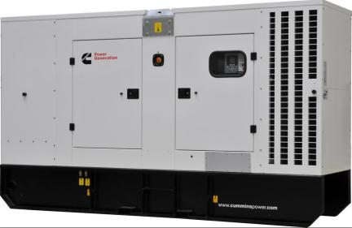

Definition:
Electricity generator powered by diesel and used for emergency power supply.

Project No. / WR No. |  |  |  | Install Date | / /
Identifier |  |  |  | ARV Cost (ex GST)
Site |  |  |  | Manufacturer
Building* |  |  |  | Model
Room | NONE |  |  | Serial No.
Installer |  |  |  | Warranty End Date | / /
Warranty Coverage
OH&S Notes
General Notes
Form Filled Out By
*Building it is connected to

Connected to Asset:
Identifier
Switchboard - Distribution
Switchboard - Main
Switchboard - Mechanical

Attributes:
Standby Rating (kVA) |  | Tank Capacity (L)
Asset Life (20)

University Use:
Class / Group / Cat / Cat Type |  |  |  | PLANT & EQUIP / ELECEQ/ GENERATORS / -
BC (775) |  | Cond. | EXCL |  | Crit. | C5 | FMC | ELECPREV | Asset No.

Generator - Solar

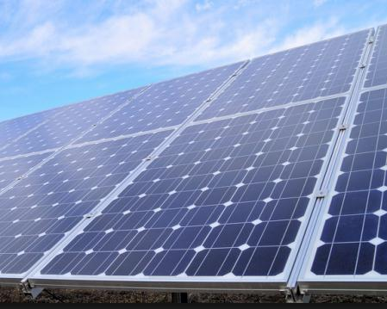

Definition:
Photovoltaic (PV) electricity generation system. One asset per inverter string.

Project No. / WR No. |  |  |  | Install Date | / /
Identifier |  |  |  | ARV Cost (ex GST and RECS)
Site |  |  |  | Manufacturer
Building |  |  |  | Model
Room* |  |  |  | Serial No. (start and end)
Installer |  |  |  | Warranty End Date | / /
Warranty Coverage
OH&S Notes
General Notes |  | Number of Panels?
Form Filled Out By
*The room that it is above, below or outside of

Connected to Asset (one of the below):
Identifier
Generator – Solar-inverter

Attributes:
Generation Capacity (kW) |  | Asset Life (25)

University Use:
Class / Group / Cat / Cat Type |  |  |  | PLANT & EQUIP / ELECEQ/ GENERATORS / -
BC (775) |  | Cond. | EXCL |  | Crit. | C3 | FMC | ELECPREV | Asset No.

Generator – Solar-inverter

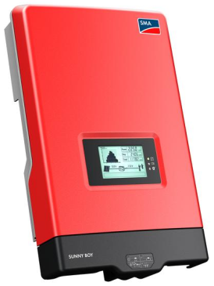

Definition:
Inverter of a Photovoltaic (PV) electricity generation system.

Project No. / WR No. |  |  |  | Install Date | / /
Identifier |  |  |  | ARV Cost (ex GST)
Site |  |  |  | Manufacturer
Building |  |  |  | Model
Room* |  |  |  | Serial No.
Installer |  |  |  | Warranty End Date | / /
Warranty Coverage
OH&S Notes
General Notes |  | Single or Three Phase?
Form Filled Out By
*If not within a room then use the room that it is above, below or outside of

Connected to Asset:
Identifier
Switchboard – Main / Distribution

Attributes:
Rating (kW) |  | Asset Life (20)

University Use:
Class / Group / Cat / Cat Type |  |  |  | PLANT & EQUIP / ELECEQ/ GENERATORS / -
BC (775) |  | Cond. | EXCL |  | Crit. | C3 | FMC | ELECPREV | Asset No.

UPS System

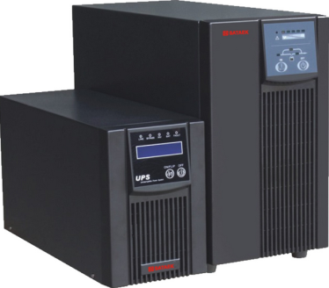

Definition:
Uninterruptable power supply. Typically battery or mass based electrical energy storage.

Project No. / WR No. |  |  |  | Install Date | / /
Identifier |  |  |  | ARV Cost (ex GST)
Site |  |  |  | Manufacturer
Building |  |  |  | Model
Room |  |  |  | Serial No.
Installer |  |  |  | Warranty End Date | / /
Warranty Coverage
OH&S Notes
General Notes
Form Filled Out By

Connected to Asset:
Identifier
Switchboard – Distribution / Main / Mechanical

Attributes:
Storage Capacity (kVA) |  | Asset Life (10)

University Use:
Class / Group / Cat / Cat Type |  |  |  | PLANT & EQUIP / ELECEQ/ GENERATORS / -
BC (775) |  | Cond. | EXCL |  | Crit. | C5 | FMC | ELECPREV | Asset No.

Switchboard – In Substation

Definition:
Low voltage switchboard contained within a substation that can only be accessed from within it, i.e. High Voltage area.

Project No. / WR No. |  |  |  | Install Date | / /
Identifier* |  |  |  | ARV Cost (ex GST)
Site |  |  |  | Manufacturer
Building |  |  |  | Model
Room |  |  |  | Serial No.
Installer |  |  |  | Warranty End Date | / /
Warranty Coverage
OH&S Notes
General Notes
Form Filled Out By

*Identifier to be University designated

Within Substation:
Identifier
Substation - Kiosk
Substation In-Building

Attributes:
Fault Rating (kVA) |  | Asset Life (35)

University Use:
Class / Group / Cat / Cat Type |  |  |  | PLANT & EQUIP / ELECEQ/ LOW VOLTAGE SYSTEMS / -
BC (775) |  | Cond. | EXCL |  | Crit. | C5 | FMC | ELECPREV | Asset No.

Switchboard - Main

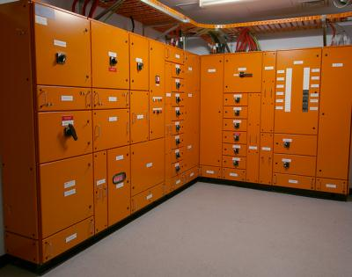

Definition:
Fed by the Distribution Service Network Provider (TasNetworks), or, first point of supply for a building, or, first switchboard NOT accessed from within the HV side of a University substation.
Project No. / WR No. |  |  |  | Install Date | / /
Identifier* |  |  |  | ARV Cost (ex GST)
Site |  |  |  | Manufacturer
Building |  |  |  | Model
Room** |  |  |  | Serial No.
Installer |  |  |  | Warranty End Date | / /
Warranty Coverage
OH&S Notes
General Notes
Form Filled Out By
* Identifier to be University designated
**If not within a room then use the room that it is above, below or outside of

Fed from Asset:
Identifier
Substation – Kiosk / In-Building / Pad Mount; or
Switchboard – In Substation / Main

Components:
Quantity
RCDs

Attributes:
Fault Rating (kVA) |  | Asset Life (35)

University Use:
Class / Group / Cat / Cat Type |  |  |  | PLANT & EQUIP / ELECEQ/ LOW VOLTAGE SYSTEMS / -
BC (775) |  | Cond. | EXCL |  | Crit. | C5 | FMC | ELECSTAT | Asset No.

Switchboard - Distribution

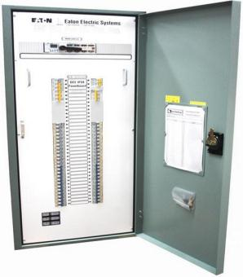

Definition:
Any switchboard that is not a SWITCHBOARD - MAIN, or SWITCHBOARD – MECHANICAL, or SWITCHBOARD – IN SUBSTATION

Project No. / WR No. |  |  |  | Install Date | / /
Identifier* |  |  |  | ARV Cost (ex GST)
Site |  |  |  | Manufacturer
Building |  |  |  | Model
Room* |  |  |  | Serial No.
Installer |  |  |  | Warranty End Date | / /
Warranty Coverage
OH&S Notes
General Notes
Form Filled Out By
*Identifier to be University designated
**If not within a room then use the room that it is above, below or outside of

Fed from Asset:
Identifier
Switchboard – Main / Distribution / Mechanical

Components:
Quantity
RCDs

Attributes:
Fault Rating (kVA) |  | Asset Life (35)

University Use:
Class / Group / Cat / Cat Type |  |  |  | PLANT & EQUIP / ELECEQ/ LOW VOLTAGE SYSTEMS / -
BC (775) |  | Cond. | EXCL |  | Crit. | C5 | FMC | ELECSTAT | Asset No.

Power Factor Correction Unit
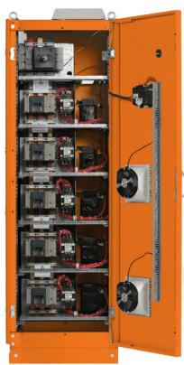

Definition:
Device installed primarily for power factor correction.

Project No. / WR No. |  |  |  | Install Date | / /
Identifier |  |  |  | ARV Cost (ex GST)
Site |  |  |  | Manufacturer
Building |  |  |  | Model
Room |  |  |  | Serial No.
Installer |  |  |  | Warranty End Date | / /
Warranty Coverage
OH&S Notes
General Notes
Form Filled Out By

Connected to Asset:
Identifier
Switchboard – Main / Distribution / Mechanical

Attributes:
Rating (kVA) |  | Asset Life (25)

University Use:
Class / Group / Cat / Cat Type |  |  |  | PLANT & EQUIP / ELECEQ/ LOW VOLTAGE SYSTEMS / -
BC (775) |  | Cond. | EXCL |  | Crit. | C4 | FMC | ELECPREV | Asset No.

Lightning Protection System

Definition:
Typically a series of conductors and associated earthing to reduce risk from lightning strike on a building

Project No. / WR No. |  |  |  | Install Date | / /
Identifier |  |  |  | ARV Cost (ex GST)
Site |  |  |  | Manufacturer
Building |  |  |  | Warranty End Date | / /
Installer
Warranty Coverage
OH&S Notes
General Notes
Form Filled Out By

Attributes:

Asset Life (50)

University Use:
Class / Group / Cat / Cat Type |  |  |  | PLANT & EQUIP / ELECEQ/ LOW VOLTAGE SYSTEMS / -
BC (775) |  | Cond. | EXCL |  | Crit. | C5 | FMC | ELECPREV | Asset No.

Surge Protection Unit

Definition:
Large surge protection device (with or without filter) generally installed in switchboards to divert surges and protect electrical distribution assets. If part of a lightning protection system then include as sub-asset.

Project No. / WR No. |  |  |  | Install Date | / /
Identifier |  |  |  | ARV Cost (ex GST)
Site |  |  |  | Manufacturer
Building |  |  |  | Model
Room |  |  |  | Serial No.
Installer |  |  |  | Warranty End Date | / /
Warranty Coverage
OH&S Notes
General Notes
Form Filled Out By

Connected to Asset:
Identifier
Switchboard – Main / Distribution / Mechanical

Attributes:
Asset Life (25)

University Use:
Class / Group / Cat / Cat Type |  |  |  | PLANT & EQUIP / ELECEQ/ LOW VOLTAGE SYSTEMS / -
BC (775) |  | Cond. | EXCL |  | Crit. | C5 | FMC | ELECPREV | Asset No.

General Power Reticulation

Definition:
General electricity reticulation including wiring points, power outlets, etc, one per building.

If undertaking significant works for an existing building asset provide value of works on asset form otherwise an asset form for the existing building is not required.

Project No. / WR No. |  |  |  | Install Date | / /
Identifier |  |  |  | ARV Cost (ex GST)*
Site |  |  |  | Warranty End Date | / /
Building |  |  |  | Installer
Warranty Coverage
OH&S Notes
General Notes
Form Filled Out By

*Estimated total cost of general power installation.

Attributes:

Asset Life (30)

University Use:
Class / Group / Cat / Cat Type |  |  |  | PLANT & EQUIP / ELECEQ/ LOW VOLTAGE SYSTEMS / -
BC (775) |  | Cond. | EXCL |  | Crit. | C3 | FMC | ELECPREV | Asset No.

General Lighting Reticulation

Definition:
General lighting reticulation, one per building.

If undertaking significant works for an existing building asset provide value of works on asset form otherwise an asset form for the existing building is not required.

Project No. / WR No. |  |  |  | Install Date | / /
Identifier |  |  |  | ARV Cost (ex GST)*
Site |  |  |  | Building
Installer |  |  |  | Warranty End Date | / /
Warranty Coverage
OH&S Notes
General Notes
Form Filled Out By

*Estimated total cost of lighting installation

Attributes:

Asset Life (15)

University Use:
Class / Group / Cat / Cat Type |  |  |  | PLANT & EQUIP / ELECEQ/ LOW VOLTAGE SYSTEMS / -
BC (775) |  | Cond. | EXCL |  | Crit. | C3 | FMC | ELECPREV | Asset No.

Emergency Lighting & Fire Exit Signs

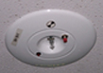

Definition:
Exit and emergency lighting for a building.

One asset per building. Provide completed asset form for all works for the University to amend its asset information.

Project No. / WR No. |  |  |  | Install Date | / /
Identifier |  |  |  | ARV Cost (ex GST)
Site |  |  |  | Warranty End Date | / /
Building
Installer
Warranty Coverage
OH&S Notes
General Notes
Form Filled Out By

Components:
 | Make/Model | Quantity
Exit Fittings*
EML Fittings*
Test Switches

*One per make/model type, EML fittings to include light fittings with emergency packs.

Attributes:
Asset Life (15)

University Use:
Class / Group / Cat / Cat Type |  |  |  | PLANT & EQUIP / ELECEQ/ LOW VOLTAGE SYSTEMS / -
BC (775) |  | Cond. | EXCL |  | Crit. | C5 | FMC | ELECSTAT | Asset No.

Automatic Door Control Assembly

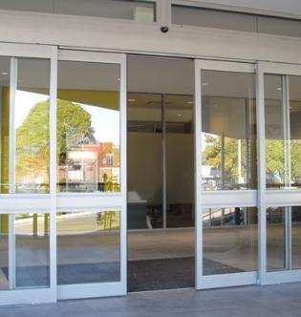

Definition:

Actuators and control system for the automatic or assisted opening of a door.

Project No. / WR No. |  |  |  | Install Date | / /
Identifier |  |  |  | ARV Cost (ex GST)
Site |  |  |  | Manufacturer
Building |  |  |  | Model
Room |  |  |  | Serial No.
Installer |  |  |  | Warranty End Date | / /
Warranty Coverage
OH&S Notes
General Notes
Form Filled Out By

Attributes:
Fire Mode | Open/Close/Lock | Asset Life (10)

University Use:
Class / Group / Cat / Cat Type |  |  |  | PLANT & EQUIP / ELECEQ/ LOW VOLTAGE SYSTEMS / -
BC (775) |  | Cond. | EXCL |  | Crit. | C3 | FMC | ELECPREV | Asset No.

Automatic External Defibrillator

Definition:

A defibrillator mounted within an enclosure that is alarmed on the security system.

Project No. / WR No. |  |  |  | Install Date | / /
Identifier |  |  |  | ARV Cost (ex GST)
Site |  |  |  | Manufacturer
Building |  |  |  | Model
Room |  |  |  | Serial No.
Installer |  |  |  | Warranty End Date | / /
Warranty Coverage
OH&S Notes
General Notes
Form Filled Out By

Attributes:
Asset Life (10)

University Use:
Class / Group / Cat / Cat Type |  |  |  | PLANT & EQUIP / MISCEQ / SAFETY PROTECTION / -
BC (775) |  | Cond. | EXCL |  | Crit. | C5 | FMC | DEFIBSTAT | Asset No.

Fire Asset Forms

Refer to Asset Forms General Instructions section before completing these forms.

Fire Indicator Panel 50
Fire Indicator Panel - Sub 51
Fire Alarm Reticulation 52
Fire Alarm VESDA 53
Early Warning Information Systems (EWIS) 54
Fire Sprinkler Reticulation System 55
Fire Sprinkler Valve Box 56
Fire Sprinkler Booster Assembly 57
Fire Pump - Electric 58
Fire Pump - Diesel 59
Gas Suppression System 60
Fire Blankets 61
Fire Extinguishers 62
Fire Hose Reel 63
Fire Hydrant 64
Fire Hydrant Booster Assembly 65
Fire Damper - Intumescent 66
Fire Damper – Fusible Link 67
Fire Door 68

Fire Indicator Panel

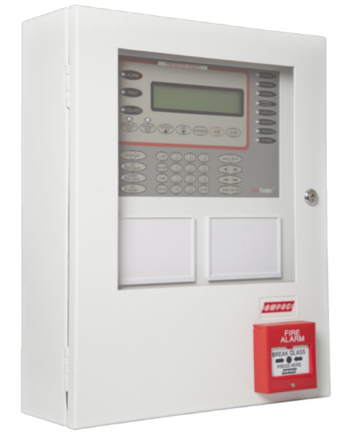

Definition:
Fire Indicator Panel (FIP), reports alarms to a monitoring system

Project No. / WR No. |  |  |  | Install Date | / /
Identifier |  |  |  | ARV Cost (ex GST)
Site |  |  |  | Manufacturer
Building |  |  |  | Model
Room* |  |  |  | Serial No.
Installer |  |  |  | Warranty End Date | / /
Warranty Coverage
OH&S Notes
General Notes
Form Filled Out By
*If not within a room then the room it is outside of

Attributes:
Number of Zones |  | Asset Life (15)

University Use:
Class / Group / Cat / Cat Type |  |  |  | PLANT & EQUIP / FIREEQ/ FIRE DETECTION EQUIPMENT / FP
BC (775) |  | Cond. | EXCL |  | Crit. | C5 | FMC | FIRESTATA | Asset No.

Fire Indicator Panel - Sub

Definition:
Reports to a Fire Indicator Panel, AKA Sub Indicator Panel (SIP)

Project No. / WR No. |  |  |  | Install Date | / /
Identifier |  |  |  | ARV Cost (ex GST)
Site |  |  |  | Manufacturer
Building |  |  |  | Model
Room |  |  |  | Serial No.
Installer |  |  |  | Warranty End Date | / /
Warranty Coverage
OH&S Notes
General Notes
Form Filled Out By

Connected to Asset:
Identifier
Fire Indicator Panel

Attributes:
Number of Zones |  | Asset Life (15)

University Use:
Class / Group / Cat / Cat Type |  |  |  | PLANT & EQUIP / FIREEQ/ FIRE DETECTION EQUIPMENT / FP
BC (775) |  | Cond. | EXCL |  | Crit. | C5 | FMC | FIRESTATA | Asset No.

Fire Alarm Reticulation

Definition:
System of detector heads, sounders, bells, MCPs that connect to an FIP or SIP.

One asset per building. Provide completed asset form for all works for the University to amend its asset information.

Project No. / WR No. |  |  |  | Install Date | / /
Identifier |  |  |  | ARV Cost (ex GST)
Site |  |  |  | Building
Installer |  |  |  | Warranty End Date | / /
Warranty Coverage
OH&S Notes
General Notes
Form Filled Out By

Connected to Asset:
Identifier
Fire Indicator Panel / Sub

Components:
 | Make/Model | Quantity
Smoke Detector
Thermal Detector
Break Glass Alarm
Bell
Sounder
Door Release

Attributes:
Asset Life (15)

University Use:
Class / Group / Cat / Cat Type |  |  |  | PLANT & EQUIP / FIREEQ/ FIRE DETECTION EQUIPMENT / FP
BC (775) |  | Cond. | EXCL |  | Crit. | C5 | FMC | FIRESTATA | Asset No.

Fire Alarm VESDA

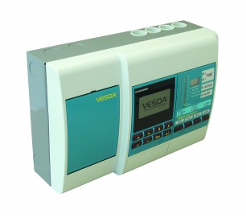

Definition:
Very Early Smoke Detection Apparatus. The detector unit.

Project No. / WR No. |  |  |  | Install Date | / /
Identifier |  |  |  | ARV Cost (ex GST)
Site |  |  |  | Manufacturer
Building |  |  |  | Model
Room |  |  |  | Serial No.
Installer |  |  |  | Warranty End Date | / /
Warranty Coverage
OH&S Notes
General Notes
Form Filled Out By

Connected to Asset:
Identifier
Fire Indicator Panel / Sub

Attributes:
Total length of sampling conduits (m) |  | Asset Life (15)

University Use:
Class / Group / Cat / Cat Type |  |  |  | PLANT & EQUIP / FIREEQ/ FIRE DETECTION EQUIPMENT / FP
BC (775) |  | Cond. | EXCL |  | Crit. | C5 | FMC | FIRESTATA | Asset No.

Early Warning Information Systems (EWIS)

Definition:
Early warning information system. Intercom system used for evacuation generally located next to or within a Fire Indicator Panel.

Project No. / WR No. |  |  |  | Install Date | / /
Identifier |  |  |  | ARV Cost (ex GST)
Site |  |  |  | Manufacturer
Building |  |  |  | Model
Room |  |  |  | Serial No.
Installer |  |  |  | Warranty End Date | / /
Warranty Coverage
OH&S Notes
General Notes
Form Filled Out By

Components:
 | Make/Model | Quantity
Speakers
WIP Phones

Attributes:
Asset Life (15)

University Use:
Class / Group / Cat / Cat Type |  |  |  | PLANT & EQUIP / FIREEQ/ FIRE DETECTION EQUIPMENT / FP
BC (775) |  | Cond. | EXCL |  | Crit. | C5 | FMC | FIRESTATA | Asset No.

Fire Sprinkler Reticulation System

Definition:
System of fire sprinkler heads and pipework.

One asset per building system. Provide completed asset form for all works for the University to amend its asset information.

Project No. / WR No. |  |  |  | Install Date | / /
Identifier |  |  |  | ARV Cost (ex GST)
Site |  |  |  | Manufacturer
Building
Installer |  |  |  | Warranty End Date | / /
Warranty Coverage
OH&S Notes
General Notes
Form Filled Out By

Connected Asset:
Identifier
Fire Sprinkler Valve Box

Components:
 | Make/Model | Quantity
Pendant Heads
Wall Wetting Heads
High Temperature Heads
Recessed Heads

Attributes:
Asset Life (30)

University Use:
Class / Group / Cat / Cat Type |  |  |  | PLANT & EQUIP / FIREEQ/ FIRE SUPPRESSION EQUIP / FP
BC (775) |  | Cond. | EXCL |  | Crit. | C5 | FMC | FIRESTATB | Asset No.

Fire Sprinkler Valve Box

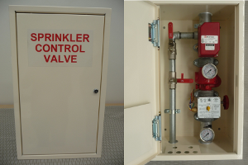

Definition:
Sprinkler valve control box

Project No. / WR No. |  |  |  | Install Date | / /
Identifier |  |  |  | ARV Cost (ex GST)
Site |  |  |  | Manufacturer
Building |  |  |  | Model
Room |  |  |  | Serial No.
Installer |  |  |  | Warranty End Date | / /
Warranty Coverage
OH&S Notes
General Notes
Form Filled Out By

Attributes:
Asset Life (30)

University Use:
Class / Group / Cat / Cat Type |  |  |  | PLANT & EQUIP / FIREEQ/ FIRE SUPPRESSION EQUIP / FP
BC (775) |  | Cond. | EXCL |  | Crit. | C5 | FMC | FIRESTATB | Asset No.

Fire Sprinkler Booster Assembly

Definition:
Booster for fire sprinklers

Project No. / WR No. |  |  |  | Install Date | / /
Identifier |  |  |  | ARV Cost (ex GST)
Site |  |  |  | Manufacturer
Building |  |  |  | Model
Room* |  |  |  | Serial No.
Installer |  |  |  | Warranty End Date | / /
Warranty Coverage
OH&S Notes
General Notes
Form Filled Out By
*Or room it is located outside of

Attributes:

Asset Life (30)

Connected Asset:
Identifier
Fire Sprinkler Valve Box

University Use:
Class / Group / Cat / Cat Type |  |  |  | PLANT & EQUIP / FIREEQ/ FIRE SUPPRESSION EQUIP / FP
BC (775) |  | Cond. | EXCL |  | Crit. | C5 | FMC | FIRESTATB | Asset No.

Fire Pump - Electric

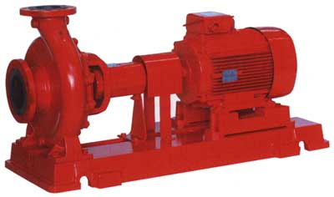

Definition:
Electric booster pump for fire fighting

Project No. / WR No. |  |  |  | Install Date | / /
Identifier |  |  |  | ARV Cost (ex GST)
Site |  |  |  | Manufacturer
Building |  |  |  | Model
Room |  |  |  | Serial No.
Installer |  |  |  | Warranty End Date | / /
Warranty Coverage
OH&S Notes
General Notes
Form Filled Out By

Attributes:
Capacity (L/s) |  | Power (kW)
Asset Life (15)

University Use:
Class / Group / Cat / Cat Type |  |  |  | PLANT & EQUIP / FIREEQ/ FIRE SUPPRESSION EQUIP / FP
BC (775) |  | Cond. | EXCL |  | Crit. | C5 | FMC | FIRESTATB | Asset No.

Fire Pump - Diesel

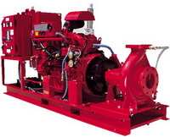

Definition:
Diesel booster pump for fire fighting

Project No. / WR No. |  |  |  | Install Date | / /
Identifier |  |  |  | ARV Cost (ex GST)
Site |  |  |  | Manufacturer
Building |  |  |  | Model
Room |  |  |  | Serial No.
Installer |  |  |  | Warranty End Date | / /
Warranty Coverage
OH&S Notes
General Notes
Form Filled Out By

Attributes:
Fuel Tank Capacity (L) |  | Capacity (L/s)
Power (kW) |  | Asset Life (30)

University Use:
Class / Group / Cat / Cat Type |  |  |  | PLANT & EQUIP / FIREEQ/ FIRE SUPPRESSION EQUIP / FP
BC (775) |  | Cond. | EXCL |  | Crit. | C5 | FMC | FIRESTATB | Asset No.

Gas Suppression System

Definition:
Gaseous fire suppression system

Project No. / WR No. |  |  |  | Install Date | / /
Identifier |  |  |  | ARV Cost (ex GST)
Site |  |  |  | Manufacturer
Building |  |  |  | Model
Room |  |  |  | Serial No.
Installer |  |  |  | Warranty End Date | / /
Warranty Coverage
OH&S Notes
General Notes
Form Filled Out By

Attributes:
System Capacity (kg) |  | Suppression Agent
Asset Life (30)

University Use:
Class / Group / Cat / Cat Type |  |  |  | PLANT & EQUIP / FIREEQ/ FIRE SUPPRESSION EQUIP / FP
BC (775) |  | Cond. | EXCL |  | Crit. | C5 | FMC | FIRESTATB | Asset No.

Fire Blankets

Definition:
All Fire Blankets for the building.

One asset per building. Provide completed asset form for all works for the University to amend its asset information.

Project No. / WR No. |  |  |  | Install Date | / /
Identifier |  |  |  | ARV Cost (ex GST)
Site |  |  |  | Building
Installer
OH&S Notes
General Notes
Form Filled Out By

Components:
 | Make/Model | Quantity
Fire Blankets (one per type & size)

University Use:
Class / Group / Cat / Cat Type |  |  |  | PLANT & EQUIP / FIREEQ/ FIRE SUPPRESSION EQUIP / FP
BC (775) |  | Cond. | EXCL |  | Crit. | C5 | FMC | FIRESTATC | Asset No.

Fire Extinguishers

Definition:
All Fire Extinguishers for the building

One asset per building. Provide completed asset form for all works for the University to amend its asset information.

Project No. / WR No. |  |  |  | Install Date | / /
Identifier |  |  |  | ARV Cost (ex GST)
Site |  |  |  | Manufacturer
Building |  |  |  | Warranty End Date | / /
Installer
Warranty Coverage
OH&S Notes
General Notes
Form Filled Out By

Components:
 | Make/Model | Quantity
Fire Extinguisher (one per type & size)

University Use:
Class / Group / Cat / Cat Type |  |  |  | PLANT & EQUIP / FIREEQ/ FIRE SUPPRESSION EQUIP / FP
BC (775) |  | Cond. | EXCL |  | Crit. | C5 | FMC | FIRESTATC | Asset No.

Fire Hose Reel

Definition:
Fire Hose Reel (FHR)

Project No. / WR No. |  |  |  | Install Date | / /
Identifier |  |  |  | ARV Cost (ex GST)
Site |  |  |  | Manufacturer
Building |  |  |  | Warranty End Date | / /
Room |  |  |  | Installer
Warranty Coverage
OH&S Notes
General Notes
Form Filled Out By

Attributes:
Asset Life (30)

University Use:
Class / Group / Cat / Cat Type |  |  |  | PLANT & EQUIP / FIREEQ/ FIRE SUPPRESSION EQUIP / FP
BC (775) |  | Cond. | EXCL |  | Crit. | C5 | FMC | FIRESTATC | Asset No.

Fire Hydrant

Definition:
Hydrant that is used for firefighting, can be attack or feed.

Project No. / WR No. |  |  |  | Install Date | / /
Identifier |  |  |  | ARV Cost (ex GST)
Site |  |  |  | Manufacturer
Building |  |  |  | Warranty End Date | / /
Room |  |  |  | Installer
Warranty Coverage
OH&S Notes
General Notes
Form Filled Out By

Connected to Asset:
Identifier
Fire Hydrant Booster Assembly

Attributes:
Asset Life (30)

University Use:
Class / Group / Cat / Cat Type |  |  |  | PLANT & EQUIP / FIREEQ/ FIRE SUPPRESSION EQUIP / FP
BC (775) |  | Cond. | EXCL |  | Crit. | C5 | FMC | FIRESTATC | Asset No.

Fire Hydrant Booster Assembly

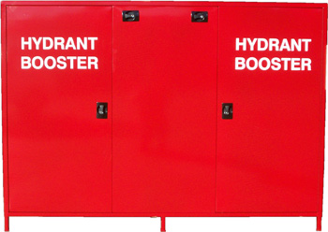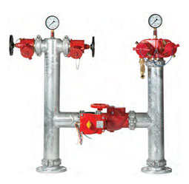

Definition:
Booster for attack hydrants

Project No. / WR No. |  |  |  | Install Date | / /
Identifier |  |  |  | ARV Cost (ex GST)
Site |  |  |  | Manufacturer
Building |  |  |  | Warranty End Date | / /
Room |  |  |  | Installer
Warranty Coverage
OH&S Notes
General Notes
Form Filled Out By

Attributes:

Asset Life (30)

University Use:
Class / Group / Cat / Cat Type |  |  |  | PLANT & EQUIP / FIREEQ/ FIRE SUPPRESSION EQUIP / FP
BC (775) |  | Cond. | EXCL |  | Crit. | C5 | FMC | FIRESTATC | Asset No.

Fire Damper - Intumescent

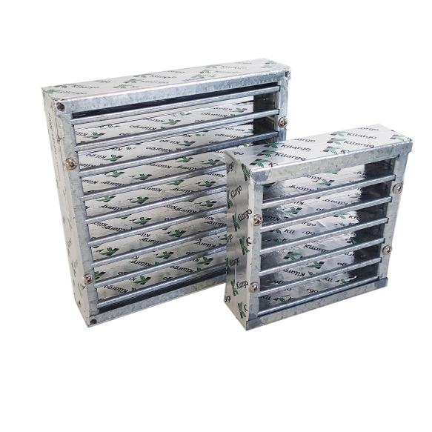

Definition:
Intumescent fire damper within ductwork, openings, or surrounding pipework

Project No. / WR No. |  |  |  | Install Date | / /
Identifier |  |  |  | ARV Cost (ex GST)
Site |  |  |  | Manufacturer
Building |  |  |  | Model
Room |  |  |  | Serial No.
Installer |  |  |  | Warranty End Date | / /
Warranty Coverage
OH&S Notes
General Notes
Form Filled Out By

Attributes:
Asset Life (20)

University Use:
Class / Group / Cat / Cat Type |  |  |  | PLANT & EQUIP / FIREEQ/ FIRE SUPPRESSION EQUIP / FP
BC (775) |  | Cond. | EXCL |  | Crit. | C5 | FMC | HVACSTAT | Asset No.

Fire Damper – Fusible Link

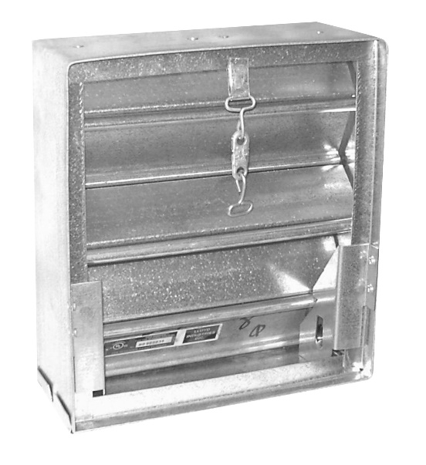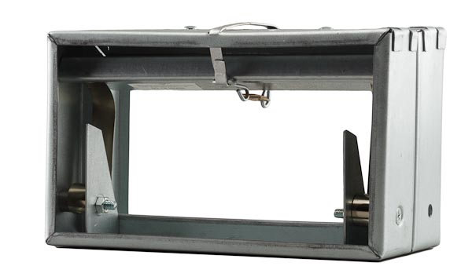

Definition:
Fusible link fire damper within ductwork or openings

Project No. / WR No. |  |  |  | Install Date | / /
Identifier |  |  |  | ARV Cost (ex GST)
Site |  |  |  | Manufacturer
Building |  |  |  | Model
Room |  |  |  | Serial No.
Installer |  |  |  | Warranty End Date | / /
Warranty Coverage
OH&S Notes
General Notes
Form Filled Out By

Attributes:
Asset Life (15)

University Use:
Class / Group / Cat / Cat Type |  |  |  | PLANT & EQUIP / FIREEQ/ FIRE SUPPRESSION EQUIP / FP
BC (775) |  | Cond. | EXCL |  | Crit. | C5 | FMC | HVACSTAT | Asset No.

Fire Door

Definition:
Fire rated door used to maintain fire separation

Project No. / WR No. |  |  |  | Install Date | / /
Identifier |  |  |  | ARV Cost (ex GST)
Site |  |  |  | Manufacturer
Building |  |  |  | Model
Room |  |  |  | Serial No.
Installer |  |  |  | Warranty End Date | / /
Warranty Coverage
OH&S Notes
General Notes
Form Filled Out By

Attributes:
Asset Life (30)

University Use:
Class / Group / Cat / Cat Type |  |  |  | PLANT & EQUIP / FIREEQ/ FIRE SUPPRESSION EQUIP / FP
BC (775) |  | Cond. | EXCL |  | Crit. | C5 | FMC | FIRESTATC | Asset No.

Hydraulic Asset Forms

Refer to Asset Forms General Instructions section before completing these forms.

Pump – DHW Circulating 71
Pump – DCW Supply 72
Pump – Sewer 73
Sewer Drainage System 74
Sewer – Septic Tank 75
Sewer – Reed Bed 76
Sewer – Pump Station 77
Stormwater Drainage System 78
Stormwater – First Flush 79
Grease Trap 80
Grease Pit 81
Neutralising Tank 82
Neutralising Pit 83
Sediment Trap 84
Gross Pollutant Trap 85
Backflow Prevention Device - Testable 86
Boiling / Chilled Water Unit 87
Drinking Fountain 88
Safety Shower 89
Safety Eye Wash 90
Safety Shower and Eye Wash 91
Harvested Water System 92
Irrigation Water System 93
Mains Water System 94
Water Treatment System - Chemical 95
Sewer Treatment System - Chemical 96
Recycled Water System 97
Thermostatic Mixing Valve 98
Tempering Valve 99
Hot Water Cylinder Electric 100
Hot Water Cylinder Gas 101
Hot Water Instantaneous Gas 102
Hot Water Instantaneous Electric 103
Hot Water Cylinder Heat Pump 104
Hot Water Heat Pump 105
Hot Water Storage Cylinder 106
Hot Water Exchanger Cylinder 107
Hot Water Solar Collector Evacuated Tube 108
Hot Water Solar Collector Flat Plate 109
Water Filter - Backwash 110
Water Filter - Cartridge 111
Water Filter – Ultraviolet Light 112
Water Filter – Reverse Osmosis 113
Water Filter – Tank 114

Pump – DHW Circulating

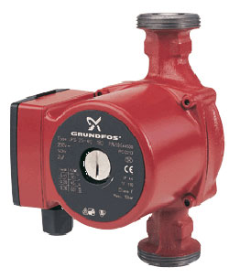

Definition:
A pump used for the circulation of domestic hot water

Project No. / WR No. |  |  |  | Install Date | / /
Identifier |  |  |  | ARV Cost (ex GST)
Site |  |  |  | Manufacturer
Building |  |  |  | Model
Room* |  |  |  | Serial No
Installer |  |  |  | Warranty End Date | / /
Warranty Coverage
OH&S Notes
General Notes
Form Filled Out By
*If not within a room then use the room that it is above, below or outside of

Attributes:
Duty Pressure (kPa) |  | Duty Flow (l/s)
Asset Life (15)

University Use:
Class / Group / Cat / Cat Type |  |  |  | PLANT & EQUIP / HYDREQ/ WATER SUPPLY SYSTEMS / WS
BC (775) |  | Cond. | EXCL |  | Crit. | C3 | FMC | N/A | Asset No.

Pump – DCW Supply

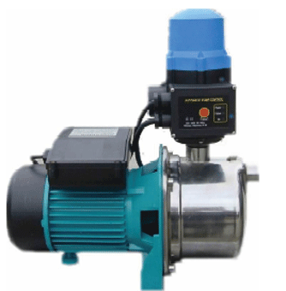

Definition:
A pump used for the supply of domestic cold water. Potable and non-potable.

Project No. / WR No. |  |  |  | Install Date | / /
Identifier |  |  |  | ARV Cost (ex GST)
Site |  |  |  | Manufacturer
Building |  |  |  | Model
Room* |  |  |  | Serial No
Installer |  |  |  | Warranty End Date | / /
Warranty Coverage
OH&S Notes
General Notes
Form Filled Out By
*If not within a room then use the room that it is above, below or outside of

Attributes:
Duty Pressure (kPa) |  | Duty Flow (l/s)
Asset Life (15)

University Use:
Class / Group / Cat / Cat Type |  |  |  | PLANT & EQUIP / HYDREQ/ WATER SUPPLY SYSTEMS / WS
BC (775) |  | Cond. | EXCL |  | Crit. | C4 | FMC | N/A | Asset No.

Pump – Sewer

Definition:
A pump used for the pumping of sewerage including trade waste.

Project No. / WR No. |  |  |  | Install Date | / /
Identifier |  |  |  | ARV Cost (ex GST)
Site |  |  |  | Manufacturer
Building |  |  |  | Model
Room* |  |  |  | Serial No
Installer |  |  |  | Warranty End Date | / /
Warranty Coverage
OH&S Notes
General Notes
Form Filled Out By
*If not within a room then use the room that it is above, below or outside of

Attributes:
Duty Pressure (kPa) |  | Duty Flow (l/s)
Asset Life (15)

University Use:
Class / Group / Cat / Cat Type |  |  |  | PLANT & EQUIP / HYDREQ/ DRAINAGE SYSTEMS / PD
BC (775) |  | Cond. | EXCL |  | Crit. | C5 | FMC | HYDRSTAT | Asset No.

Sewer Drainage System

Definition:
Overall sewerage system for a building or site. One asset per site. One asset per building.

If undertaking significant works for an existing building’s or site’s asset provide value of works on asset form otherwise an asset form for the existing building or site is not required.

Project No. / WR No. |  |  |  | Install Date | / /
Site |  |  |  | ARV Cost (ex GST)*
Building |  |  |  | Installer
OH&S Notes
General Notes
Form Filled Out By
*estimated value is sufficient exact cost not required (though can be provided)

Attributes:
Capacity (Loading Units)
Asset Life (15)

University Use:
Class / Group / Cat / Cat Type |  |  |  | PLANT & EQUIP / HYDREQ/ DRAINAGE SYSTEMS / PD
BC (775) |  | Cond. | EXCL |  | Crit. | C3 | FMC | N/A | Asset No.

Sewer – Septic Tank

Definition:
A tank used for the collection and breakdown of waste water before further disposal

Project No. / WR No. |  |  |  | Install Date | / /
Identifier |  |  |  | ARV Cost (ex GST)
Site |  |  |  | Manufacturer
Building |  |  |  | Model
Room* |  |  |  | Serial No
Installer |  |  |  | Warranty End Date | / /
Warranty Coverage
OH&S Notes
General Notes
Form Filled Out By
*If not within a room then use the room that it is above, below or outside of

Attributes:
Volume (L)
Asset Life (15)

University Use:
Class / Group / Cat / Cat Type |  |  |  | PLANT & EQUIP / HYDREQ/ DRAINAGE SYSTEMS / PD
BC (775) |  | Cond. | EXCL |  | Crit. | C4 | FMC | HYDRSTAT | Asset No.

Sewer – Reed Bed

Definition:
A reed bed used for further breakdown and filtering of wastewater

Project No. / WR No. |  |  |  | Install Date | / /
Identifier |  |  |  | ARV Cost (ex GST)
Site |  |  |  | Installer
OH&S Notes
General Notes
Form Filled Out By

Attributes:
Volume (L)
Asset Life (15)

University Use:
Class / Group / Cat / Cat Type |  |  |  | PLANT & EQUIP / HYDREQ/ DRAINAGE SYSTEMS / PD
BC (775) |  | Cond. | EXCL |  | Crit. | C4 | FMC | HYDRSTAT | Asset No.

Sewer – Pump Station

Definition:
A pit containing a submersible pump for the pumping of sewerage

Project No. / WR No. |  |  |  | Install Date | / /
Identifier |  |  |  | ARV Cost (ex GST)
Site |  |  |  | Manufacturer
Building |  |  |  | Model
Room* |  |  |  | Serial No
Installer |  |  |  | Warranty End Date | / /
Warranty Coverage
OH&S Notes
General Notes
Form Filled Out By
*If not within a room then use the room that it is above, below or outside of

Attributes:
Volume (L)
Duty Pressure (kPa)
Duty Flow (l/s)
Asset Life (15)

University Use:
Class / Group / Cat / Cat Type |  |  |  | PLANT & EQUIP / HYDREQ/ DRAINAGE SYSTEMS / PD
BC (775) |  | Cond. | EXCL |  | Crit. | C5 | FMC | HYDRSTAT | Asset No.

Stormwater Drainage System

Definition:
Overall stormwater system for a building or site. One asset per site. One asset per building.

If undertaking significant works for an existing building’s or site’s asset provide value of works on asset form otherwise an asset form for the existing building or site is not required.

Project No. / WR No. |  |  |  | Install Date | / /
Site |  |  |  | ARV Cost (ex GST)*
Building |  |  |  | Installer
OH&S Notes
General Notes
Form Filled Out By
*estimated value is sufficient exact cost not required (though can be provided)

Attributes
Capacity (m2)
Asset Life (50)

University Use:
Class / Group / Cat / Cat Type |  |  |  | PLANT & EQUIP / HYDREQ / DRAINAGE SYSTEMS / -
BC (775) |  | Cond. | EXCL |  | Crit. | C3 | FMC | N/A | Asset No.

Stormwater – First Flush

Definition:
Device for diverting the first flow or ‘flush’ of stormwater into a debris collection then stormwater rather directly into a rain water harvesting system.

Project No. / WR No. |  |  |  | Install Date | / /
Identifier |  |  |  | ARV Cost (ex GST)
Site |  |  |  | Manufacturer
Building |  |  |  | Model
Room* |  |  |  | Serial No
Installer |  |  |  | Warranty End Date | / /
Warranty Coverage
OH&S Notes
General Notes
Form Filled Out By
*If not within a room then use the room that it is above, below or outside of

Attributes:
Asset Life (20)

University Use:
Class / Group / Cat / Cat Type |  |  |  | PLANT & EQUIP / HYDREQ/ DRAINAGE SYSTEMS / -
BC (775) |  | Cond. | EXCL |  | Crit. | C3 | FMC | HYDRPREV | Asset No.

Grease Trap

Definition:
Above ground or under bench trap for reducing the grease and solids of sewerage.

Project No. / WR No. |  |  |  | Install Date | / /
Identifier |  |  |  | ARV Cost (ex GST)
Site |  |  |  | Manufacturer
Building |  |  |  | Model
Room* |  |  |  | Serial No
Installer |  |  |  | Warranty End Date | / /
Warranty Coverage
OH&S Notes
General Notes
Form Filled Out By
*If not within a room then use the room that it is above, below or outside of

Attributes:

Capacity (L)
Asset Life (20)

University Use:
Class / Group / Cat / Cat Type |  |  |  | PLANT & EQUIP / HYDREQ/ DRAINAGE SYSTEMS / PD
BC (775) |  | Cond. | EXCL |  | Crit. | C4 | FMC | TRWASTAT | Asset No.

Grease Pit

Definition:
Below ground trap for reducing the grease and solids content of sewerage.

Project No. / WR No. |  |  |  | Install Date | / /
Identifier |  |  |  | ARV Cost (ex GST)
Site |  |  |  | Manufacturer
Building |  |  |  | Model
Room* |  |  |  | Serial No
Installer |  |  |  | Warranty End Date | / /
Warranty Coverage
OH&S Notes
General Notes
Form Filled Out By
*If not within a room then use the room that it is above, below or outside of

Attributes:

Capacity (L)
Asset Life (20)

University Use:
Class / Group / Cat / Cat Type |  |  |  | PLANT & EQUIP / HYDREQ/ DRAINAGE SYSTEMS / PD
BC (775) |  | Cond. | EXCL |  | Crit. | C4 | FMC | TRWASTAT | Asset No.

Neutralising Tank

Definition:
Above ground or below bench tank for the reducing the acidity of sewerage.

Project No. / WR No. |  |  |  | Install Date | / /
Identifier |  |  |  | ARV Cost (ex GST)
Site |  |  |  | Manufacturer
Building |  |  |  | Model
Room* |  |  |  | Serial No
Installer |  |  |  | Warranty End Date | / /
Warranty Coverage
OH&S Notes
General Notes
Form Filled Out By
*If not within a room then use the room that it is above, below or outside of

Attributes:
Capacity (L)
Asset Life (20)

University Use:
Class / Group / Cat / Cat Type |  |  |  | PLANT & EQUIP / HYDREQ/ DRAINAGE SYSTEMS / PD
BC (775) |  | Cond. | EXCL |  | Crit. | C4 | FMC | TRWASTAT | Asset No.

Neutralising Pit

Definition:
Below ground pit for the reducing the acidity of sewerage.

Project No. / WR No. |  |  |  | Install Date | / /
Identifier |  |  |  | ARV Cost (ex GST)
Site |  |  |  | Manufacturer
Building |  |  |  | Model
Room* |  |  |  | Serial No
Installer |  |  |  | Warranty End Date | / /
Warranty Coverage
OH&S Notes
General Notes
Form Filled Out By
*If not within a room then use the room that it is above, below or outside of

Attributes:
Capacity (L)
Asset Life (20)

University Use:
Class / Group / Cat / Cat Type |  |  |  | PLANT & EQUIP / HYDREQ/ DRAINAGE SYSTEMS / PD
BC (775) |  | Cond. | EXCL |  | Crit. | C4 | FMC | TRWASTAT | Asset No.

Sediment Trap

Definition:
Above ground or below bench trap for the reducing of sludge or sediment in sewerage.

Project No. / WR No. |  |  |  | Install Date | / /
Identifier |  |  |  | ARV Cost (ex GST)
Site |  |  |  | Manufacturer
Building |  |  |  | Model
Room* |  |  |  | Serial No
Installer |  |  |  | Warranty End Date | / /
Warranty Coverage
OH&S Notes
General Notes
Form Filled Out By
*If not within a room then use the room that it is above, below or outside of

Attributes:

Capacity (L)
Asset Life (20)

University Use:
Class / Group / Cat / Cat Type |  |  |  | PLANT & EQUIP / HYDREQ/ DRAINAGE SYSTEMS / PD
BC (775) |  | Cond. | EXCL |  | Crit. | C4 | FMC | TRWASTAT | Asset No.

Gross Pollutant Trap

Definition:
Below ground stormwater filtration device

Project No. / WR No. |  |  |  | Install Date | / /
Identifier |  |  |  | ARV Cost (ex GST)
Site |  |  |  | Manufacturer
Building |  |  |  | Model
Room* |  |  |  | Serial No
Installer |  |  |  | Warranty End Date | / /
Warranty Coverage
OH&S Notes
General Notes
Form Filled Out By
*If not within a room then use the room that it is above, below or outside of

Attributes:
Capacity (L)
Asset Life (20)

University Use:
Class / Group / Cat / Cat Type |  |  |  | PLANT & EQUIP / HYDREQ/ DRAINAGE SYSTEMS / PD
BC (775) |  | Cond. | EXCL |  | Crit. | C4 | FMC | HYDRPREV | Asset No.

Backflow Prevention Device - Testable

Definition:
A testable device requiring periodic maintenance used for the prevention of water flow back into a mains system

Project No. / WR No. |  |  |  | Install Date | / /
Identifier |  |  |  | ARV Cost (ex GST)
Site |  |  |  | Manufacturer
Building |  |  |  | Model
Room* |  |  |  | Serial No
Installer |  |  |  | Warranty End Date | / /
Warranty Coverage
OH&S Notes
General Notes
Form Filled Out By
*If not within a room then use the room that it is above, below or outside of

Attributes:
Size (diameter mm)
Backflow Device Type | RBT / RAG / PVB / SPVB / RPZD / DCV / RPDA / DCDA / SCTV SCDAT
Asset Life (20)

Backflow Device Type Acronyms:

RBT, Registered Break Tank
RAG, Registered Air Gap
PVB, Pressure-type Vacuum-Breaker
SPVB, Spill resistant Pressure-type Vacuum-Breaker
RPZD, Reduced Pressure Zone Device
DCV, Double Check Valve (not dual)
RPDA, Reduce Pressure Detector Assembly
DCDC, Double Check Detector Assembly
SCVT, Single Check Valve Testable
SCDAT, Single Check Detector Assembly Testable

University Use:
Class / Group / Cat / Cat Type |  |  |  | PLANT & EQUIP / HYDREQ/ WATER SUPPLY SYSTEMS / WS
BC (775) |  | Cond. | EXCL |  | Crit. | C4 | FMC | HYDRSTAT | Asset No.

Boiling / Chilled Water Unit

Definition:
Under or above bench unit that supplies hot, cold or both, potable water

Project No. / WR No. |  |  |  | Install Date | / /
Identifier |  |  |  | ARV Cost (ex GST)
Site |  |  |  | Manufacturer
Building |  |  |  | Model
Room |  |  |  | Serial No
Installer |  |  |  | Warranty End Date | / /
Warranty Coverage
OH&S Notes
General Notes
Form Filled Out By

Attributes:
Asset Life (20)

University Use:
Class / Group / Cat / Cat Type |  |  |  | PLANT & EQUIP / HYDREQ/ WATER SUPPLY SYSTEMS / -
BC (775) |  | Cond. | EXCL |  | Crit. | C3 | FMC | HYDRPREV | Asset No.

Drinking Fountain

Definition:
Internal or external drinking fountain / bottle filling station

Project No. / WR No. |  |  |  | Install Date | / /
Identifier |  |  |  | ARV Cost (ex GST)
Site |  |  |  | Manufacturer
Building |  |  |  | Model
Room |  |  |  | Serial No
Installer |  |  |  | Warranty End Date | / /
Warranty Coverage
OH&S Notes
General Notes
Form Filled Out By

Attributes:
Asset Life (20)

University Use:
Class / Group / Cat / Cat Type |  |  |  | PLANT & EQUIP / HYDREQ/ WATER SUPPLY SYSTEMS / -
BC (775) |  | Cond. | EXCL |  | Crit. | C3 | FMC | N/A | Asset No.

Safety Shower

Definition:
A deluge shower

Project No. / WR No. |  |  |  | Install Date | / /
Identifier |  |  |  | ARV Cost (ex GST)
Site |  |  |  | Manufacturer
Building |  |  |  | Model
Room |  |  |  | Serial No
Installer |  |  |  | Warranty End Date | / /
Warranty Coverage
OH&S Notes
General Notes
Form Filled Out By

Attributes:
Asset Life (20)

University Use:
Class / Group / Cat / Cat Type |  |  |  | PLANT & EQUIP / MISCEQ / SAFETY PROTECTION / -
BC (775) |  | Cond. | EXCL |  | Crit. | C4 | FMC | HYDRSTAT | Asset No.

Safety Eye Wash

Definition:
An eyewash station or fixture

Project No. / WR No. |  |  |  | Install Date | / /
Identifier |  |  |  | ARV Cost (ex GST)
Site |  |  |  | Manufacturer
Building |  |  |  | Model
Room |  |  |  | Serial No
Installer |  |  |  | Warranty End Date | / /
Warranty Coverage
OH&S Notes
General Notes
Form Filled Out By

Attributes:
Asset Life (20)

University Use:
Class / Group / Cat / Cat Type |  |  |  | PLANT & EQUIP / MISCEQ / SAFETY PROTECTION / -
BC (775) |  | Cond. | EXCL |  | Crit. | C4 | FMC | HYDRSTAT | Asset No.

Safety Shower and Eye Wash

Definition:
A combined safety deluge shower and eyewash station or fixture

Project No. / WR No. |  |  |  | Install Date | / /
Identifier |  |  |  | ARV Cost (ex GST)
Site |  |  |  | Manufacturer
Building |  |  |  | Model
Room |  |  |  | Serial No
Installer |  |  |  | Warranty End Date | / /
Warranty Coverage
OH&S Notes
General Notes
Form Filled Out By

Attributes:
Asset Life (20)

University Use:
Class / Group / Cat / Cat Type |  |  |  | PLANT & EQUIP / MISCEQ / SAFETY PROTECTION / -
BC (775) |  | Cond. | EXCL |  | Crit. | C4 | FMC | HYDRSTAT | Asset No.

Harvested Water System

Definition:
System consisting of tank and automatic controls for the collection of rainwater for re-use

Project No. / WR No. |  |  |  | Install Date | / /
Identifier |  |  |  | ARV Cost (ex GST)
Site |  |  |  | Manufacturer
Building |  |  |  | Model
Room |  |  |  | Serial No
Installer |  |  |  | Warranty End Date | / /
Warranty Coverage
OH&S Notes
General Notes
Form Filled Out By

Attributes:
Asset Life (20)
Volume (L)

University Use:
Class / Group / Cat / Cat Type |  |  |  | PLANT & EQUIP / HYDREQ/ WATER SUPPLY SYSTEMS / WS
BC (775) |  | Cond. | EXCL |  | Crit. | C3 | FMC | N/A | Asset No.

Irrigation Water System

Definition:
System of pipework, sprinklers, sprayers, soakers, valves and controllers for the irrigation of landscaping and grounds.

One asset per site.

If undertaking significant works for an existing site asset provide value of works on asset form otherwise an asset form for the existing site is not required.

Project No. / WR No. |  |  |  | Install Date | / /
Identifier |  |  |  | ARV Cost (ex GST)
Site |  |  |  | Manufacturer
Installer |  |  |  | Warranty End Date | / /
Warranty Coverage
OH&S Notes
General Notes
Form Filled Out By

Attributes:
Asset Life (20)

University Use:
Class / Group / Cat / Cat Type |  |  |  | PLANT & EQUIP / HYDREQ/ WATER SUPPLY SYSTEMS / -
BC (775) |  | Cond. | EXCL |  | Crit. | C3 | FMC | N/A | Asset No.

Mains Water System

Definition:
Domestic cold and fire mains system connected to TasWater or the sites infrastructure

One asset per site. One asset per building.

If undertaking significant works for an existing site/building asset provide value of works on asset form otherwise an asset form for the existing site/building is not required.

Project No. / WR No. |  |  |  | Install Date | / /
Identifier |  |  |  | ARV Cost (ex GST)
Site |  |  |  | Installer
Building |  |  |  | Warranty End Date | / /
Warranty Coverage
OH&S Notes
General Notes
Form Filled Out By

Attributes:
Asset Life (50)

University Use:
Class / Group / Cat / Cat Type |  |  |  | PLANT & EQUIP / HYDREQ/ WATER SUPPLY SYSTEMS / WS
BC (775) |  | Cond. | EXCL |  | Crit. | C5 | FMC | N/A | Asset No.

Water Treatment System - Chemical

Definition:
A system that chemically treats water to make it potable, typically chlorine based.

Project No. / WR No. |  |  |  | Install Date | / /
Identifier |  |  |  | ARV Cost (ex GST)
Site |  |  |  | Manufacturer
Building |  |  |  | Model
Room |  |  |  | Serial No
Installer |  |  |  | Warranty End Date | / /
Warranty Coverage
OH&S Notes
General Notes
Form Filled Out By

Attributes:
Chemical | Chlorine / Brine
Asset Life (20)

University Use:
Class / Group / Cat / Cat Type |  |  |  | PLANT & EQUIP / HYDREQ/ WATER SUPPLY SYSTEMS / WS
BC (775) |  | Cond. | EXCL |  | Crit. | C5 | FMC | HYDRSTAT | Asset No.

Sewer Treatment System - Chemical

Definition:
A system that chemically treats trade waste water, typically to lower its pH with automatic sampling and control.

Project No. / WR No. |  |  |  | Install Date | / /
Identifier |  |  |  | ARV Cost (ex GST)
Site |  |  |  | Manufacturer
Building |  |  |  | Model
Room |  |  |  | Serial No
Installer |  |  |  | Warranty End Date | / /
Warranty Coverage
OH&S Notes
General Notes
Form Filled Out By

Attributes:
Asset Life (20)

University Use:
Class / Group / Cat / Cat Type |  |  |  | PLANT & EQUIP / HYDREQ / DRAINAGE SYSTEM / -
BC (775) |  | Cond. | EXCL |  | Crit. | C4 | FMC | TRWASTAT | Asset No.

Recycled Water System

Definition:
A system consisting of tank and controls that generates grey or black water.

Project No. / WR No. |  |  |  | Install Date | / /
Identifier |  |  |  | ARV Cost (ex GST)
Site |  |  |  | Manufacturer
Building |  |  |  | Model
Room |  |  |  | Serial No
Installer |  |  |  | Warranty End Date | / /
Warranty Coverage
OH&S Notes
General Notes
Form Filled Out By

Attributes:
Asset Life (20)

University Use:
Class / Group / Cat / Cat Type |  |  |  | PLANT & EQUIP / HYDREQ/ WATER SUPPLY SYSTEMS / WS
BC (775) |  | Cond. | EXCL |  | Crit. | C4 | FMC | HYDRSTAT | Asset No.

Thermostatic Mixing Valve

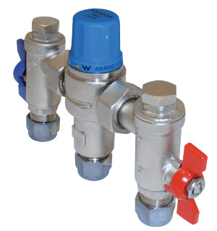

Definition:
Valve that mixes hot and cold water to supply a set temperature

Project No. / WR No. |  |  |  | Install Date | / /
Identifier |  |  |  | ARV Cost (ex GST)
Site |  |  |  | Manufacturer
Building |  |  |  | Model
Room* |  |  |  | Serial No
Installer |  |  |  | Warranty End Date | / /
Warranty Coverage
OH&S Notes
General Notes
Form Filled Out By
*If not in a room, then the room it is above, below or outside of.

Attributes:
Asset Life (20)

University Use:
Class / Group / Cat / Cat Type |  |  |  | PLANT & EQUIP / HYDREQ/ WATER SUPPLY SYSTEMS / WS
BC (775) |  | Cond. | EXCL |  | Crit. | C5 | FMC | HYDRSTAT | Asset No.

Tempering Valve

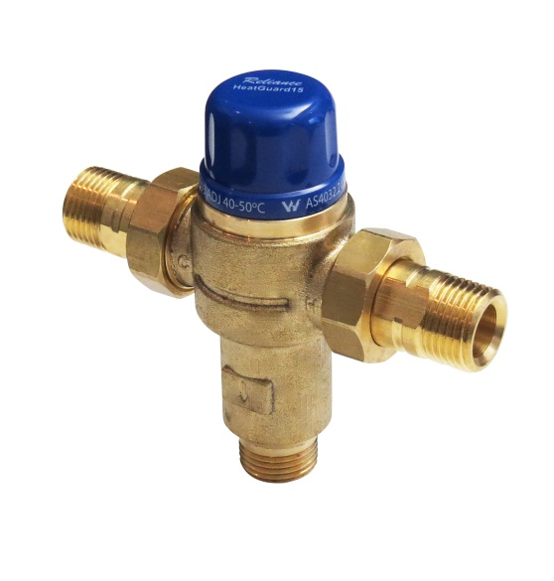

Definition:
Valve that mixes hot and cold water to supply an approximate temperature

Project No. / WR No. |  |  |  | Install Date | / /
Identifier |  |  |  | ARV Cost (ex GST)
Site |  |  |  | Manufacturer
Building |  |  |  | Model
Room* |  |  |  | Serial No
Installer |  |  |  | Warranty End Date | / /
Warranty Coverage
OH&S Notes
General Notes
Form Filled Out By
*If not in a room, then the room it is above, below or outside of.

Attributes:
Asset Life (20)

University Use:
Class / Group / Cat / Cat Type |  |  |  | PLANT & EQUIP / HYDREQ/ WATER SUPPLY SYSTEMS / WS
BC (775) |  | Cond. | EXCL |  | Crit. | C4 | FMC | HYDRPREV | Asset No.

Hot Water Cylinder Electric

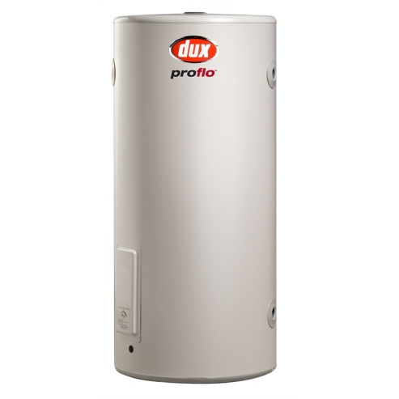

Definition:
Electric element domestic hot water cylinder

Project No. / WR No. |  |  |  | Install Date | / /
Identifier |  |  |  | ARV Cost (ex GST)
Site |  |  |  | Manufacturer
Building |  |  |  | Model
Room* |  |  |  | Serial No
Installer |  |  |  | Warranty End Date | / /
Warranty Coverage
OH&S Notes
General Notes
Form Filled Out By
*If not within a room then use the room that it is above, below or outside of

Components:
 | No. | Size (kW)
Element

Attributes:
Asset Life (10) |  | Capacity (kW)*
Volume (L) |  | Cylinder Type | Stainless / Copper / Vitreous Enamel

*Total capacity, e.g. if 3 x 4.8kW elements then capacity is 14.4kW.

University Use:
Class / Group / Cat / Cat Type |  |  |  | PLANT & EQUIP / HYDREQ/ WATER SUPPLY SYSTEMS / WS
BC (775) |  | Cond. | EXCL |  | Crit. | C3 | FMC | HYDRSTAT | Asset No.

Hot Water Cylinder Gas

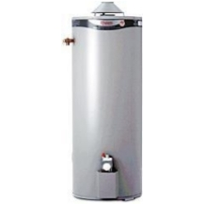

Definition:
Gas fired domestic hot water cylinder

Project No. / WR No. |  |  |  | Install Date | / /
Identifier |  |  |  | ARV Cost (ex GST)
Site |  |  |  | Manufacturer
Building |  |  |  | Model
Room* |  |  |  | Serial No
Installer |  |  |  | Warranty End Date | / /
Warranty Coverage
OH&S Notes
General Notes
Form Filled Out By
*If not within a room then use the room that it is above, below or outside of

Attributes:
Asset Life (10)
Volume (L)
Capacity (kW)
Gas Type | LPG / Natural
Cylinder Type | Stainless / Copper / Vitreous Enamel

University Use:
Class / Group / Cat / Cat Type |  |  |  | PLANT & EQUIP / HYDREQ / WATER SUPPLY SYSTEMS / WS
BC (775) |  | Cond. | EXCL |  | Crit. | C3 | FMC | HYDRSTAT | Asset No.

Hot Water Instantaneous Gas

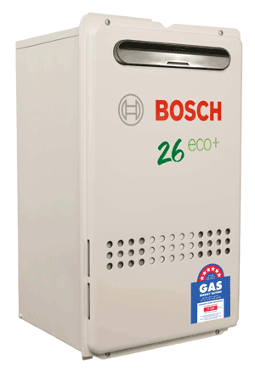

Definition:
Instant gas fired domestic hot water cylinder

Project No. / WR No. |  |  |  | Install Date | / /
Identifier |  |  |  | ARV Cost (ex GST)
Site |  |  |  | Manufacturer
Building |  |  |  | Model
Room* |  |  |  | Serial No
Installer |  |  |  | Warranty End Date | / /
Warranty Coverage
OH&S Notes
General Notes
Form Filled Out By

*If not within a room then use the room that it is above, below or outside of

Attributes:
Asset Life (10)
Capacity (kW)
Gas Type | LPG / Natural

University Use:
Class / Group / Cat / Cat Type |  |  |  | PLANT & EQUIP / HYDREQ / WATER SUPPLY SYSTEMS / WS
BC (775) |  | Cond. | EXCL |  | Crit. | C3 | FMC | HYDRSTAT | Asset No.

Hot Water Instantaneous Electric

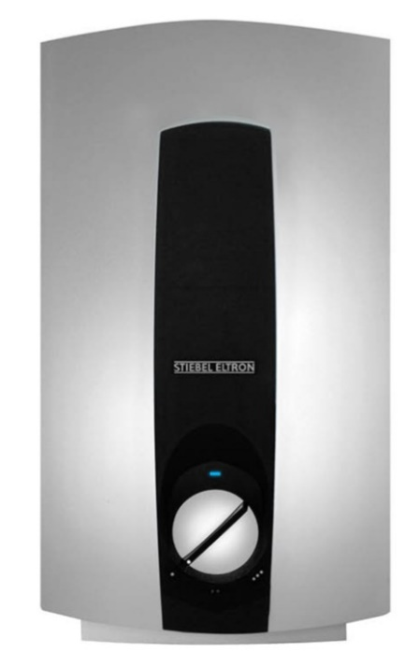

Definition:
Instant electric domestic hot water cylinder

Project No. / WR No. |  |  |  | Install Date | / /
Identifier |  |  |  | ARV Cost (ex GST)
Site |  |  |  | Manufacturer
Building |  |  |  | Model
Room* |  |  |  | Serial No
Installer |  |  |  | Warranty End Date | / /
Warranty Coverage
OH&S Notes
General Notes |  | Singe / Three Phase
Form Filled Out By
*If not within a room then use the room that it is above, below or outside of

Attributes:
Asset Life (10)
Capacity (kW)

University Use:
Class / Group / Cat / Cat Type |  |  |  | PLANT & EQUIP / HYDREQ / WATER SUPPLY SYSTEMS / WS
BC (775) |  | Cond. | EXCL |  | Crit. | C3 | FMC | HYDRSTAT | Asset No.

Hot Water Cylinder Heat Pump

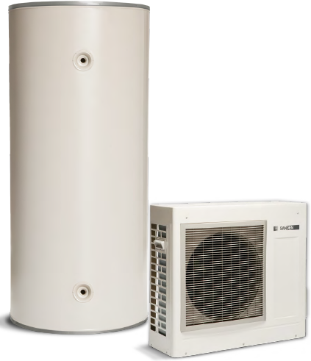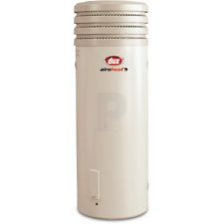

Definition:
Heat pump hot water cylinder

Project No. / WR No. |  |  |  | Install Date | / /
Identifier |  |  |  | ARV Cost (ex GST)
Site |  |  |  | Manufacturer
Building |  |  |  | Model
Room* |  |  |  | Serial No
Installer |  |  |  | Warranty End Date | / /
Warranty Coverage
OH&S Notes
General Notes
Form Filled Out By
*If not within a room then use the room that it is above, below or outside of

Attributes:
Asset Life (10)
Volume (L)
Capacity (kW)
Refrigerant | R
Refrigerant Charge (kg)
Cylinder Type | Stainless / Copper / Vitreous Enamel

University Use:
Class / Group / Cat / Cat Type |  |  |  | PLANT & EQUIP / HYDREQ / WATER SUPPLY SYSTEMS / WS
BC (775) |  | Cond. | EXCL |  | Crit. | C3 | FMC | HYDRSTAT | Asset No.

Hot Water Heat Pump

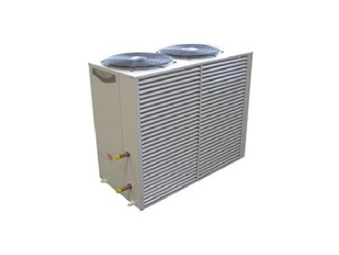

Definition:
Heat pump hot water unit that doesn’t have storage

Project No. / WR No. |  |  |  | Install Date | / /
Identifier |  |  |  | ARV Cost (ex GST)
Site |  |  |  | Manufacturer
Building |  |  |  | Model
Room* |  |  |  | Serial No
Installer |  |  |  | Warranty End Date | / /
Warranty Coverage
OH&S Notes
General Notes
Form Filled Out By
*If not within a room then use the room that it is above, below or outside of

Attributes:
Asset Life (10)
Capacity (kW)
Refrigerant | R
Refrigerant Charge (kg)

University Use:
Class / Group / Cat / Cat Type |  |  |  | PLANT & EQUIP / HYDREQ / WATER SUPPLY SYSTEMS / WS
BC (775) |  | Cond. | EXCL |  | Crit. | C3 | FMC | HYDRPREV | Asset No.

Hot Water Storage Cylinder

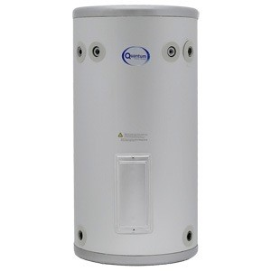

Definition:
Storage vessel for domestic hot water, no heating elements

Project No. / WR No. |  |  |  | Install Date | / /
Identifier |  |  |  | ARV Cost (ex GST)
Site |  |  |  | Manufacturer
Building |  |  |  | Model
Room* |  |  |  | Serial No
Installer |  |  |  | Warranty End Date | / /
Warranty Coverage
OH&S Notes
General Notes
Form Filled Out By
*If not within a room then use the room that it is above, below or outside of

Attributes:
Asset Life (10)
Volume (L)
Cylinder Type | Stainless / Copper / Vitreous Enamel

University Use:
Class / Group / Cat / Cat Type |  |  |  | PLANT & EQUIP / HYDREQ/ WATER SUPPLY SYSTEMS / WS
BC (775) |  | Cond. | EXCL |  | Crit. | C3 | FMC | HYDRSTAT | Asset No.

Hot Water Exchanger Cylinder

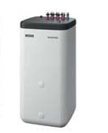

Definition:
Storage vessel for domestic hot water with internal coil or heat exchanger

Project No. / WR No. |  |  |  | Install Date | / /
Identifier |  |  |  | ARV Cost (ex GST)
Site |  |  |  | Manufacturer
Building |  |  |  | Model
Room* |  |  |  | Serial No
Installer |  |  |  | Warranty End Date | / /
Warranty Coverage
OH&S Notes
General Notes
Form Filled Out By

*If not within a room then use the room that it is above, below or outside of

Attributes:
Asset Life (10)
Volume (L)
Cylinder Type | Stainless / Copper / Vitreous Enamel

University Use:
Class / Group / Cat / Cat Type |  |  |  | PLANT & EQUIP / HYDREQ/ WATER SUPPLY SYSTEMS / WS
BC (775) |  | Cond. | EXCL |  | Crit. | C3 | FMC | HYDRSTAT | Asset No.

Hot Water Solar Collector Evacuated Tube

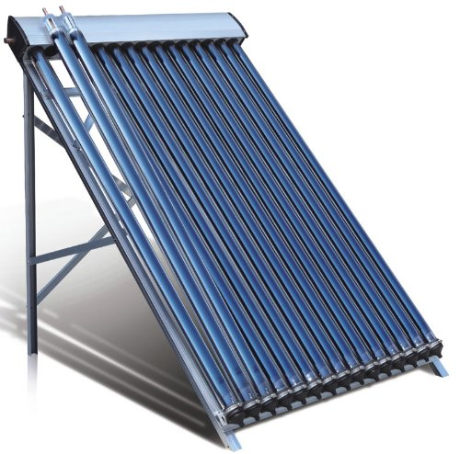

Definition:
Evacuated tube collector ‘panel’ for domestic hot water system

Project No. / WR No. |  |  |  | Install Date | / /
Identifier |  |  |  | ARV Cost (ex GST)
Site |  |  |  | Manufacturer
Building |  |  |  | Model
Room* |  |  |  | Serial No
Installer |  |  |  | Warranty End Date | / /
Warranty Coverage
OH&S Notes
General Notes
Form Filled Out By
*If not within a room then use the room that it is above, below or outside of

Attributes:
Asset Life (25)

University Use:
Class / Group / Cat / Cat Type |  |  |  | PLANT & EQUIP / HYDREQ/ WATER SUPPLY SYSTEMS / WS
BC (775) |  | Cond. | EXCL |  | Crit. | C3 | FMC | HYDRPREV | Asset No.

Hot Water Solar Collector Flat Plate

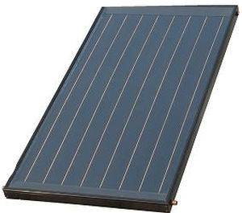

Definition:
Flat panel or plate type collector system for domestic hot water system

Project No. / WR No. |  |  |  | Install Date | / /
Identifier |  |  |  | ARV Cost (ex GST)
Site |  |  |  | Manufacturer
Building |  |  |  | Model
Room* |  |  |  | Serial No
Installer |  |  |  | Warranty End Date | / /
Warranty Coverage
OH&S Notes
General Notes
Form Filled Out By
*If not within a room then use the room that it is above, below or outside of

Attributes:
Asset Life (15)

University Use:
Class / Group / Cat / Cat Type |  |  |  | PLANT & EQUIP / HYDREQ/ WATER SUPPLY SYSTEMS / WS
BC (775) |  | Cond. | EXCL |  | Crit. | C3 | FMC | HYDRPREV | Asset No.

Water Filter - Backwash

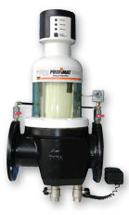

Definition:
Backwashing water filter

Project No. / WR No. |  |  |  | Install Date | / /
Identifier |  |  |  | ARV Cost (ex GST)
Site |  |  |  | Manufacturer
Building |  |  |  | Model
Room* |  |  |  | Serial No
Installer |  |  |  | Warranty End Date | / /
Warranty Coverage
OH&S Notes
General Notes
Form Filled Out By

*If not in a room, then the room it is above, below or outside of.

Attributes:
Asset Life (10)

University Use:
Class / Group / Cat / Cat Type |  |  |  | PLANT & EQUIP / HYDREQ/ WATER SUPPLY SYSTEMS / WS
BC (775) |  | Cond. | EXCL |  | Crit. | C4 | FMC | HYDRPREV | Asset No.

Water Filter - Cartridge

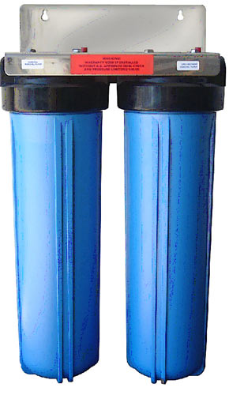

Definition:
Cartridge based water filter, in-line or other types

Project No. / WR No. |  |  |  | Install Date | / /
Identifier |  |  |  | ARV Cost (ex GST)
Site |  |  |  | Manufacturer
Building |  |  |  | Model
Room* |  |  |  | Serial No
Installer |  |  |  | Warranty End Date | / /
Warranty Coverage
OH&S Notes
General Notes
Form Filled Out By
*If not in a room, then the room it is above, below or outside of.

Component:
 | Quantity | Make | Model
Filter – Water Cartridge

Attributes:
Asset Life (20)

University Use:
Class / Group / Cat / Cat Type |  |  |  | PLANT & EQUIP / HYDREQ/ WATER SUPPLY SYSTEMS / WS
BC (775) |  | Cond. | EXCL |  | Crit. | C4 | FMC | HYDRPREV | Asset No.

Water Filter – Ultraviolet Light

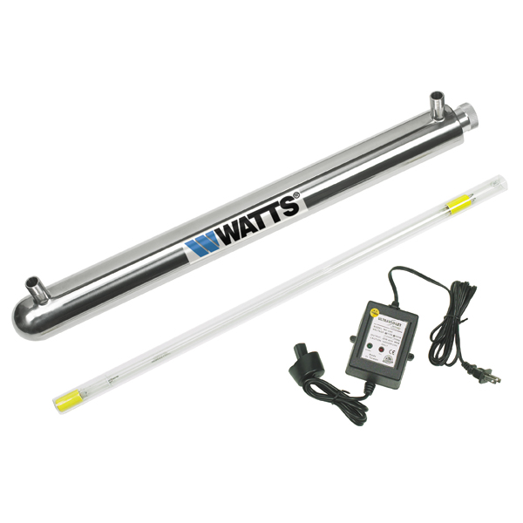

Definition:
Ultraviolet light water filter/treatment

Project No. / WR No. |  |  |  | Install Date | / /
Identifier |  |  |  | ARV Cost (ex GST)
Site |  |  |  | Manufacturer
Building |  |  |  | Model
Room* |  |  |  | Serial No
Installer |  |  |  | Warranty End Date | / /
Warranty Coverage
OH&S Notes
General Notes
Form Filled Out By
*If not in a room, then the room it is above, below or outside of.

Component:
 | Quantity | Make | Model
Filter – Water UV Lamp

Attributes:
Asset Life (20)

University Use:
Class / Group / Cat / Cat Type |  |  |  | PLANT & EQUIP / HYDREQ/ WATER SUPPLY SYSTEMS / WS
BC (775) |  | Cond. | EXCL |  | Crit. | C3 | FMC | HYDRPREV | Asset No.

Water Filter – Reverse Osmosis

Definition:
Reverse Osmosis filtration unit for potable water (not research). Large fixed unit, not portable.

Project No. / WR No. |  |  |  | Install Date | / /
Identifier |  |  |  | ARV Cost (ex GST)
Site |  |  |  | Manufacturer
Building |  |  |  | Model
Room* |  |  |  | Serial No
Installer |  |  |  | Warranty End Date | / /
Warranty Coverage
OH&S Notes
General Notes
Form Filled Out By
*If not in a room, then the room it is above, below or outside of.

Attributes:
Asset Life (20)

University Use:
Class / Group / Cat / Cat Type |  |  |  | PLANT & EQUIP / HYDREQ/ WATER SUPPLY SYSTEMS / WS
BC (775) |  | Cond. | EXCL |  | Crit. | C3 | FMC | HYDRPREV | Asset No.

Water Filter – Tank

Definition:
Large water filtration tank. Typically pass through filtration similar to cartridge only larger and often carbon filtration.

Project No. / WR No. |  |  |  | Install Date | / /
Identifier |  |  |  | ARV Cost (ex GST)
Site |  |  |  | Manufacturer
Building |  |  |  | Model
Room* |  |  |  | Serial No
Installer |  |  |  | Warranty End Date | / /
Warranty Coverage
OH&S Notes
General Notes
Form Filled Out By
*If not in a room, then the room it is above, below or outside of.

Attributes:

Filter Medium | Carbon / Sand
Asset Life (20)

University Use:
Class / Group / Cat / Cat Type |  |  |  | PLANT & EQUIP / HYDREQ/ WATER SUPPLY SYSTEMS / WS
BC (775) |  | Cond. | EXCL |  | Crit. | C3 | FMC | HYDRPREV | Asset No.

Gas Asset Forms

Refer to Asset Forms General Instructions section before completing these forms.

Compressor Air 116
Compressed Air Unit 117
Nitrogen Generator 118
Pressure Vessel – Gas 119
Air Receiver 120
Gas Dryer – Desiccant 121
Gas Dryer – Cooler 122
Vacuum Pump 123
Gas Alarm Panel 124
Gas Distribution System 125
Gas Regulator 126
Gas Filter 127
Gas Electronic Safety Control 128
Gas Meter 129

Compressor Air

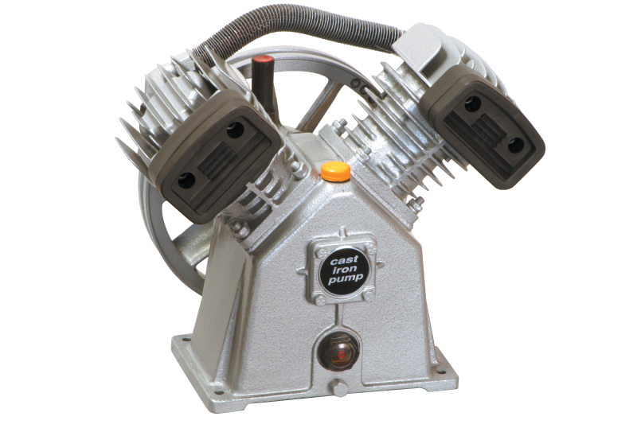

Definition:
An air compressor, without integral storage pressure vessel

Project No. / WR No. |  |  |  | Install Date | / /
Identifier |  |  |  | ARV Cost (ex GST)
Site |  |  |  | Manufacturer
Building |  |  |  | Model
Room* |  |  |  | Serial No
Installer |  |  |  | Warranty End Date | / /
Warranty Coverage
OH&S Notes
General Notes
Form Filled Out By
*If not in a room, then the room it is above, below or outside of.

Attributes:
Asset Life (15)

University Use:
Class / Group / Cat / Cat Type |  |  |  | PLANT & EQUIP / RESCHEQ / RETICULATED GASES / GS
BC (775) |  | Cond. | EXCL |  | Crit. | C5 | FMC | GASPREV | Asset No.

Compressed Air Unit

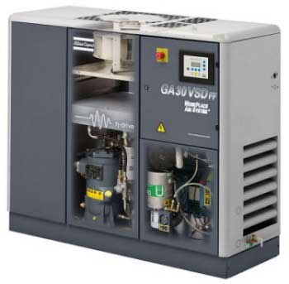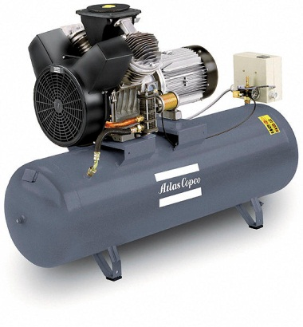

Definition:
An air compressor, with integral storage pressure vessel

Project No. / WR No. |  |  |  | Install Date | / /
Identifier* |  |  |  | ARV Cost (ex GST)
Site |  |  |  | Manufacturer
Building |  |  |  | Model
Room** |  |  |  | Serial No
Installer |  |  |  | Warranty End Date | / /
Warranty Coverage
OH&S Notes
General Notes
Form Filled Out By
*Identifier to be the UTAS supplied Hazardous plant registration ID.
**If not in a room, then the room it is above, below or outside of.

Attributes:
Working Pressure (kPa)
Volume (L)
Asset Life (15)

Hazardous Plant Registration Number:

IF HAZARDOUS PLANT REGISTRATION PAPERWORK (PRF4 FROM WORKSAFE TASMANIA) MUST BE SUBMITTED WITH THIS ASSET FORM. INSPECTION AND SIGN OFF MUST BE COMPLETED PRIOR TO SUBMISSION.

University Use:
Class / Group / Cat / Cat Type |  |  |  | PLANT & EQUIP / RESCHEQ / RETICULATED GASES / GS
BC (775) |  | Cond. | EXCL |  | Crit. | C5 | FMC | HAZPSTAT | Asset No.

Nitrogen Generator

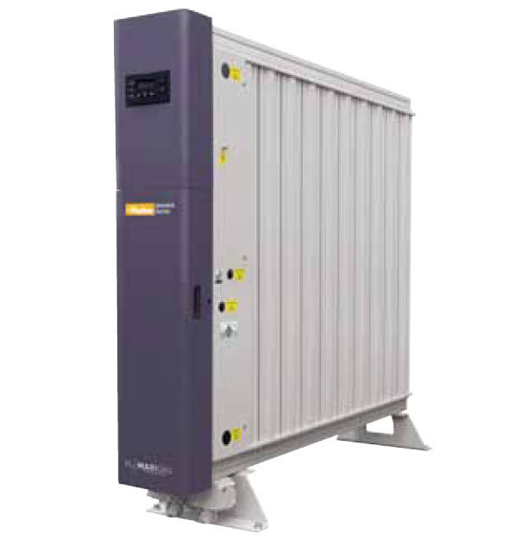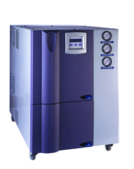

Definition:
A device for producing nitrogen from air

Project No. / WR No. |  |  |  | Install Date | / /
Identifier* |  |  |  | ARV Cost (ex GST)
Site |  |  |  | Manufacturer
Building |  |  |  | Model
Room** |  |  |  | Serial No
Installer |  |  |  | Warranty End Date | / /
Warranty Coverage
OH&S Notes
General Notes
Form Filled Out By
*Identifier to be the UTAS supplied Hazardous plant registration ID.
**If not in a room, then the room it is above, below or outside of.

Attributes:
Asset Life (15)

University Use:
Class / Group / Cat / Cat Type |  |  |  | PLANT & EQUIP / RESCHEQ / RETICULATED GASES / GS
BC (775) |  | Cond. | EXCL |  | Crit. | C5 | FMC | GASPREV | Asset No.

Pressure Vessel – Gas

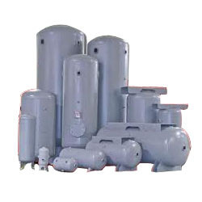
Definition:
Storage vessel for gas under high pressure that is not integral to gas producing equipment.
Pressure vessels for air to be recorded as Air Receiver

Project No. / WR No. |  |  |  | Install Date | / /
Identifier* |  |  |  | ARV Cost (ex GST)
Site |  |  |  | Manufacturer
Building |  |  |  | Model
Room** |  |  |  | Serial No
Installer |  |  |  | Warranty End Date | / /
Warranty Coverage
OH&S Notes
General Notes
Form Filled Out By
*Identifier to be the UTAS supplied Hazardous plant registration ID.
**If not in a room, then the room it is above, below or outside of.

Attributes:
Working Pressure (kPa) |  | Gas Type
Volume (L) |  | Asset Life (15)

Hazardous Plant Registration Number:

IF HAZARDOUS PLANT REGISTRATION PAPERWORK (PRF4 FROM WORKSAFE TASMANIA) MUST BE SUBMITTED WITH THIS ASSET FORM. INSPECTION AND SIGN OFF MUST BE COMPLETED PRIOR TO SUBMISSION.

University Use:
Class / Group / Cat / Cat Type |  |  |  | PLANT & EQUIP / RESCHEQ / RETICULATED GASES / GS
BC (775) |  | Cond. | EXCL |  | Crit. | C5 | FMC | HAZPSTAT | Asset No.

Air Receiver

Definition:
Storage vessel for compressed air under high pressure.

Project No. / WR No. |  |  |  | Install Date | / /
Identifier* |  |  |  | ARV Cost (ex GST)
Site |  |  |  | Manufacturer
Building |  |  |  | Model
Room** |  |  |  | Serial No
Installer |  |  |  | Warranty End Date | / /
Warranty Coverage
OH&S Notes
General Notes
Form Filled Out By
*Identifier to be the UTAS supplied Hazardous plant registration ID.
**If not in a room, then the room it is above, below or outside of.

Attributes:
Working Pressure (kPa)
Volume (L)
Asset Life (15)

Hazardous Plant Registration Number:

IF HAZARDOUS PLANT REGISTRATION PAPERWORK (PRF4 FROM WORKSAFE TASMANIA) MUST BE SUBMITTED WITH THIS ASSET FORM. INSPECTION AND SIGN OFF MUST BE COMPLETED PRIOR TO SUBMISSION.

University Use:
Class / Group / Cat / Cat Type |  |  |  | PLANT & EQUIP / RESCHEQ / RETICULATED GASES / GS
BC (775) |  | Cond. | EXCL |  | Crit. | C5 | FMC | HAZPSTAT | Asset No.

Gas Dryer – Desiccant

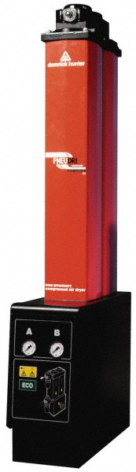

Definition:
A desiccant type dryer for a gas

Project No. / WR No. |  |  |  | Install Date | / /
Identifier |  |  |  | ARV Cost (ex GST)
Site |  |  |  | Manufacturer
Building |  |  |  | Model
Room* |  |  |  | Serial No
Installer |  |  |  | Warranty End Date | / /
Warranty Coverage
OH&S Notes
General Notes
Form Filled Out By

*If not in a room, then the room it is above, below or outside of.

Attributes:
Asset Life (15)

University Use:
Class / Group / Cat / Cat Type |  |  |  | PLANT & EQUIP / RESCHEQ / RETICULATED GASES / GS
BC (775) |  | Cond. | EXCL |  | Crit. | C5 | FMC | GASPREV | Asset No.

Gas Dryer – Cooler

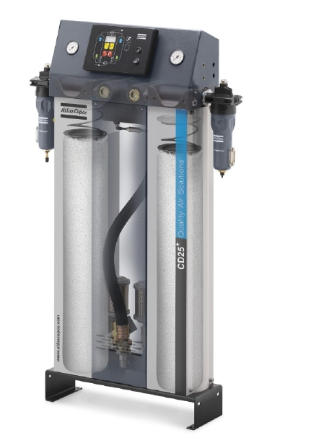

Definition:
A gas cooler for drying of the gas, typically refrigeration based cooling system

Project No. / WR No. |  |  |  | Install Date | / /
Identifier |  |  |  | ARV Cost (ex GST)
Site |  |  |  | Manufacturer
Building |  |  |  | Model
Room* |  |  |  | Serial No
Installer |  |  |  | Warranty End Date | / /
Warranty Coverage
OH&S Notes
General Notes
Form Filled Out Bt
*If not in a room, then the room it is above, below or outside of.

Attributes:
Asset Life (15)
Refrigerant | R
Refrigerant Charge (kg)

University Use:
Class / Group / Cat / Cat Type |  |  |  | PLANT & EQUIP / RESCHEQ / RETICULATED GASES / GS
BC (775) |  | Cond. | EXCL |  | Crit. | C5 | FMC | GASPREV | Asset No.

Vacuum Pump

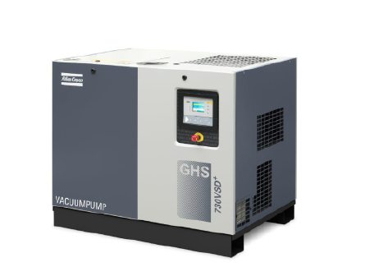
Definition:
Suction or vacuum pump

Project No. / WR No. |  |  |  | Install Date | / /
Identifier |  |  |  | ARV Cost (ex GST)
Site |  |  |  | Manufacturer
Building |  |  |  | Model
Room* |  |  |  | Serial No
Installer |  |  |  | Warranty End Date | / /
Warranty Coverage
OH&S Notes
General Notes
Form Filled Out By
*If not in a room, then the room it is above, below or outside of.

Attributes:
Asset Life (15)

University Use:
Class / Group / Cat / Cat Type |  |  |  | PLANT & EQUIP / RESCHEQ / RETICULATED GASES / GS
BC (775) |  | Cond. | EXCL |  | Crit. | C3 | FMC | GASPREV | Asset No.

Gas Alarm Panel

Definition:
An alarm panel for the indication of low or no flow of gas.

Project No. / WR No. |  |  |  | Install Date | / /
Identifier |  |  |  | ARV Cost (ex GST)
Site |  |  |  | Manufacturer
Building |  |  |  | Model
Room |  |  |  | Serial No
Installer |  |  |  | Warranty End Date | / /
Warranty Coverage
OH&S Notes
General Notes
Form Filled Out By

Attributes:
Asset Life (15)

University Use:
Class / Group / Cat / Cat Type |  |  |  | PLANT & EQUIP / RESCHEQ / RETICULATED GASES / GS
BC (775) |  | Cond. | EXCL |  | Crit. | C4 | FMC | N/A | Asset No.

Gas Distribution System

Definition:
Gas distribution system from TasGas supply or site infrastructure.

One asset per site infrastructure. One asset per building.

If undertaking significant works for an existing buildings or sites asset provide value of works on asset form otherwise an asset form for the existing site or building is not required.

Project No. / WR No. |  |  |  | Install Date | / /
Identifier |  |  |  | ARV Cost (ex GST)
Site |  |  |  | Installer
Building |  |  |  | Warranty End Date | / /
Warranty Coverage
OH&S Notes
General Notes

Attributes:
Asset Life (30)
Gas Type | LPG / Natural

University Use:
Class / Group / Cat / Cat Type |  |  |  | PLANT & EQUIP / HYDREQ / RETICULATED GASES / GS
BC (775) |  | Cond. | EXCL |  | Crit. | C5 | FMC | GASSTAT | Asset No.

Gas Regulator

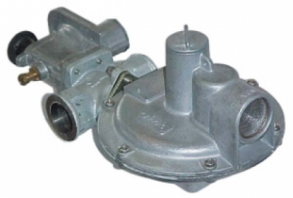

Definition:
A distribution regulator for gas pressure. Not, appliance/equipment regulator.

Project No. / WR No. |  |  |  | Install Date | / /
Identifier |  |  |  | ARV Cost (ex GST)
Site |  |  |  | Manufacturer
Building |  |  |  | Model
Room* |  |  |  | Serial No
Installer |  |  |  | Warranty End Date | / /
Warranty Coverage
OH&S Notes
General Notes
Form Filled Out By

*If not in a room, then the room it is above, below or outside of.

Gas Distribution System Connected to:
Identifier

Attributes:
Asset Life (15)
Gas Type | LPG / Natural

University Use
Class / Group / Cat / Cat Type |  |  |  | PLANT & EQUIP / HYDREQ / RETICULATED GASES / GS
BC (775) |  | Cond. | EXCL |  | Crit. | C5 | FMC | GASSTAT | Asset No.

Gas Filter

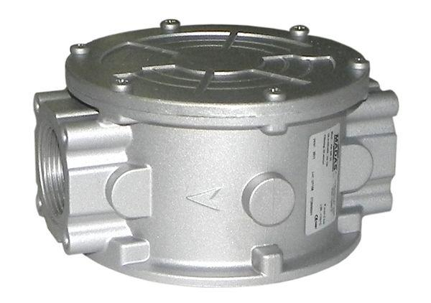

Definition:
A standalone filter for gas, typically only on natural gas installation.

Project No. / WR No. |  |  |  | Install Date | / /
Identifier |  |  |  | ARV Cost (ex GST)
Site |  |  |  | Manufacturer
Building |  |  |  | Model
Room* |  |  |  | Serial No
Installer |  |  |  | Warranty End Date | / /
Warranty Coverage
OH&S Notes
General Notes
Form Filled Out By

*If not in a room, then the room it is above, below or outside of.

Gas Distribution System Connected to:
Identifier

Attributes:
Asset Life (15)
Gas Type | LPG / Natural

University Use
Class / Group / Cat / Cat Type |  |  |  | PLANT & EQUIP / HYDREQ / RETICULATED GASES / GS
BC (775) |  | Cond. | EXCL |  | Crit. | C5 | FMC | GASPREV | Asset No.

Gas Electronic Safety Control

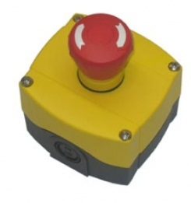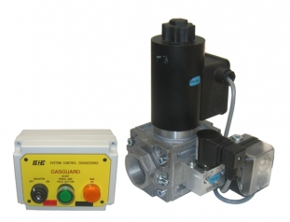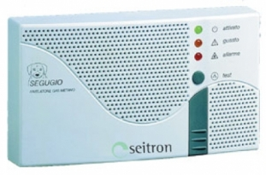

Definition:
An electronic control system for the shutdown of gas supply.

Project No. / WR No. |  |  |  | Install Date | / /
Identifier |  |  |  | ARV Cost (ex GST)
Site |  |  |  | Manufacturer
Building |  |  |  | Model
Room* |  |  |  | Serial No
Installer |  |  |  | Warranty End Date | / /
Warranty Coverage
OH&S Notes
General Notes

*Use the location of the pressure proving or push button

Components:
Location(s)*
Solenoid Valve(s)
Fire Panel Signal
Push Button(s)
Pressure Proving
Gas Detector
*Location to be given as the site, building and room (or room that it is outside, above, or below of).

Gas Distribution System Connected to:
Identifier

Attributes:
Asset Life (15)
Gas Type | LPG / Natural

University Use
Class / Group / Cat / Cat Type |  |  |  | PLANT & EQUIP / HYDREQ / RETICULATED GASES / GS
BC (775) |  | Cond. | EXCL |  | Crit. | C5 | FMC | GASSTAT | Asset No.

Gas Meter

Definition:

Meter for natural gas or lpg requiring maintenance to ensure flow of gas

Project No. / WR No. |  |  |  | Install Date | / /
Identifier |  |  |  | ARV Cost (ex GST)
Site |  |  |  | Manufacturer
Building |  |  |  | Model
Room* |  |  |  | Serial No
Installer |  |  |  | Warranty End Date | / /
Warranty Coverage
OH&S Notes
General Notes
Form Filled Out By

*If not in a room, then the room it is above, below or outside of.

Gas Distribution System Connected to:
Identifier

Attributes:
Asset Life (15)
Gas Type | LPG / Natural

University Use
Class / Group / Cat / Cat Type |  |  |  | PLANT & EQUIP / HYDREQ / RETICULATED GASES / GS
BC (775) |  | Cond. | EXCL |  | Crit. | C5 | FMC | GASPREV | Asset No.

Mechanical Asset Forms

Refer to Asset Forms General Instructions section before completing these forms.

Air Conditioner – Single Split 132
Air Conditioner – Multi-Split 133
Air Conditioner – Variable Refrigerant 134
Indoor Unit – High Wall 135
Indoor Unit – Ducted 136
Indoor Unit – Floor 137
Indoor Unit – Recessed Cassette 138
Indoor Unit – Under Ceiling 139
Duct Coil - DX 140
Filter Assembly 141
Air Handling Unit 142
Header Tank 143
Automatic Refill Unit 144
Dosing Pot or Point 145
Expansion Tank 146
Air Conditioner - Packaged Unit 147
Air Conditioner - Packed Terminal Unit 148
Air Curtain 149
Air Fan - Return 150
Air Fan - Supply 151
Air Fan - Fresh 152
Air Fan – Exhaust – Car Park 153
Air Fan – Exhaust – General 154
Air Fan – Exhaust – Kitchen 155
Air Fan – Exhaust – Fume 156
Air Fan – Exhaust – Chemical 157
Air Fan – Stairwell Pressurisation 158
Air Fan – Exhaust – Smoke Spill 159
Boiler – Electric 160
Boiler – Gas Fired 161
Boiler – Oil Fired 162
Calorifer 163
Chiller – Air Cooled 164
Chiller – Water Cooled 165
Heat Pump – Air Source 166
Heat Pump – Water Source 167
Heat Pump Chiller – Water Cooled 168
Heat Pump Chiller – Air Cooled 169
Circulating Pump 170
Condenser Pump 171
Dedicated Circulating Pump 172
Cooling Tower 173
Hydronic Building Reticulation 174
Evaporative Air Cooler 175
Dry Cooler 176
Extraction System - Dust 177
Fan Coil Unit – High Wall 178
Fan Coil Unit – Ducted 179
Fan Coil Unit – Floor 180
Fan Coil Unit – Recessed Cassette 181
Fan Coil Unit – Under Ceiling 182
Duct Coil - Hydronic 183
Data Centre Floor Mount DX Unit 184
Data Centre Condenser 185
Duct Heater - Electric 186
Duct Heater - Gas 187
Heat Exchanger – Shell & Tube 188
Heat Exchanger – Plate 189
Heat Recovery – Plate 190
Heat Recovery – Wheel 191
Heat Recovery – Unit 192
Heater - Hydronic 193
Heater – Hydronic Floor Coil 194
Heater - Electric 195
Heater – Electric Floor Coil 196
Heater - Gas 197
Heater – Forced Air 198
Humidifier 199
Hydronic Storage Vessel 200
Switchboard - Mechanical 201
Variable Speed Drive 202
VAV Unit 203
Fire Damper - HVAC 204
Smoke Damper - HVAC 205
Constant Temperature Room 206
Cool Room 207
Freezer Room 208
Condenser 209
Evaporator 210
Growth Room or Chamber 211
Fume Cupboard 211
Controller System 212

Air Conditioner – Single Split

Definition:
Refrigerant split Air Conditioning system with one indoor unit to one outdoor unit

Project No. / WR No. |  |  |  | Install Date | / /
Identifier |  |  |  | ARV Cost (ex GST)
Site |  |  |  | Manufacturer
Building |  |  |  | Model (outdoor unit)
Room* |  |  |  | Serial No. (outdoor unit)
Installer |  |  |  | Warranty End Date | / /
Warranty Coverage
OH&S Notes
General Notes
Form Fill Out By
*If not within a room then use the room that it is above, below or outside of

Attributes:

Heating Capacity (kW) |  | Cooling Capacity (kW)
Refrigerant | R | Refrigerant Charge (kg)
Asset Life (15)

University Use:
Class / Group / Cat / Cat Type |  |  |  | PLANT & EQUIP / HVACEQ / HVAC PLANT / AC
BC (775) |  | Cond. | EXCL |  | Crit. | C3 | FMC | HVACPREV | Asset No.

Air Conditioner – Multi-Split

Definition:
Refrigerant split Air Conditioning system with one outdoor unit and more than one indoor unit. Indoor units cannot have individual modes (i.e. whole system is cooling or heating).

Project No. / WR No. |  |  |  | Install Date | / /
Identifier |  |  |  | ARV Cost (ex GST)
Site |  |  |  | Manufacturer
Building |  |  |  | Model (outdoor unit)
Room* |  |  |  | Serial No. (outdoor unit)
Installer |  |  |  | Warranty End Date | / /
Warranty Coverage
OH&S Notes
General Notes
Form Filled Out By
*If not within a room then use the room that it is above, below or outside of

Attributes:

Heating Capacity (kW) |  | Cooling Capacity (kW)
Refrigerant | R | Refrigerant Charge (kg)
Asset Life (15)

University Use:
Class / Group / Cat / Cat Type |  |  |  | PLANT & EQUIP / HVACEQ / HVAC PLANT / AC
BC (775) |  | Cond. | EXCL |  | Crit. | C3 | FMC | HVACPREV | Asset No.

Air Conditioner – Variable Refrigerant

Definition:
Refrigerant split Air Conditioning system with one outdoor unit and many indoor units. Use variable refrigerant volume/flow to allow simultaneous heating and cooling operation.

Project No. / WR No. |  |  |  | Install Date | / /
Identifier |  |  |  | ARV Cost (ex GST)
Site |  |  |  | Manufacturer
Building |  |  |  | Model (outdoor unit)
Room* |  |  |  | Serial No. (outdoor unit)
Installer |  |  |  | Warranty End Date | / /
Warranty Coverage
OH&S Notes
General Notes
Form Filled Out By
*If not within a room then use the room that it is above, below or outside of

Attributes:

Heating Capacity (kW) |  | Cooling Capacity (kW)
Refrigerant | R | Refrigerant Charge (kg)
Asset Life (20)

University Use:
Class / Group / Cat / Cat Type |  |  |  | PLANT & EQUIP / HVACEQ / HVAC PLANT / AC
BC (775) |  | Cond. | EXCL |  | Crit. | C3 | FMC | HVACPREV | Asset No.

Indoor Unit – High Wall

Definition:
A terminal unit designed to be mounted high on a wall (above 1600 AFFL), provided with refrigerant from a split refrigerant system

Project No. / WR No. |  |  |  | Install Date | / /
Identifier |  |  |  | ARV Cost (ex GST) | Include in parent cost
Site | Same as parent |  |  | Manufacturer | Same as parent
Building | Same as parent |  |  | Model
Room |  |  |  | Serial No.
Installer |  |  |  | Warranty End Date | / /
Warranty Coverage
OH&S Notes
General Notes
Form Filled Out By

Connected Asset:
Identifier
Single / Multi / Variable Split

Components:
Quantity
Filter – Unit Standard

Attributes:
Heating Capacity (kW) |  | Cooling Capacity (kW)
Fire Alarm Operation | On / Off / NA | Condensate Drain Pump | Yes / No
Asset Life (10)

University Use:
Class / Group / Cat / Cat Type |  |  |  | PLANT & EQUIP / HVACEQ / HVAC PLANT / AC
BC (775) |  | Cond. | EXCL |  | Crit. | C3 | FMC | HVACPREV | Asset No.

Indoor Unit – Ducted

Definition:
A terminal unit designed to be concealed with a ceiling space and delivers air via ductwork and diffusers, provided with refrigerant from a split refrigerant system. Includes ‘bulkhead’ units.

Project No. / WR No. |  |  |  | Install Date | / /
Identifier |  |  |  | ARV Cost (ex GST) | Include in parent cost
Site | Same as parent |  |  | Manufacturer | Same as parent
Building | Same as parent |  |  | Model
Room |  |  |  | Serial No.
Installer |  |  |  | Warranty End Date | / /
Warranty Coverage
OH&S Notes
General Notes
Form Filled Out By

Connected Asset:
Identifier
Single / Multi / Variable Split

Components:
Quantity
Filter – Unit Standard

Attributes:
Heating Capacity (kW) |  | Cooling Capacity (kW)
Fire Alarm Operation | On / Off / NA | Condensate Drain Pump | Yes / No
Asset Life (15)

University Use:
Class / Group / Cat / Cat Type |  |  |  | PLANT & EQUIP / HVACEQ / HVAC PLANT / AC
BC (775) |  | Cond. | EXCL |  | Crit. | C3 | FMC | HVACSTAT | Asset No.

Indoor Unit – Floor

Definition:
A terminal unit designed to be mounted low on a wall, provided with refrigerant from a split refrigerant system

Project No. / WR No. |  |  |  | Install Date | / /
Identifier |  |  |  | ARV Cost (ex GST) | Include in parent cost
Site | Same as parent |  |  | Manufacturer | Same as parent
Building | Same as parent |  |  | Model
Room |  |  |  | Serial No.
Installer |  |  |  | Warranty End Date | / /
Warranty Coverage
OH&S Notes
General Notes
Form Filled Out By

Connected Asset:
Identifier
Single / Multi / Variable Split

Components:
Quantity
Filter – Unit Standard

Attributes:
Heating Capacity (kW) |  | Cooling Capacity (kW)
Fire Alarm Operation | On / Off / NA | Condensate Drain Pump | Yes / No
Asset Life (10)

University Use:
Class / Group / Cat / Cat Type |  |  |  | PLANT & EQUIP / HVACEQ / HVAC PLANT / AC
BC (775) |  | Cond. | EXCL |  | Crit. | C3 | FMC | HVACPREV | Asset No.

Indoor Unit – Recessed Cassette

Definition:
A terminal unit designed to be recessed into a ceiling and providing up to 4 directions of air flow, provided with refrigerant from a split refrigerant system

Project No. / WR No. |  |  |  | Install Date | / /
Identifier |  |  |  | ARV Cost (ex GST) | Include in parent cost
Site | Same as parent |  |  | Manufacturer | Same as parent
Building | Same as parent |  |  | Model
Room |  |  |  | Serial No.
Installer |  |  |  | Warranty End Date | / /
Warranty Coverage
OH&S Notes
General Notes
Form Filled Out By

Connected Asset:
Identifier
Single / Multi / Variable Split

Components:
Quantity
Filter – Unit Standard

Attributes:
Heating Capacity (kW) |  | Cooling Capacity (kW)
Fire Alarm Operation | On / Off / NA | Condensate Drain Pump | Yes / No
Asset Life (15)

University Use:
Class / Group / Cat / Cat Type |  |  |  | PLANT & EQUIP / HVACEQ / HVAC PLANT / AC
BC (775) |  | Cond. | EXCL |  | Crit. | C3 | FMC | HVACPREV | Asset No.

Indoor Unit – Under Ceiling

Definition:
A terminal unit designed to be surface mounted under a ceiling, provided with refrigerant from a split refrigerant system

Project No. / WR No. |  |  |  | Install Date | / /
Identifier |  |  |  | ARV Cost (ex GST) | Include in parent cost
Site | Same as parent |  |  | Manufacturer | Same as parent
Building | Same as parent |  |  | Model
Room |  |  |  | Serial No.
Installer |  |  |  | Warranty End Date | / /
Warranty Coverage
OH&S Notes
General Notes
Form Filled Out By

Connected Asset:
Identifier
Single / Multi / Variable Split

Components:
Quantity
Filter – Unit Standard

Attributes:
Heating Capacity (kW) |  | Cooling Capacity (kW)
Fire Alarm Operation | On / Off / NA | Condensate Drain Pump | Yes / No
Asset Life (10)

University Use:
Class / Group / Cat / Cat Type |  |  |  | PLANT & EQUIP / HVACEQ / HVAC PLANT / AC
BC (775) |  | Cond. | EXCL |  | Crit. | C3 | FMC | HVACPREV | Asset No.

Duct Coil - DX

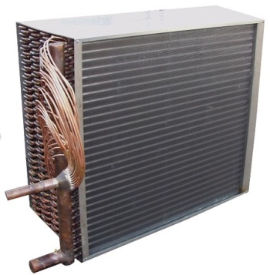

Definition:
In-duct coil for thermal transfer from refrigerant to air, mounted in ductwork, not part of a ducted or other mass produced unit. Generally paired with a Condenser asset.

Project No. / WR No. |  |  |  | Install Date | / /
Identifier |  |  |  | ARV Cost (ex GST)
Site |  |  |  | Manufacturer
Building |  |  |  | Model
Room |  |  |  | Serial No.
Installer |  |  |  | Warranty End Date | / /
Warranty Coverage
OH&S Notes
General Notes
Form Filled Out By

Condenser / Split Asset:

Identifier
Condenser / Split

Attributes:

Heating Capacity (kW) |  | Cooling Capacity (kW)
Condensate Drain Pump | Yes / No | Asset Life (30)

University Use:
Class / Group / Cat / Cat Type |  |  |  | PLANT & EQUIP / HVACEQ / HVAC PLANT / AC
BC (775) |  | Cond. | EXCL |  | Crit. | C3 | FMC | HVACSTAT | Asset No.

Filter Assembly

Definition:
A filter bank, clips, tray, slot or other physical arrangement that holds a filter or filters. ONLY used when the filters are NOT a component of a unit/asset (i.e. not physically inside or within).

Project No. / WR No. |  |  |  | Install Date | / /
Identifier |  |  |  | Manufacturer
Site |  |  |  | Model
Building |  |  |  | Warranty End Date | / /
Room |  |  |  | Installer
Warranty Coverage
OH&S Notes
General Notes
Form Filled Out By

Filter Assembly’s Parent Asset:

Asset Type |  | Identifier

Components (one of the below only type):
 | Size (HxWxD mm) | Quantity
Filter – Activated Carbon
Filter – Deep Bed
Filter – Electrostatic
Filter – HEPA
Filter – Pleated Media
Filter – Roll Media
Filter – Stainless Wire Mesh

Attributes:
Clean Pressure (Pa) |  | Dirty Pressure (Pa)

University Use:
Class / Group / Cat / Cat Type |  |  |  | PLANT & EQUIP / HVACEQ / HVAC PLANT / VE
BC (775) |  | Cond. | EXCL |  | Crit. | C3 | FMC | HVACSTAT | Asset No.

Air Handling Unit

Definition:
Large, purpose built or prefabricated panel, single unit for supply of air. Generally floor mounted and comprised of a fan, filters and heating / cooling coils or both.

Project No. / WR No. |  |  |  | Install Date | / /
Identifier |  |  |  | ARV Cost (ex GST)
Site |  |  |  | Manufacturer
Building |  |  |  | Model
Room |  |  |  | Serial No.
Installer |  |  |  | Warranty End Date | / /
Warranty Coverage
OH&S Notes
General Notes
Form Filled Out By

Filter Components:
 | Size (HxWxD mm) | Quantity
Filter – Activated Carbon
Filter – Deep Bed
Filter – Electrostatic
Filter – HEPA
Filter – Pleated Media
Filter – Roll Media
Filter – Stainless Wire Mesh

Belt Components:
 | Type | Quantity
Fan Belt(s)

Attributes:
Heating Capacity (kW) |  | Cooling Capacity (kW)
Clean Pressure (Pa) |  | Dirty Pressure (Pa)
Fire Alarm Operation | On / Off / NA | Asset Life (30)

University Use:
Class / Group / Cat / Cat Type |  |  |  | PLANT & EQUIP / HVACEQ / HVAC PLANT / AC
BC (775) |  | Cond. | EXCL |  | Crit. | C4 | FMC | HVACSTAT | Asset No.

Header Tank

Definition:
Water storage tank used for the provision of gravity powered pressure differential, makeup water and expansion in an open Heating or Cooling Water Building Reticulation System.

Project No. / WR No. |  |  |  | Install Date | / /
Identifier |  |  |  | ARV Cost (ex GST)
Site |  |  |  | Manufacturer
Building |  |  |  | Model
Room* |  |  |  | Serial No.
Installer |  |  |  | Warranty End Date | / /
Warranty Coverage
OH&S Notes
General Notes
*If not within a room then use the room that it is above, below or outside of

Attributes:

Volume (L) |  | Asset Life (30)

Automatic Refill Unit

Definition:
Unit consisting of registered air break tank, fill valve, pressure pump and pressure switch.

Project No. / WR No. |  |  |  | Install Date | / /
Identifier |  |  |  | ARV Cost (ex GST)
Site |  |  |  | Manufacturer
Building |  |  |  | Model
Room* |  |  |  | Serial No.
Installer |  |  |  | Warranty End Date | / /
Warranty Coverage
OH&S Notes
General Notes
Form Filled Out By
*If not within a room then use the room that it is above, below or outside of

Attributes:

Asset Life (20)

University Use:
Class / Group / Cat / Cat Type |  |  |  | PLANT & EQUIP / HVACEQ / HVAC PLANT / HVAC
BC (775) |  | Cond. | EXCL |  | Crit. | C3 | FMC | HVACPREV | Asset No.

Dosing Pot or Point

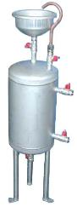

Definition:
Equipment used for adding of chemical treatment to a Heating, Heat Recovery or Cooling Water Building Reticulation System

Project No. / WR No. |  |  |  | Install Date | / /
Identifier |  |  |  | ARV Cost (ex GST)
Site |  |  |  | Manufacturer
Building |  |  |  | Model
Room |  |  |  | Serial No.
Installer |  |  |  | Warranty End Date | / /
Warranty Coverage
OH&S Notes
General Notes
Form Filled Out By

Attributes:

Dosing Water Volume (L) |  | Chemical

University Use:
Class / Group / Cat / Cat Type |  |  |  | PLANT & EQUIP / HVACEQ / HVAC PLANT / HVAC
BC (775) |  | Cond. | EXCL |  | Crit. | C3 | FMC | HVACPREV | Asset No.

Expansion Tank

Definition:
Pressure vessel used for expansion in a closed Heating or Cooling Water Building Reticulation System.

Project No. / WR No. |  |  |  | Install Date | / /
Identifier* |  |  |  | ARV Cost (ex GST)
Site |  |  |  | Manufacturer
Building |  |  |  | Model
Room** |  |  |  | Serial No.
Installer |  |  |  | Warranty End Date | / /
Warranty Coverage
OH&S Notes
General Notes
Form Filled Out By

*Identifier to be the UTAS supplied hazardous plant registration ID if hazardous plant.
**If not within a room then use the room that it is above, below or outside of

Attributes:
Volume (L) |  | Asset Life (30)

Hazardous Plant Registration Number:

IF HAZARDOUS PLANT REGISTRATION PAPERWORK (PRF4 FROM WORKSAFE TASMANIA) MUST BE SUBMITTED WITH THIS ASSET FORM. INSPECTION AND SIGN OFF MUST BE COMPLETED PRIOR TO SUBMISSION.

University Use:
Class / Group / Cat / Cat Type |  |  |  | PLANT & EQUIP / HVACEQ / HVAC PLANT / HVAC
BC (775) |  | Cond. | EXCL |  | Crit. | C5 | FMC | HAZPSTAT | Asset No.

Air Conditioner - Packaged Unit
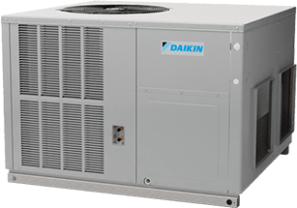
Definition:
Ducted packaged AC unit, typically roof mounted and providing ventilation also with reverse cycle DX, filters, dampers.

Project No. / WR No. |  |  |  | Install Date | / /
Identifier |  |  |  | ARV Cost (ex GST)
Site |  |  |  | Manufacturer
Building |  |  |  | Model
Room* |  |  |  | Serial No.
Installer |  |  |  | Warranty End Date | / /
Warranty Coverage
OH&S Notes
General Notes
Form Filled Out By
*If not within a room then use the room that it is above, below or outside of

Filter Components:
 | Size (HxWxD mm) | Quantity
Filter – Activated Carbon
Filter – Deep Bed
Filter – Electrostatic
Filter – HEPA
Filter – Pleated Media
Filter – Roll Media
Filter – Stainless Wire Mesh

Belt Components:
 | Type | Quantity
Fan Belt(s)

Attributes:
Heating Capacity (kW) |  | Cooling Capacity (kW)
Clean Pressure (Pa) |  | Dirty Pressure (Pa)
Fire Alarm Operation | On / Off / NA | Asset Life (25)

University Use:
Class / Group / Cat / Cat Type |  |  |  | PLANT & EQUIP / HVACEQ / HVAC PLANT / AC
BC (775) |  | Cond. | EXCL |  | Crit. | C3 | FMC | HVACSTAT | Asset No.

Air Conditioner - Packed Terminal Unit
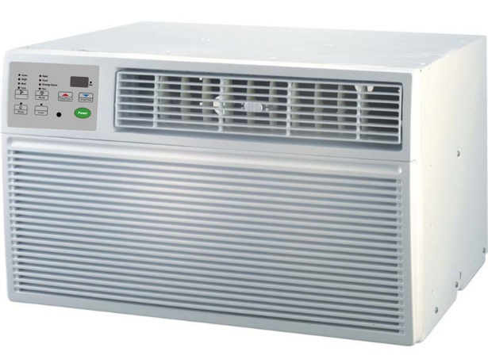

Definition:
'Window rattler' or PTAC. Self-contained packaged unit that also includes the distribution outlet/vent

Project No. / WR No. |  |  |  | Install Date | / /
Identifier |  |  |  | ARV Cost (ex GST)
Site |  |  |  | Manufacturer
Building |  |  |  | Model
Room |  |  |  | Serial No.
Installer |  |  |  | Warranty End Date | / /
Warranty Coverage
OH&S Notes
General Notes
Form Filled Out By

Components:

Quantity
Filter – Unit Standard

Attributes:

Heating Capacity (kW) |  | Cooling Capacity (kW)
Fire Alarm Operation | On / Off / NA | Asset Life (15)

University Use:
Class / Group / Cat / Cat Type |  |  |  | PLANT & EQUIP / HVACEQ / HVAC PLANT / AC
BC (775) |  | Cond. | EXCL |  | Crit. | C3 | FMC | HVACPREV | Asset No.

Air Curtain

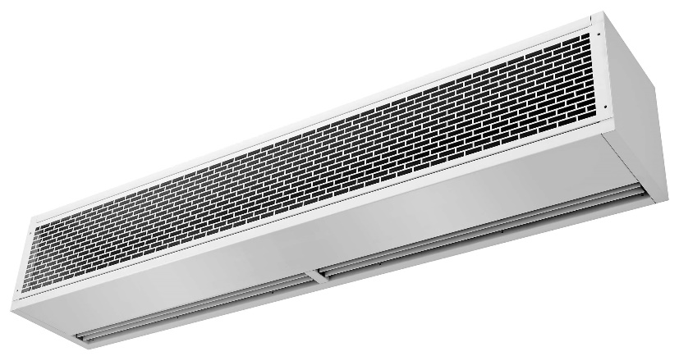

Definition:
Recirculating air curtain with or without heating element

Project No. / WR No. |  |  |  | Install Date | / /
Identifier |  |  |  | ARV Cost (ex GST)
Site |  |  |  | Manufacturer
Building |  |  |  | Model
Room |  |  |  | Serial No.
Installer |  |  |  | Warranty End Date | / /
Warranty Coverage
OH&S Notes
General Notes
Form Filled Out By

Components:
Quantity
Filter – Unit Standard

Attributes:
Heating Capacity (kW) |  | Fire Alarm Operation | On / Off / NA
Asset Life (10)

University Use:
Class / Group / Cat / Cat Type |  |  |  | PLANT & EQUIP / HVACEQ / HVAC PLANT / HVAC
BC (775) |  | Cond. | EXCL |  | Crit. | C3 | FMC | HVACPREV | Asset No.

Air Fan - Return

Definition:
A standalone fan that draws return air only

Project No. / WR No. |  |  |  | Install Date | / /
Identifier |  |  |  | ARV Cost (ex GST)
Site |  |  |  | Manufacturer
Building |  |  |  | Model
Room* |  |  |  | Serial No.
Installer |  |  |  | Warranty End Date | / /
Warranty Coverage
OH&S Notes
General Notes
Form Filled Out By
*If not within a room then use the room that it is above, below or outside of

Belt Components:
 | Type | Quantity
Fan Belt(s)

Attributes:
Fire Alarm Operation | On / Off / NA
Asset Life (15)

University Use:
Class / Group / Cat / Cat Type |  |  |  | PLANT & EQUIP / HVACEQ / HVAC PLANT / VE
BC (775) |  | Cond. | EXCL |  | Crit. | C3 | FMC | HVACPREV | Asset No.

Air Fan - Supply

Definition:
A standalone fan that draws a mixture of fresh and return air

Project No. / WR No. |  |  |  | Install Date | / /
Identifier |  |  |  | ARV Cost (ex GST)
Site |  |  |  | Manufacturer
Building |  |  |  | Model
Room* |  |  |  | Serial No.
Installer |  |  |  | Warranty End Date | / /
Warranty Coverage
OH&S Notes
General Notes
Form Filled Out By
*If not within a room then use the room that it is above, below or outside of

Belt Components:

 | Type | Quantity
Fan Belt(s)

Attributes:

Fire Alarm Operation | On / Off / NA
Asset Life (15)

University Use:
Class / Group / Cat / Cat Type |  |  |  | PLANT & EQUIP / HVACEQ / HVAC PLANT / VE
BC (775) |  | Cond. | EXCL |  | Crit. | C5 | FMC | HVACSTAT | Asset No.

Air Fan - Fresh

Definition:
A standalone fan that draws fresh air only

Project No. / WR No. |  |  |  | Install Date | / /
Identifier |  |  |  | ARV Cost (ex GST)
Site |  |  |  | Manufacturer
Building |  |  |  | Model
Room* |  |  |  | Serial No.
Installer |  |  |  | Warranty End Date | / /
Warranty Coverage
OH&S Notes
General Notes
Form Filled Out By
*If not within a room then use the room that it is above, below or outside of

Belt Components:

 | Type | Quantity
Fan Belt(s)

Attributes:

Fire Alarm Operation | On / Off / NA
Asset Life (15)

University Use:
Class / Group / Cat / Cat Type |  |  |  | PLANT & EQUIP / HVACEQ / HVAC PLANT / VE
BC (775) |  | Cond. | EXCL |  | Crit. | C5 | FMC | HVACSTAT | Asset No.

Air Fan – Exhaust – Car Park

Definition:
An exhaust fan that does car park exhaust

Project No. / WR No. |  |  |  | Install Date | / /
Identifier |  |  |  | ARV Cost (ex GST)
Site |  |  |  | Manufacturer
Building |  |  |  | Model
Room* |  |  |  | Serial No.
Installer |  |  |  | Warranty End Date | / /
Warranty Coverage
OH&S Notes
General Notes
Form Filled Out By
*If not within a room then use the room that it is above, below or outside of

Belt Components:

 | Type | Quantity
Fan Belt(s)

Attributes:

Fire Alarm Operation | On / Off / NA
Asset Life (15)

University Use:
Class / Group / Cat / Cat Type |  |  |  | PLANT & EQUIP / HVACEQ / HVAC PLANT / VE
BC (775) |  | Cond. | EXCL |  | Crit. | C5 | FMC | HVACSTAT | Asset No.

Air Fan – Exhaust – General

Definition:
A fan used for general exhaust, such as toilet, utility, kitchenette or change room

Project No. / WR No. |  |  |  | Install Date | / /
Identifier |  |  |  | ARV Cost (ex GST)
Site |  |  |  | Manufacturer
Building |  |  |  | Model
Room* |  |  |  | Serial No.
Installer |  |  |  | Warranty End Date | / /
Warranty Coverage
OH&S Notes
General Notes
Form Filled Out By
*If not within a room then use the room that it is above, below or outside of

Belt Components:

 | Type | Quantity
Fan Belt(s)

Attributes:

Fire Alarm Operation | On / Off / NA
Asset Life (15)

University Use:
Class / Group / Cat / Cat Type |  |  |  | PLANT & EQUIP / HVACEQ / HVAC PLANT / VE
BC (775) |  | Cond. | EXCL |  | Crit. | C3 | FMC | HVACPREV | Asset No.

Air Fan – Exhaust – Kitchen

Definition:
A fan connected to a kitchen exhaust hood (not rangehood)

Project No. / WR No. |  |  |  | Install Date | / /
Identifier |  |  |  | ARV Cost (ex GST)
Site |  |  |  | Manufacturer
Building |  |  |  | Model
Room* |  |  |  | Serial No.
Installer |  |  |  | Warranty End Date | / /
Warranty Coverage
OH&S Notes
General Notes
Form Filled Out By
*If not within a room then use the room that it is above, below or outside of

Belt Components:

 | Type | Quantity
Fan Belt(s)

Attributes:

Fire Alarm Operation | On / Off / NA
Asset Life (15)

University Use:
Class / Group / Cat / Cat Type |  |  |  | PLANT & EQUIP / HVACEQ / HVAC PLANT / VE
BC (775) |  | Cond. | EXCL |  | Crit. | C3 | FMC | HVACSTAT | Asset No.

Air Fan – Exhaust – Fume

Definition:
A fan used for fume extraction or fume extraction systems. Includes fume cupboard fans if not integral.

Project No. / WR No. |  |  |  | Install Date | / /
Identifier |  |  |  | ARV Cost (ex GST)
Site |  |  |  | Manufacturer
Building |  |  |  | Model
Room* |  |  |  | Serial No.
Installer |  |  |  | Warranty End Date | / /
Warranty Coverage
OH&S Notes
General Notes
Form Filled Out By
*If not within a room then use the room that it is above, below or outside of

Belt Components:

 | Type | Quantity
Fan Belt(s)

Attributes:

Fire Alarm Operation | On / Off / NA
Asset Life (15)

University Use:
Class / Group / Cat / Cat Type |  |  |  | PLANT & EQUIP / HVACEQ/ FUME TREATMENT/VE
BC (775) |  | Cond. | EXCL |  | Crit. | C4 | FMC | HVACPREV | Asset No.

Air Fan – Exhaust – Chemical

Definition:
A fan used for chemical storage exhaust, generally running 24/7

Project No. / WR No. |  |  |  | Install Date | / /
Identifier |  |  |  | ARV Cost (ex GST)
Site |  |  |  | Manufacturer
Building |  |  |  | Model
Room* |  |  |  | Serial No.
Installer |  |  |  | Warranty End Date | / /
Warranty Coverage
OH&S Notes
General Notes
Form Filled Out By
*If not within a room then use the room that it is above, below or outside of

Belt Components:

 | Type | Quantity
Fan Belt(s)

Attributes:

Fire Alarm Operation | On / Off / NA
Asset Life (15)

University Use:
Class / Group / Cat / Cat Type |  |  |  | PLANT & EQUIP / HVACEQ/ FUME TREATMENT/VE
BC (775) |  | Cond. | EXCL |  | Crit. | C5 | FMC | HVACSTAT | Asset No.

Air Fan – Stairwell Pressurisation

Definition:
Fan dedicated to pressurise an area and only operates under fire alarm, typically stairwell to prevent smoke ingress and aid evacuation

Project No. / WR No. |  |  |  | Install Date | / /
Identifier |  |  |  | ARV Cost (ex GST)
Site |  |  |  | Manufacturer
Building |  |  |  | Model
Room* |  |  |  | Serial No.
Installer |  |  |  | Warranty End Date | / /
Warranty Coverage
OH&S Notes
General Notes
Form Filled Out By
*If not within a room then use the room that it is above, below or outside of

Belt Components:

 | Type | Quantity
Fan Belt(s)

Attributes:

Fire Alarm Operation | On / Off / NA
Asset Life (20)

University Use:
Class / Group / Cat / Cat Type |  |  |  | PLANT & EQUIP / HVACEQ/ HVAC PLANT / VE
BC (775) |  | Cond. | EXCL |  | Crit. | C5 | FMC | HVACSTAT | Asset No.

Air Fan – Exhaust – Smoke Spill

Definition:
Fan dedicated to smoke spill (exhaust).

Project No. / WR No. |  |  |  | Install Date | / /
Identifier |  |  |  | ARV Cost (ex GST)
Site |  |  |  | Manufacturer
Building |  |  |  | Model
Room* |  |  |  | Serial No.
Installer |  |  |  | Warranty End Date | / /
Warranty Coverage
OH&S Notes
General Notes
Form Filled Out By
*If not within a room then use the room that it is above, below or outside of

Belt Components:

 | Type | Quantity
Fan Belt(s)

Attributes:

Fire Alarm Operation | On / Off / NA
Asset Life (20)

University Use:
Class / Group / Cat / Cat Type |  |  |  | PLANT & EQUIP / HVACEQ/ HVAC PLANT / VE
BC (775) |  | Cond. | EXCL |  | Crit. | C5 | FMC | HVACSTAT | Asset No.

Boiler – Electric

Definition:
Electric element water heater for heating

Project No. / WR No. |  |  |  | Install Date | / /
Identifier* |  |  |  | ARV Cost (ex GST)
Site |  |  |  | Manufacturer
Building |  |  |  | Model
Room |  |  |  | Serial No.
Installer |  |  |  | Warranty End Date | / /
Warranty Coverage
OH&S Notes
General Notes
Form Filled Out By
*Identifier to be the UTAS supplied Hazardous plant registration ID.

Attributes:

Heating Capacity (kW)
Asset Life (15)

Hazardous Plant Registration Number:

HAZARDOUS PLANT REGISTRATION PAPERWORK (PRF4 FROM WORKSAFE TASMANIA) MUST BE SUBMITTED WITH THIS ASSET FORM. INSPECTION AND SIGN OFF MUST BE COMPLETED PRIOR TO SUBMISSION.

University Use:
Class / Group / Cat / Cat Type |  |  |  | PLANT & EQUIP / HVACEQ/ HVAC PLANT / HVAC
BC (775) |  | Cond. | EXCL |  | Crit. | C4 | FMC | HVACSTAT | Asset No.

Boiler – Gas Fired

Definition:
Gas fired water heater for heating

Project No. / WR No. |  |  |  | Install Date | / /
Identifier |  |  |  | ARV Cost (ex GST)
Site |  |  |  | Manufacturer
Building |  |  |  | Model
Room* |  |  |  | Serial No.
Installer |  |  |  | Warranty End Date | / /
Warranty Coverage
OH&S Notes
General Notes
Form Filled Out By
*If not within a room then use the room that it is above, below or outside of

Component (only if ‘gun’ burner):

 | Manufacturer | Model | Serial No.
Burner - Gun

Attributes:

Heating Capacity (kW) |  | Gas Type | LPG / Natural
Condensing | Yes / No | Burner | Atmospheric / Forced
Number of Burners |  | Asset Life (30)

University Use:
Class / Group / Cat / Cat Type |  |  |  | PLANT & EQUIP / HVACEQ / HVAC PLANT / SH
BC (775) |  | Cond. | EXCL |  | Crit. | C4 | FMC | HVACSTAT | Asset No.

Boiler – Oil Fired

Definition:
Non condensing forced air oil water heater for heating

Project No. / WR No. |  |  |  | Install Date | / /
Identifier |  |  |  | ARV Cost (ex GST)
Site |  |  |  | Manufacturer
Building |  |  |  | Model
Room* |  |  |  | Serial No.
Installer |  |  |  | Warranty End Date | / /
Warranty Coverage
OH&S Notes
General Notes
Form Filled Out By
*If not within a room then use the room that it is above, below or outside of

Component (only if ‘gun’ burner):

 | Manufacturer | Model | Serial No.
Burner - Gun

Attributes:

Heating Capacity (kW) |  | Oil Type
Condensing | Yes / No | Burner | Atmospheric / Forced
Asset Life (30)

University Use:
Class / Group / Cat / Cat Type |  |  |  | PLANT & EQUIP / HVACEQ / HVAC PLANT / SH
BC (775) |  | Cond. | EXCL |  | Crit. | C4 | FMC | HVACSTAT | Asset No.

Calorifer

Definition:
For UTAS a water immersed coil water to water heat exchanger

Project No. / WR No. |  |  |  | Install Date | / /
Identifier |  |  |  | ARV Cost (ex GST)
Site |  |  |  | Manufacturer
Building |  |  |  | Model
Room* |  |  |  | Serial No.
Installer |  |  |  | Warranty End Date | / /
Warranty Coverage
OH&S Notes
General Notes
Form Filled Out By
*If not within a room then use the room that it is above, below or outside of

Attributes:

Heating Capacity (kW)
Asset Life (30)

University Use:
Class / Group / Cat / Cat Type |  |  |  | PLANT & EQUIP / HVACEQ / HVAC PLANT / SH
BC (775) |  | Cond. | EXCL |  | Crit. | C4 | FMC | HVACSTAT | Asset No.

Chiller – Air Cooled

Definition:
Air cooled chiller used for the cooling / heating of water or glycol.

Project No. / WR No. |  |  |  | Install Date | / /
Identifier |  |  |  | ARV Cost (ex GST)
Site |  |  |  | Manufacturer
Building |  |  |  | Model
Room* |  |  |  | Serial No.
Installer |  |  |  | Warranty End Date | / /
Warranty Coverage
OH&S Notes
General Notes
Form Filled Out By
*If not within a room then use the room that it is above, below or outside of

Attributes:

Heating Capacity (kW) |  | Cooling Capacity (kW)
Refrigerant | R | Refrigerant Charge (kg)
Compressor Type | Reciprocating / Screw / Centrifugal | Magnetic Bearings | Yes / No
Asset Life (25)

University Use:
Class / Group / Cat / Cat Type |  |  |  | PLANT & EQUIP / HVACEQ / HVAC PLANT / AC
BC (775) |  | Cond. | EXCL |  | Crit. | C4 | FMC | HVACPREV | Asset No.

Chiller – Water Cooled

Definition:
Water cooled chiller used for the cooling / heating of water or glycol.

Project No. / WR No. |  |  |  | Install Date | / /
Identifier |  |  |  | ARV Cost (ex GST)
Site |  |  |  | Manufacturer
Building |  |  |  | Model
Room* |  |  |  | Serial No.
Installer |  |  |  | Warranty End Date | / /
Warranty Coverage
OH&S Notes
General Notes
Form Filled Out By
*If not within a room then use the room that it is above, below or outside of

Attributes:

Heating Capacity (kW) |  | Cooling Capacity (kW)
Refrigerant | R | Refrigerant Charge (kg)
Compressor Type | Reciprocating / Screw / Centrifugal | Magnetic Bearings | Yes / No
Asset Life (25)

University Use:
Class / Group / Cat / Cat Type |  |  |  | PLANT & EQUIP / HVACEQ / HVAC PLANT / AC
BC (775) |  | Cond. | EXCL |  | Crit. | C4 | FMC | HVACPREV | Asset No.

Heat Pump – Air Source

Definition:
Air source heat pump used for only heating only of water or glycol.

Project No. / WR No. |  |  |  | Install Date | / /
Identifier |  |  |  | ARV Cost (ex GST)
Site |  |  |  | Manufacturer
Building |  |  |  | Model
Room* |  |  |  | Serial No.
Installer |  |  |  | Warranty End Date | / /
Warranty Coverage
OH&S Notes
General Notes
Form Filled Out By
*If not within a room then use the room that it is above, below or outside of

Attributes:

Heating Capacity (kW) |  | Refrigerant Charge (kg)
Refrigerant | R | Magnetic Bearings | Yes / No
Compressor Type | Reciprocating / Screw / Centrifugal
Asset Life (15)

University Use:
Class / Group / Cat / Cat Type |  |  |  | PLANT & EQUIP / HVACEQ / HVAC PLANT / SH
BC (775) |  | Cond. | EXCL |  | Crit. | C4 | FMC | HVACPREV | Asset No.

Heat Pump – Water Source

Definition:
Water source heat pump used for only heating of water or glycol.

Project No. / WR No. |  |  |  | Install Date | / /
Identifier |  |  |  | ARV Cost (ex GST)
Site |  |  |  | Manufacturer
Building |  |  |  | Model
Room* |  |  |  | Serial No
Installer |  |  |  | Warranty End Date | / /
Warranty Coverage
OH&S Notes
General Notes
Form Filled Out By
*If not within a room then use the room that it is above, below or outside of

Attributes:

Heating Capacity (kW) |  | Refrigerant Charge (kg)
Refrigerant | R | Magnetic Bearings | Yes / No
Compressor Type | Reciprocating / Screw / Centrifugal
Asset Life (15)

University Use:
Class / Group / Cat / Cat Type |  |  |  | PLANT & EQUIP / HVACEQ / HVAC PLANT / SH
BC (775) |  | Cond. | EXCL |  | Crit. | C4 | FMC | HVACPREV | Asset No.

Heat Pump Chiller – Water Cooled

Definition:
Water cooled chiller used for the cooling and heating of water or glycol.

Project No. / WR No. |  |  |  | Install Date | / /
Identifier |  |  |  | ARV Cost (ex GST)
Site |  |  |  | Manufacturer
Building |  |  |  | Model
Room* |  |  |  | Serial No.
Installer |  |  |  | Warranty End Date | / /
Warranty Coverage
OH&S Notes
General Notes
Form Filled Out By
*If not within a room then use the room that it is above, below or outside of

Attributes:

Heating Capacity (kW) |  | Cooling Capacity (kW)
Refrigerant | R | Refrigerant Charge (kg)
Compressor Type | Reciprocating / Screw / Centrifugal | Magnetic Bearings | Yes / No
Asset Life (15)

University Use:
Class / Group / Cat / Cat Type |  |  |  | PLANT & EQUIP / HVACEQ / HVAC PLANT / AC
BC (775) |  | Cond. | EXCL |  | Crit. | C4 | FMC | HVACPREV | Asset No.

Heat Pump Chiller – Air Cooled

Definition:
Air cooled chiller used for the cooling and heating of water or glycol.

Project No. / WR No. |  |  |  | Install Date | / /
Identifier |  |  |  | ARV Cost (ex GST)
Site |  |  |  | Manufacturer
Building |  |  |  | Model
Room* |  |  |  | Serial No.
Installer |  |  |  | Warranty End Date | / /
Warranty Coverage
OH&S Notes
General Notes
Form Filled Out By
*If not within a room then use the room that it is above, below or outside of

Attributes:

Heating Capacity (kW) |  | Cooling Capacity (kW)
Refrigerant | R | Refrigerant Charge (kg)
Compressor Type | Reciprocating / Screw / Centrifugal | Magnetic Bearings | Yes / No
Asset Life (15)

University Use:
Class / Group / Cat / Cat Type |  |  |  | PLANT & EQUIP / HVACEQ / HVAC PLANT / AC
BC (775) |  | Cond. | EXCL |  | Crit. | C4 | FMC | HVACPREV | Asset No.

Circulating Pump

Definition:
A pump used for the circulation of heating, heat recovery or cooling water for building reticulation e.g. secondary side/circuit. Not dedicated boiler/chiller/manifold pumps e.g. primary side/circuit.

If no primary/secondary circuit i.e. just one circuit and pump (or standby / duty) then pump is a circulating pump.

Project No. / WR No. |  |  |  | Install Date | / /
Identifier |  |  |  | ARV Cost (ex GST)
Site |  |  |  | Manufacturer
Building |  |  |  | Model
Room* |  |  |  | Serial No
Installer |  |  |  | Warranty End Date | / /
Warranty Coverage
OH&S Notes
General Notes
Form Filled Out By
*If not within a room then use the room that it is above, below or outside of

Attributes:

Duty Pressure (kPa) |  | Duty Flow (l/s)
Hydronic Type | Heating / Cooling / Heat & Cool / Heat Recovery
Asset Life (15)

University Use:
Class / Group / Cat / Cat Type |  |  |  | PLANT & EQUIP / HVACEQ / HVAC PLANT / HVAC
BC (775) |  | Cond. | EXCL |  | Crit. | C4 | FMC | HVACPREV | Asset No.

Condenser Pump

Definition:
A pump used for the circulation of condenser water or glycol

Project No. / WR No. |  |  |  | Install Date | / /
Identifier |  |  |  | ARV Cost (ex GST)
Site |  |  |  | Manufacturer
Building |  |  |  | Model
Room* |  |  |  | Serial No
Installer |  |  |  | Warranty End Date | / /
Warranty Coverage
OH&S Notes
General Notes
Form Filled Out By
*If not within a room then use the room that it is above, below or outside of

Attributes:

Duty Pressure (kPa) |  | Duty Flow (l/s)
Asset Life (15)

University Use:
Class / Group / Cat / Cat Type |  |  |  | PLANT & EQUIP / HVACEQ / HVAC PLANT / HVAC
BC (775) |  | Cond. | EXCL |  | Crit. | C4 | FMC | HVACPREV | Asset No.

Dedicated Circulating Pump

Definition:
A water pump dedicated to a boiler/heat pump chiller/ chiller/manifold, e.g. primary side or single boiler.

Project No. / WR No. |  |  |  | Install Date | / /
Identifier |  |  |  | ARV Cost (ex GST)
Site |  |  |  | Manufacturer
Building |  |  |  | Model
Room* |  |  |  | Serial No
Installer |  |  |  | Warranty End Date | / /
Warranty Coverage
OH&S Notes
General Notes
Form Filled Out By
*If not within a room then use the room that it is above, below or outside of

Attributes:

Duty Pressure (kPa) |  | Duty Flow (l/s)
Asset Life (15)

University Use:
Class / Group / Cat / Cat Type |  |  |  | PLANT & EQUIP / HVACEQ / HVAC PLANT / HVAC
BC (775) |  | Cond. | EXCL |  | Crit. | C4 | FMC | HVACPREV | Asset No.

Cooling Tower

Definition:
Evaporative cooling tower used for cooling of water

Project No. / WR No. |  |  |  | Install Date | / /
Identifier* |  |  |  | ARV Cost (ex GST)
Site |  |  |  | Manufacturer
Building |  |  |  | Model
Room** |  |  |  | Serial No.
Installer |  |  |  | Warranty End Date | / /
Warranty Coverage
OH&S Notes
General Notes
Form Filled Out By
*Identifier to be the UTAS supplied Hazardous plant registration ID.

**If not within a room then use the room that it is above, below or outside of

Filter Components:

 | Size (HxWxD mm) | Quantity
Filter – Evaporative Pad - Aspen
Filter – Evaporative Pad - Celdek

Attributes:

Cooling Capacity (kW)
Asset Life (25)

Hazardous Plant Registration Number:

HAZARDOUS PLANT REGISTRATION PAPERWORK (PRF4 FROM WORKSAFE TASMANIA) MUST BE SUBMITTED WITH THIS ASSET FORM. INSPECTION AND SIGN OFF MUST BE COMPLETED PRIOR TO SUBMISSION.

University Use:
Class / Group / Cat / Cat Type |  |  |  | PLANT & EQUIP / HVACEQ / HVAC PLANT / EC
BC (775) |  | Cond. | EXCL |  | Crit. | C5 | FMC | HVACSTAT | Asset No.

Hydronic Building Reticulation

Definition:
Hydronic, meaning use of water as a heat-transfer medium.

Heating, cooling or both, water distribution system within a building. Made up of supply and return pipework, valves, pumps, expansion, makeup water, etc.

One asset per reticulation system i.e. heating water distribution is one asset and cooling water distribution is another. Unless a single set of supply/return pipework does both.

Project No. / WR No. |  |  |  | Install Date | / /
Identifier |  |  |  | ARV Cost (ex GST)
Site |  |  |  | Manufacturer
Building |  |  |  | Model
Room* |  |  |  | Serial No.
Installer |  |  |  | Warranty End Date | / /
Warranty Coverage
OH&S Notes
General Notes
Form Filled Out By
*If not within a room then use the room that it is above, below or outside of

Components:

Quantity
Air and Dirt Separator
Strainer
Isolating valves
Control valves

Attributes:

Hydronic Type | Heating / Cooling / Heat & Cool / Heat Recovery
Asset Life (30)

University Use:
Class / Group / Cat / Cat Type |  |  |  | PLANT & EQUIP / HVACEQ / HVAC PLANT / HVAC
BC (775) |  | Cond. | EXCL |  | Crit. | C4 | FMC | HVACPREV | Asset No.

Evaporative Air Cooler

Definition:
Evaporative cooler used for cooling of supply air to condition a room

Project No. / WR No. |  |  |  | Install Date | / /
Identifier |  |  |  | ARV Cost (ex GST)
Site |  |  |  | Manufacturer
Building |  |  |  | Model
Room* |  |  |  | Serial No.
Installer |  |  |  | Warranty End Date | / /
Warranty Coverage
OH&S Notes
General Notes
Form Filled Out By
*If not within a room then use the room that it is above, below or outside of

Filter Components:

 | Size (HxWxD mm) | Quantity
Filter – Evaporative Pad - Aspen
Filter – Evaporative Pad - Celdek

Attributes:

Cooling Capacity (kW)
Asset Life (20)

University Use:
Class / Group / Cat / Cat Type |  |  |  | PLANT & EQUIP / HVACEQ / HVAC PLANT / EC
BC (775) |  | Cond. | EXCL |  | Crit. | C4 | FMC | HVACSTAT | Asset No.

Dry Cooler

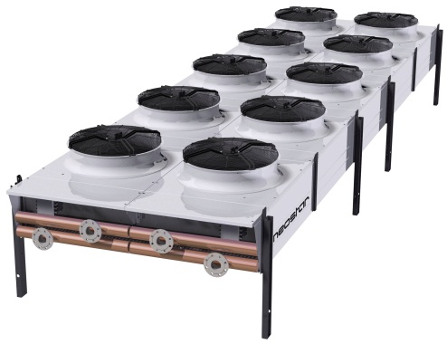

Definition:
Outdoor heat exchanger used for cooling of water or glycol with air. Fans are the only active component.

Project No. / WR No. |  |  |  | Install Date | / /
Identifier |  |  |  | ARV Cost (ex GST)
Site |  |  |  | Manufacturer
Building |  |  |  | Model
Room* |  |  |  | Serial No.
Installer |  |  |  | Warranty End Date | / /
Warranty Coverage
OH&S Notes
General Notes
Form Filled Out By
*If not within a room then use the room that it is above, below or outside of

Attributes:

Cooling Capacity (kW)
Asset Life (15)

University Use:
Class / Group / Cat / Cat Type |  |  |  | PLANT & EQUIP / HVACEQ / HVAC PLANT / HVAC
BC (775) |  | Cond. | EXCL |  | Crit. | C4 | FMC | HVACPREV | Asset No.

Extraction System - Dust

Definition:
System of ductwork, gates, connectors, fan and hopper used for saw dust removal.

Project No. / WR No. |  |  |  | Install Date | / /
Identifier |  |  |  | ARV Cost (ex GST)
Site |  |  |  | Manufacturer
Building |  |  |  | Model
Room* |  |  |  | Serial No.
Installer |  |  |  | Warranty End Date | / /
Warranty Coverage
OH&S Notes
General Notes
Form Filled Out By
*If not within a room then use the room that it is above, below or outside of

Belt Components:

 | Type | Quantity
Fan Belt(s)

Attributes:

Fire Alarm Operation | On / Off / NA
Asset Life (20)

University Use:
Class / Group / Cat / Cat Type |  |  |  | PLANT & EQUIP / HVACEQ / HVAC PLANT / HVAC
BC (775) |  | Cond. | EXCL |  | Crit. | C3 | FMC | HVACPREV | Asset No.

Fan Coil Unit – High Wall

Definition:
A terminal unit designed to be mounted high on a wall (above 1600 AFFL), provided with chilled / heated water from a hydronic system

Project No. / WR No. |  |  |  | Install Date | / /
Identifier |  |  |  | ARV Cost (ex GST)
Site |  |  |  | Manufacturer
Building |  |  |  | Model
Room |  |  |  | Serial No.
Installer |  |  |  | Warranty End Date | / /
Warranty Coverage
OH&S Notes
General Notes
Form Filled Out By

Components:

Quantity
Filter – Unit Standard

Attributes:

Heating Capacity (kW) |  | Cooling Capacity (kW)
Fire Alarm Operation | On / Off / NA | Condensate Drain Pump | Yes / No
Asset Life (15)

University Use:
Class / Group / Cat / Cat Type |  |  |  | PLANT & EQUIP / HVACEQ / HVAC PLANT / AC
BC (775) |  | Cond. | EXCL |  | Crit. | C3 | FMC | HVACPREV | Asset No.

Fan Coil Unit – Ducted

Definition:
A terminal unit designed to be concealed with a ceiling space and delivers air via ductwork and diffusers, provided with chilled / heated water from a hydronic system. Includes ‘bulkhead’ units.

Project No. / WR No. |  |  |  | Install Date | / /
Identifier |  |  |  | ARV Cost (ex GST)
Site |  |  |  | Manufacturer
Building |  |  |  | Model
Room |  |  |  | Serial No.
Installer |  |  |  | Warranty End Date | / /
Warranty Coverage
OH&S Notes
General Notes
Form Filled Out By

Attributes:
Heating Capacity (kW) |  | Cooling Capacity (kW)
Fire Alarm Operation | On / Off / NA | Condensate Drain Pump | Yes / No
Asset Life (20)

University Use:
Class / Group / Cat / Cat Type |  |  |  | PLANT & EQUIP / HVACEQ / HVAC PLANT / AC
BC (775) |  | Cond. | EXCL |  | Crit. | C3 | FMC | HVACSTAT | Asset No.

Fan Coil Unit – Floor

Definition:
A terminal unit designed to be mounted low on a wall, provided with chilled / heated water from a hydronic system

Project No. / WR No. |  |  |  | Install Date | / /
Identifier |  |  |  | ARV Cost (ex GST)
Site |  |  |  | Manufacturer
Building |  |  |  | Model
Room |  |  |  | Serial No.
Installer |  |  |  | Warranty End Date | / /
Warranty Coverage
OH&S Notes
General Notes
Form Filled Out By

Components:
Quantity
Filter – Unit Standard

Attributes:
Heating Capacity (kW) |  | Cooling Capacity (kW)
Fire Alarm Operation | On / Off / NA | Condensate Drain Pump | Yes / No
Asset Life (15)

University Use:
Class / Group / Cat / Cat Type |  |  |  | PLANT & EQUIP / HVACEQ / HVAC PLANT / AC
BC (775) |  | Cond. | EXCL |  | Crit. | C3 | FMC | HVACPREV | Asset No.

Fan Coil Unit – Recessed Cassette

Definition:
A terminal unit designed to be recessed into a ceiling and providing up to 4 directions of air flow, provided with chilled / heated water from a hydronic system

Project No. / WR No. |  |  |  | Install Date | / /
Identifier |  |  |  | ARV Cost (ex GST)
Site |  |  |  | Manufacturer
Building |  |  |  | Model
Room |  |  |  | Serial No.
Installer |  |  |  | Warranty End Date | / /
Warranty Coverage
OH&S Notes
General Notes
Form Filled Out By

Components:

Quantity
Filter – Unit Standard

Attributes:

Heating Capacity (kW) |  | Cooling Capacity (kW)
Fire Alarm Operation | On / Off / NA | Condensate Drain Pump | Yes / No
Asset Life (15)

University Use:
Class / Group / Cat / Cat Type |  |  |  | PLANT & EQUIP / HVACEQ / HVAC PLANT / AC
BC (775) |  | Cond. | EXCL |  | Crit. | C3 | FMC | HVACPREV | Asset No.

Fan Coil Unit – Under Ceiling

Definition:
A terminal unit designed to be surface mounted under a ceiling, provided with chilled / heated water from a hydronic system

Project No. / WR No. |  |  |  | Install Date | / /
Identifier |  |  |  | ARV Cost (ex GST)
Site |  |  |  | Manufacturer
Building |  |  |  | Model
Room |  |  |  | Serial No.
Installer |  |  |  | Warranty End Date | / /
Warranty Coverage
OH&S Notes
General Notes
Form Filled Out By

Components:

Quantity
Filter – Unit Standard

Attributes:

Heating Capacity (kW) |  | Cooling Capacity (kW)
Fire Alarm Operation | On / Off / NA | Condensate Drain Pump | Yes / No
Asset Life (15)

University Use:
Class / Group / Cat / Cat Type |  |  |  | PLANT & EQUIP / HVACEQ / HVAC PLANT / AC
BC (775) |  | Cond. | EXCL |  | Crit. | C3 | FMC | HVACPREV | Asset No.

Duct Coil - Hydronic

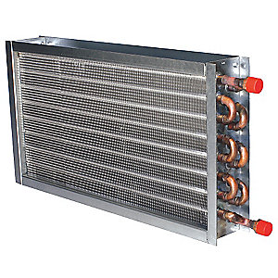
Definition:
In-duct coil for thermal transfer from a hydronic system to air, mounted in ductwork, not part of a ducted or other mass produced unit.

Project No. / WR No. |  |  |  | Install Date | / /
Identifier |  |  |  | ARV Cost (ex GST) | Include in parent cost
Site | Same as parent |  |  | Manufacturer | Same as parent
Building | Same as parent |  |  | Model
Room |  |  |  | Serial No.
Installer |  |  |  | Warranty End Date | / /
Warranty Coverage
OH&S Notes
General Notes
Form Filled Out By

Attributes:
Heating Capacity (kW) |  | Cooling Capacity (kW)
Condensate Drain Pump | Yes / No | Hydronic Type | Heating / Cooling / Heat & Cool / Heat Recovery
Asset Life (30)

University Use:
Class / Group / Cat / Cat Type |  |  |  | PLANT & EQUIP / HVACEQ / HVAC PLANT / AC
BC (775) |  | Cond. | EXCL |  | Crit. | C4 | FMC | HVACSTAT | Asset No.

Data Centre Floor Mount DX Unit

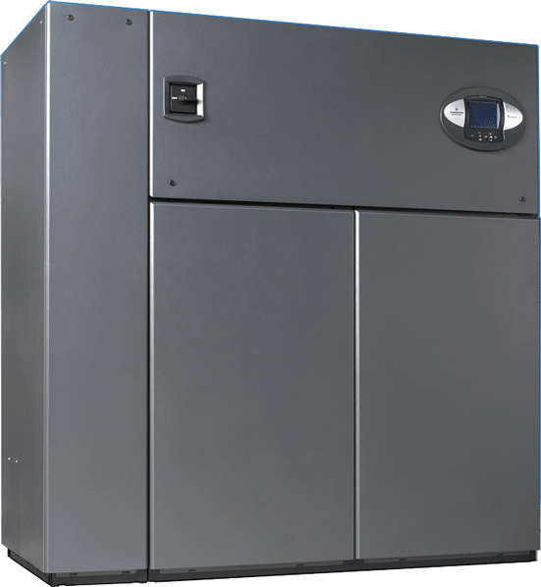

Definition:
Refrigerant split ACitioning system designed for data centre use with underfloor air distribution. Compressor and evaporator inside internal unit. Also known as CRAC or process cooler.

Project No. / WR No. |  |  |  | Install Date | / /
Identifier |  |  |  | ARV Cost (ex GST)
Site |  |  |  | Manufacturer
Building |  |  |  | Model
Room |  |  |  | Serial No.
Installer |  |  |  | Warranty End Date | / /
Warranty Coverage
OH&S Notes
General Notes
Form Filled Out By

Attributes:
Cooling Capacity (kW) |  | Refrigerant Charge (kg)
Refrigerant | R | Asset Life (10)

University Use:
Class / Group / Cat / Cat Type |  |  |  | PLANT & EQUIP / HVACEQ / HVAC PLANT / HVAC
BC (775) |  | Cond. | EXCL |  | Crit. | C5 | FMC | HVACSTAT | Asset No.

Data Centre Condenser

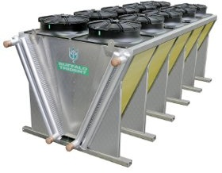

Definition:
Outdoor condenser connected to Data Centre DX unit, aka CRAC or Process Cooler

Project No. / WR No. |  |  |  | Install Date | / /
Identifier |  |  |  | ARV Cost (ex GST)
Site |  |  |  | Manufacturer
Building |  |  |  | Model
Room* |  |  |  | Serial No.
Installer |  |  |  | Warranty End Date | / /
Warranty Coverage
OH&S Notes
General Notes
Form Filled Out By
*If not within a room then use the room that it is above, below or outside of

Connected to Asset:
Identifier(s)
Data Centre Floor Mounted DX Unit

Attributes:
Asset Life (10)

University Use:
Class / Group / Cat / Cat Type |  |  |  | PLANT & EQUIP / HVACEQ / HVAC PLANT / HVAC
BC (775) |  | Cond. | EXCL |  | Crit. | C5 | FMC | HVACPREV | Asset No.

Duct Heater - Electric

Definition:
Electric element in-duct heater.

Project No. / WR No. |  |  |  | Install Date | / /
Identifier |  |  |  | ARV Cost (ex GST)
Site |  |  |  | Manufacturer
Building |  |  |  | Model
Room |  |  |  | Serial No.
Installer |  |  |  | Warranty End Date | / /
Warranty Coverage
OH&S Notes
General Notes
Form Filled Out By

Attributes:

Heating Capacity (kW)
Asset Life (12)

University Use:
Class / Group / Cat / Cat Type |  |  |  | PLANT & EQUIP / HVACEQ / HVAC PLANT / AC
BC (775) |  | Cond. | EXCL |  | Crit. | C3 | FMC | HVACSTAT | Asset No.

Duct Heater - Gas

Definition:
Indirect or direct fired gas in-duct heater

Project No. / WR No. |  |  |  | Install Date | / /
Identifier |  |  |  | ARV Cost (ex GST)
Site |  |  |  | Manufacturer
Building |  |  |  | Model
Room |  |  |  | Serial No.
Installer |  |  |  | Warranty End Date | / /
Warranty Coverage
OH&S Notes
General Notes
Form Filled Out By

Attributes:

Heating Capacity (kW) |  | Gas Type | LPG / Natural
Heat Transfer | Indirect / Direct | Asset Life (15)

University Use:
Class / Group / Cat / Cat Type |  |  |  | PLANT & EQUIP / HVACEQ / HVAC PLANT / HVAC
BC (775) |  | Cond. | EXCL |  | Crit. | C3 | FMC | HVACSTAT | Asset No.

Heat Exchanger – Shell & Tube

Definition:

Standalone shell and tube heat exchanger used in hydronic systems

Project No. / WR No. |  |  |  | Install Date | / /
Identifier |  |  |  | ARV Cost (ex GST)
Site |  |  |  | Manufacturer
Building |  |  |  | Model
Room |  |  |  | Serial No.
Installer |  |  |  | Warranty End Date | / /
Warranty Coverage
OH&S Notes
General Notes
Form Filled Out Bu

Attributes:

Transfer Capacity (kW)
Asset Life (25)

University Use:
Class / Group / Cat / Cat Type |  |  |  | PLANT & EQUIP / HVACEQ / HVAC PLANT / HVAC
BC (775) |  | Cond. | EXCL |  | Crit. | C3 | FMC | HVACPREV | Asset No.

Heat Exchanger – Plate

Definition:

Standalone plate heat exchanger used in hydronic systems

Project No. / WR No. |  |  |  | Install Date | / /
Identifier |  |  |  | ARV Cost (ex GST)
Site |  |  |  | Manufacturer
Building |  |  |  | Model
Room |  |  |  | Serial No.
Installer |  |  |  | Warranty End Date | / /
Warranty Coverage
OH&S Notes
General Notes
Form Filled Out By

Attributes:

Transfer Capacity (kW)
Asset Life (25)

University Use:
Class / Group / Cat / Cat Type |  |  |  | PLANT & EQUIP / HVACEQ / HVAC PLANT / HVAC
BC (775) |  | Cond. | EXCL |  | Crit. | C3 | FMC | HVACPREV | Asset No.

Heat Recovery – Plate

Definition:

Standalone plate heat exchanger used for heat recovery from air

Project No. / WR No. |  |  |  | Install Date | / /
Identifier |  |  |  | ARV Cost (ex GST)
Site |  |  |  | Manufacturer
Building |  |  |  | Model
Room |  |  |  | Serial No.
Installer |  |  |  | Warranty End Date | / /
Warranty Coverage
OH&S Notes
General Notes
Form Filled Out By

Attributes:

Transfer Capacity (kW)
Asset Life (25)

University Use:
Class / Group / Cat / Cat Type |  |  |  | PLANT & EQUIP / HVACEQ / HVAC PLANT / HVAC
BC (775) |  | Cond. | EXCL |  | Crit. | C3 | FMC | HVACPREV | Asset No.

Heat Recovery – Wheel

Definition:

Standalone wheel heat exchanger used for heat recovery from air

Project No. / WR No. |  |  |  | Install Date | / /
Identifier |  |  |  | ARV Cost (ex GST)
Site |  |  |  | Manufacturer
Building |  |  |  | Model
Room |  |  |  | Serial No.
Installer |  |  |  | Warranty End Date | / /
Warranty Coverage
OH&S Notes
General Notes
Form Filled Out By

Attributes:

Transfer Capacity (kW)
Asset Life (25)

University Use:
Class / Group / Cat / Cat Type |  |  |  | PLANT & EQUIP / HVACEQ / HVAC PLANT / HVAC
BC (775) |  | Cond. | EXCL |  | Crit. | C3 | FMC | HVACPREV | Asset No.

Heat Recovery – Unit

Definition:

Manufactured heat recovery unit, typically plate type with fan and filters

Project No. / WR No. |  |  |  | Install Date | / /
Identifier |  |  |  | ARV Cost (ex GST)
Site |  |  |  | Manufacturer
Building |  |  |  | Model
Room* |  |  |  | Serial No.
Installer |  |  |  | Warranty End Date | / /
Warranty Coverage
OH&S Notes
General Notes
Form Filled Out By
*If not within a room then use the room that it is above, below or outside of

Filter Components:

 | Size (HxWxD mm) | Quantity
Filter – Activated Carbon
Filter – Deep Bed
Filter – Electrostatic
Filter – HEPA
Filter – Pleated Media
Filter – Roll Media
Filter – Stainless Wire Mesh

Attributes:

Transfer Capacity (kW) |  | Asset Life (20)
Fire Alarm Operation | On / Off / NA | Condensate Drain Pump | Yes / No

University Use:
Class / Group / Cat / Cat Type |  |  |  | PLANT & EQUIP / HVACEQ / HVAC PLANT / HVAC
BC (775) |  | Cond. | EXCL |  | Crit. | C3 | FMC | HVACPREV | Asset No.

Heater - Hydronic

Definition:

Hydronic space (room) heater, radiant or natural convection i.e. not fan coil unit.

1 asset per heater.

Project No. / WR No. |  |  |  | Install Date | / /
Identifier |  |  |  | ARV Cost (ex GST)
Site |  |  |  | Manufacturer
Building |  |  |  | Model
Room |  |  |  | Serial No.
Installer |  |  |  | Warranty End Date | / /
Warranty Coverage
OH&S Notes
General Notes
Form Filled Out By

Attributes:

Heating Capacity (kW)
Asset Life (20)

University Use:
Class / Group / Cat / Cat Type |  |  |  | PLANT & EQUIP / HVACEQ / HVAC PLANT / SH
BC (775) |  | Cond. | EXCL |  | Crit. | C3 | FMC | HVACPREV | Asset No.

Heater – Hydronic Floor Coil

Definition:

Hydronic space (room) heater floor coil type.

1 asset per floor coil.

Project No. / WR No. |  |  |  | Install Date | / /
Identifier |  |  |  | ARV Cost (ex GST)
Site |  |  |  | Manufacturer
Building |  |  |  | Model
Room |  |  |  | Serial No.
Installer |  |  |  | Warranty End Date | / /
Warranty Coverage
OH&S Notes
General Notes
Form Filled Out By

Attributes:

Heating Capacity (kW)
Asset Life (30)

University Use:
Class / Group / Cat / Cat Type |  |  |  | PLANT & EQUIP / HVACEQ / HVAC PLANT / SH
BC (775) |  | Cond. | EXCL |  | Crit. | C3 | FMC | HVACPREV | Asset No.

Heater - Electric

Definition:

Electric space (room) heater, radiant or convection

Project No. / WR No. |  |  |  | Install Date | / /
Identifier |  |  |  | ARV Cost (ex GST)
Site |  |  |  | Manufacturer
Building |  |  |  | Model
Room |  |  |  | Serial No.
Installer |  |  |  | Warranty End Date | / /
Warranty Coverage
OH&S Notes
General Notes
Form Filled Out By

Attributes:

Heating Capacity (kW)
Asset Life (12)

University Use:
Class / Group / Cat / Cat Type |  |  |  | PLANT & EQUIP / HVACEQ / HVAC PLANT / SH
BC (775) |  | Cond. | EXCL |  | Crit. | C3 | FMC | - | Asset No.

Heater – Electric Floor Coil

Definition:

Electric space (room) heater, floor coil type

Project No. / WR No. |  |  |  | Install Date | / /
Identifier |  |  |  | ARV Cost (ex GST)
Site |  |  |  | Manufacturer
Building |  |  |  | Model
Room |  |  |  | Serial No.
Installer |  |  |  | Warranty End Date | / /
Warranty Coverage
OH&S Notes
General Notes
Form Filled Out By

Attributes:

Heating Capacity (kW)
Asset Life (12)

University Use:
Class / Group / Cat / Cat Type |  |  |  | PLANT & EQUIP / HVACEQ / HVAC PLANT / SH
BC (775) |  | Cond. | EXCL |  | Crit. | C3 | FMC | - | Asset No.

Heater - Gas

Definition:

Gas space (room) heater, not ducted. Radiant tube or wall mounted.

Project No. / WR No. |  |  |  | Install Date | / /
Identifier |  |  |  | ARV Cost (ex GST)
Site |  |  |  | Manufacturer
Building |  |  |  | Model
Room |  |  |  | Serial No.
Installer |  |  |  | Warranty End Date | / /
Warranty Coverage
OH&S Notes
General Notes
Form Filled Out By

Attributes:

Heating Capacity (kW) |  | Gas Type | LPG / Natural
Asset Life (15)

University Use:
Class / Group / Cat / Cat Type |  |  |  | PLANT & EQUIP / HVACEQ / HVAC PLANT / SH
BC (775) |  | Cond. | EXCL |  | Crit. | C3 | FMC | HVACSTAT | Asset No.

Heater – Forced Air

Definition:

Fix integral fan heater with electric elements used for glass/hot houses or constant temperature rooms only

Project No. / WR No. |  |  |  | Install Date | / /
Identifier |  |  |  | ARV Cost (ex GST)
Site |  |  |  | Manufacturer
Building |  |  |  | Model
Room |  |  |  | Serial No.
Installer |  |  |  | Warranty End Date | / /
Warranty Coverage
OH&S Notes
General Notes
Form Filled Out By

Attributes:

Heating Capacity (kW)
Asset Life (15)

University Use:
Class / Group / Cat / Cat Type |  |  |  | PLANT & EQUIP / HVACEQ / HVAC PLANT / SH
BC (775) |  | Cond. | EXCL |  | Crit. | C3 | FMC | HVACPREV | Asset No.

Humidifier

Definition:

Device that increases air humidity, typically through creation of steam

Project No. / WR No. |  |  |  | Install Date | / /
Identifier |  |  |  | ARV Cost (ex GST)
Site |  |  |  | Manufacturer
Building |  |  |  | Model
Room |  |  |  | Serial No.
Installer |  |  |  | Warranty End Date | / /
Warranty Coverage
OH&S Notes
General Notes
Form Filled Out By

Attributes:

Steam Capacity (kg/h)
Asset Life (15)

University Use:
Class / Group / Cat / Cat Type |  |  |  | PLANT & EQUIP / HVACEQ / HVAC PLANT / AC
BC (775) |  | Cond. | EXCL |  | Crit. | C3 | FMC | HVACSTAT | Asset No.

Hydronic Storage Vessel

Definition:

Water tank used for the storage of heated or chilled water

Project No. / WR No. |  |  |  | Install Date | / /
Identifier |  |  |  | ARV Cost (ex GST)
Site |  |  |  | Manufacturer
Building |  |  |  | Model
Room |  |  |  | Serial No.
Installer |  |  |  | Warranty End Date | / /
Warranty Coverage
OH&S Notes
General Notes
Form Filled Out By

Attributes:

Hydronic Type | Heating / Cooling / Heat & Cool / Heat Recovery
Volume Capacity (L)
Asset Life (30)

University Use:
Class / Group / Cat / Cat Type |  |  |  | PLANT & EQUIP / HVACEQ / HVAC PLANT / HVAC
BC (775) |  | Cond. | EXCL |  | Crit. | C3 | FMC | - | Asset No.

Switchboard - Mechanical

Definition:

Mechanical Services Switchboard (MSSB), not a section of a switchboard or chassis

Project No. / WR No. |  |  |  | Install Date | / /
Identifier |  |  |  | ARV Cost (ex GST)
Site |  |  |  | Manufacturer
Building |  |  |  | Model
Room |  |  |  | Serial No.
Installer |  |  |  | Warranty End Date | / /
Warranty Coverage
OH&S Notes
General Notes
Form Filled Out By

Fed from Asset:

Identifier
Switchboard – Mechanical / Main / Distribution

Attributes:

Fault Rating (kVA) |  | Asset Life (35)

University Use:
Class / Group / Cat / Cat Type |  |  |  | PLANT & EQUIP / HVACEQ / HVAC PLANT / HVAC
BC (775) |  | Cond. | EXCL |  | Crit. | C4 | FMC | HVACPREV | Asset No.

Variable Speed Drive

Definition:

Variable Speed Drive

Project No. / WR No. |  |  |  | Install Date | / /
Identifier |  |  |  | ARV Cost (ex GST)
Site |  |  |  | Manufacturer
Building |  |  |  | Model
Room |  |  |  | Serial No.
Installer |  |  |  | Warranty End Date | / /
Warranty Coverage
OH&S Notes
General Notes
Form Filled Out By

Speed Controls Asset:

Asset Type | Identifier

University Use:
Class / Group / Cat / Cat Type |  |  |  | PLANT & EQUIP / HVACEQ / HVAC PLANT / HVAC
BC (775) |  | Cond. | EXCL |  | Crit. | C4 | FMC | HVACPREV | Asset No.

VAV Unit

Definition:

VAV Box or Unit. Prefabricated unit with dampers and with or without fan to control air volume primarily for temperature control

Project No. / WR No. |  |  |  | Install Date | / /
Identifier |  |  |  | ARV Cost (ex GST)
Site |  |  |  | Manufacturer
Building |  |  |  | Model
Room |  |  |  | Serial No.
Installer |  |  |  | Warranty End Date | / /
Warranty Coverage
OH&S Notes
General Notes
Form Filled Out By

Filter Components:

 | Size (HxWxD mm) | Quantity
Filter – Activated Carbon
Filter – Deep Bed
Filter – Electrostatic
Filter – HEPA
Filter – Pleated Media
Filter – Roll Media
Filter – Stainless Wire Mesh
Filter – Unit Standard

Attributes:
Heating Capacity (kW) |  | Fire Alarm Operation | On / Off / NA
Asset Life (20)

University Use:
Class / Group / Cat / Cat Type |  |  |  | PLANT & EQUIP / HVACEQ / HVAC PLANT / AC
BC (775) |  | Cond. | EXCL |  | Crit. | C3 | FMC | HVACPREV | Asset No.

Fire Damper - HVAC

Definition:
A controlled fire damper (or combined fire & smoke) installed within HVAC ductwork or as part of an HVAC system. Does not include uncontrolled dampers, see Fire Services section for intumescent and fusible link type asset forms.

Project No. / WR No. |  |  |  | Install Date | / /
Identifier |  |  |  | ARV Cost (ex GST)
Site |  |  |  | Manufacturer
Building |  |  |  | Model
Room* |  |  |  | Serial No.
Installer |  |  |  | Warranty End Date | / /
Warranty Coverage
OH&S Notes
General Notes
Form Filled Out By
*If not within a room then use the room that it is above, below or outside of

Attributes:

Asset Life (30)

University Use:
Class / Group / Cat / Cat Type |  |  |  | PLANT & EQUIP / HVACEQ / HVAC PLANT / HVAC
BC (775) |  | Cond. | EXCL |  | Crit. | C5 | FMC | HVACSTAT | Asset No.

Smoke Damper - HVAC

Definition:
A smoke damper installed within HVAC ductwork or as part of an HVAC / smoke control system

Project No. / WR No. |  |  |  | Install Date | / /
Identifier |  |  |  | ARV Cost (ex GST)
Site |  |  |  | Manufacturer
Building |  |  |  | Model
Room* |  |  |  | Serial No.
Installer |  |  |  | Warranty End Date | / /
Warranty Coverage
OH&S Notes
General Notes
Form Filled Out By
*If not within a room then use the room that it is above, below or outside of

Attributes:

Asset Life (30)

University Use:
Class / Group / Cat / Cat Type |  |  |  | PLANT & EQUIP / HVACEQ / HVAC PLANT / HVAC
BC (775) |  | Cond. | EXCL |  | Crit. | C5 | FMC | HVACSTAT | Asset No.

Constant Temperature Room

Definition:
Room fabricated from cool or freezer room panelling. Generally above ten degree operating temperature and can contain a heater or split AC system. Used for research only.

Project No. / WR No. |  |  |  | Install Date | / /
Identifier |  |  |  | ARV Cost (ex GST)
Site |  |  |  | Manufacturer
Building |  |  |  | Model
Room* |  |  |  | Serial No.
Installer |  |  |  | Warranty End Date | / /
Warranty Coverage
OH&S Notes
General Notes
Form Filled Out By
*If not within a room then use the room that it is above, below or outside of

Connected Assets:

Asset Type | Identifier(s)

Attributes:

Monitored Alarm | Yes / No
Asset Life (25)

University Use:
Class / Group / Cat / Cat Type |  |  |  | PLANT & EQUIP / HVACEQ / TEMP CONTRLD ROOM / HVAC
BC (775) |  | Cond. | EXCL |  | Crit. | C5 | FMC | HVACSTAT | Asset No.

Cool Room

Definition:
Generally 4 degrees or higher temperature. Less insulation than a freezer room, typically 75mm thick.

Project No. / WR No. |  |  |  | Install Date | / /
Identifier |  |  |  | ARV Cost (ex GST)
Site |  |  |  | Manufacturer
Building |  |  |  | Model
Room* |  |  |  | Serial No.
Installer |  |  |  | Warranty End Date | / /
Warranty Coverage
OH&S Notes
General Notes
Form Filled Out By
*If not within a room then use the room that it is above, below or outside of

Connected Assets:

Identifier(s)
Evaporator
Condenser

Attributes:

Monitored Alarm | Yes / No
Asset Life (25)

University Use:
Class / Group / Cat / Cat Type |  |  |  | PLANT & EQUIP / HVACEQ / TEMP CONTRLD ROOM / HVAC
BC (775) |  | Cond. | EXCL |  | Crit. | C5 | FMC | HVACSTAT | Asset No.

Freezer Room

Definition:
Generally less than 0 degrees. Typically 150mm thick insulation, slab heating and threshold heater.

Project No. / WR No. |  |  |  | Install Date | / /
Identifier |  |  |  | ARV Cost (ex GST)
Site |  |  |  | Manufacturer
Building |  |  |  | Model
Room* |  |  |  | Serial No.
Installer |  |  |  | Warranty End Date | / /
Warranty Coverage
OH&S Notes
General Notes
Form Filled Out By
*If not within a room then use the room that it is above, below or outside of

Connected Assets:

Identifier(s)
Evaporator
Condenser

Attributes:

Monitored Alarm | Yes / No
Asset Life (25)

University Use:
Class / Group / Cat / Cat Type |  |  |  | PLANT & EQUIP / HVACEQ / TEMP CONTRLD ROOM / HVAC
BC (775) |  | Cond. | EXCL |  | Crit. | C5 | FMC | HVACSTAT | Asset No.

Condenser

Definition:
Component that rejects heat, typically the ‘outdoor unit’. Cool and Freezer Rooms only, but can be used with Duct Coil - DX

Project No. / WR No. |  |  |  | Install Date | / /
Identifier |  |  |  | ARV Cost (ex GST)
Site |  |  |  | Manufacturer
Building |  |  |  | Model
Room* |  |  |  | Serial No.
Installer |  |  |  | Warranty End Date | / /
Warranty Coverage
OH&S Notes
General Notes
Form Filled Out By
*If not within a room then use the room that it is above, below or outside of

Connected Asset (one of the below):

Identifier
Evaporator
Ducted Coil - DX

Attributes:

Heating Capacity (kW) |  | Cooling Capacity (kW)
Refrigerant | R | Refrigerant Charge (kg)
Asset Life (15)

University Use:
Class / Group / Cat / Cat Type |  |  |  | PLANT & EQUIP / HVACEQ / HVAC PLANT / HVAC
BC (775) |  | Cond. | EXCL |  | Crit. | C5 | FMC | HVACPREV | Asset No.

Evaporator

Definition:
Fan coil unit coupled with a Condenser. Component that absorbs heat, used for Cool and Freezer Rooms only.

Project No. / WR No. |  |  |  | Install Date | / /
Identifier |  |  |  | ARV Cost (ex GST)
Site |  |  |  | Manufacturer
Building |  |  |  | Model
Room |  |  |  | Serial No.
Installer |  |  |  | Warranty End Date | / /
Warranty Coverage
OH&S Notes
General Notes
Form Filled Out By

Attributes:

Asset Life (15)

University Use:
Class / Group / Cat / Cat Type |  |  |  | PLANT & EQUIP / HVACEQ / HVAC PLANT / HVAC
BC (775) |  | Cond. | EXCL |  | Crit. | C5 | FMC | HVACPREV | Asset No.

Growth Room or Chamber

Definition:
Room fabricated from cool or freezer room panelling. With variable operating temperature and can contain a heater or split AC system. Used for research only.

Project No. / WR No. |  |  |  | Install Date | / /
Identifier |  |  |  | ARV Cost (ex GST)
Site |  |  |  | Manufacturer
Building |  |  |  | Model
Room* |  |  |  | Serial No.
Installer |  |  |  | Warranty End Date | / /
Warranty Coverage
OH&S Notes
General Notes
Form Filled Out By
*If not within a room then use the room that it is above, below or outside of

Connected Assets:

Asset Type | Identifier(s)

Attributes:

Monitored Alarm | Yes / No
Asset Life (25)

University Use:
Class / Group / Cat / Cat Type |  |  |  | PLANT & EQUIP / HVACEQ / TEMP CONTRLD ROOM / HVAC
BC (775) |  | Cond. | EXCL |  | Crit. | C5 | FMC | HVACSTAT | Asset No.

Fume Cupboard

Definition:
A fume cupboard either ducted or recirculating. Not laminar flow or biosafety cabinets.

Asset Sticker Required: Yes

Project No. / WR No. |  |  |  | Install Date | / /
Identifier |  |  |  | ARV Cost (ex GST)
Site |  |  |  | Manufacturer
Building |  |  |  | Model
Room* |  |  |  | Serial No.
Installer |  |  |  | Warranty End Date | / /
Warranty Coverage
OH&S Notes
General Notes
Form Filled Out By
*If not within a room then use the room that it is above, below or outside of

Connected Assets:

Identifier(s)
Air Fan – Exhaust - Fume

Attributes:

Variable Speed Sash | Yes / No
Scrubber | Yes / No
Asset Life (10)

University Use:
Class / Group / Cat / Cat Type |  |  |  | PLANT & EQUIP / HVACEQ / FUME TREATMENT / HVAC
BC (775) |  | Cond. | EXCL |  | Crit. | C5 | FMC | HVACSTAT | Asset No.

Controller System

Definition:
All automated HVAC, Building Management System controls and controllers. A totalised asset for a building to track value and expense. One asset per building.

Project No. / WR No.
Initial Install Date | / /
ARV Cost (ex GST)
Site
Building
Form Filled Out By

Attributes:

Asset Life (10)

University Use:
Class / Group / Cat / Cat Type |  |  |  | PLANT & EQUIP / HVACEQ / BLDING MNGMT SYS / HVAC
BC (775) |  | Cond. | EXCL |  | Crit. | C4 | FMC | HVACPREV | Asset No.

Security Asset Forms

Refer to Asset Forms General Instructions section before completing these forms.

Surveillance System 215
Security System 216
Lock System 217
Help Point 218

Surveillance System

Definition:
A totalised asset for a building to track value and expense. One asset per building.

Project No. / WR No.
Initial Install Date | / /
ARV Cost (ex GST)*
Identifier**
Site
Building
Form Filled Out By

*Cost to be all hardware installed.

**Identifier to be building code, then VMS

Attributes:

Asset Life (10)

University Use:
Class / Group / Cat / Cat Type |  |  |  | PLANT & EQUIP / SECUREQ / SURVEILLANCE SYSTEM / SEC
BC (775) |  | Cond. | EXCL |  | Crit. | C5 | FMC | SECPREV | Asset No.

Security System

Definition:
Includes access control and intruder detection. A totalised asset for a building to track value and expense. One asset per building.

Project No. / WR No.
Initial Install Date | / /
ARV Cost (ex GST)*
Identifier**
Site
Building
Form Filled Out By

*Cost to be all hardware installed.

**Identifier to be building code, then Gallagher. E.g. SB.BE20 Gallagher

Attributes:

Asset Life (20)

University Use:
Class / Group / Cat / Cat Type |  |  |  | PLANT & EQUIP / SECUREQ / SECURITY SYSTEM / SEC
BC (775) |  | Cond. | EXCL |  | Crit. | C5 | FMC | SECPREV | Asset No.

Lock System

Definition:
Asset for each registered key system used for locks. May be campus or building level. Includes unmonitored accommodation/hotel style electronic access control systems e.g. Ving/Salto

Project No. / WR No. |  |  | Initial Install Date | / /
Identifier* |  |  | ARV Cost (ex GST)
Site |  |  | Manufacturer
Building |  |  | Model
Installer

*As per ProMaster designation.

Attributes:

Asset Life (25)

University Use:
Class / Group / Cat / Cat Type |  |  |  | PLANT & EQUIP / SECUREQ / ACCESS CONTROL / SEC
BC (775) |  | Cond. | EXCL |  | Crit. | C5 | FMC | N/A | Asset No.

Help Point

Definition:
Push button self-dialling intercom/phone.

Project No. / WR No. |  |  | Initial Install Date | / /
Identifier |  |  | ARV Cost (ex GST)
Site |  |  | Manufacturer
Building* |  |  | Model
Room* |  |  | Installer
 | Form Filled Out By
*Room or building that it is directly outside of otherwise leave blank.

Attributes:

Asset Life (15)

University Use:
Class / Group / Cat / Cat Type |  |  |  | PLANT & EQUIP / SECUREQ / ALARM SYSTEM / SEC
BC (775) |  | Cond. | EXCL |  | Crit. | C5 | FMC | SECPREV | Asset No.

Vertical Transportation Asset Forms

Refer to Asset Forms General Instructions section before completing these forms.

Passenger Lift 220
Goods Lift 221
Dumb Waiter 222
Wheelchair Lift 223
Access Hoist 224
Platform Lift 225

Passenger Lift

Definition:
Lift largely used for vertical transportation of people.

Project No. / WR No. |  |  |  | Install Date | / /
Identifier* |  |  |  | ARV Cost (ex GST)
Site |  |  |  | Manufacturer
Building |  |  |  | Model
Room |  |  |  | Serial No.
Installer |  |  |  | Warranty End Date | / /
Warranty Coverage
OH&S Notes
General Notes
Form Filled Out By

*Identifier to be the UTAS supplied Hazardous plant registration ID.

Hazardous Plant Registration Number:

HAZARDOUS PLANT REGISTRATION PAPERWORK (PRF4 FROM WORKSAFE TASMANIA) MUST BE SUBMITTED WITH THIS ASSET FORM. INSPECTION AND SIGN OFF MUST BE COMPLETED PRIOR TO SUBMISSION.

University Use:
Class / Group / Cat / Cat Type |  |  |  | PLANT & EQUIP / VTRANEQ / LIFTS / TS
BC (775) |  | Cond. | EXCL |  | Crit. | C5 | FMC | LIFTSTAT | Asset No.

Goods Lift

Definition:
Lift largely used for transportation of goods and people.

Project No. / WR No. |  |  |  | Install Date | / /
Identifier* |  |  |  | ARV Cost (ex GST)
Site |  |  |  | Manufacturer
Building |  |  |  | Model
Room |  |  |  | Serial No.
Installer |  |  |  | Warranty End Date | / /
Warranty Coverage
OH&S Notes
General Notes
Form Filled Out By

*Identifier to be the UTAS supplied Hazardous plant registration ID.

Hazardous Plant Registration Number:

HAZARDOUS PLANT REGISTRATION PAPERWORK (PRF4 FROM WORKSAFE TASMANIA) MUST BE SUBMITTED WITH THIS ASSET FORM. INSPECTION AND SIGN OFF MUST BE COMPLETED PRIOR TO SUBMISSION.

University Use:
Class / Group / Cat / Cat Type |  |  |  | PLANT & EQUIP / VTRANEQ / LIFTS / TS
BC (775) |  | Cond. | EXCL |  | Crit. | C5 | FMC | LIFTSTAT | Asset No.

Dumb Waiter

Definition:
Lift largely used for vertical transportation of small goods.

Project No. / WR No. |  |  |  | Install Date | / /
Identifier* |  |  |  | ARV Cost (ex GST)
Site |  |  |  | Manufacturer
Building |  |  |  | Model
Room |  |  |  | Serial No.
Installer |  |  |  | Warranty End Date | / /
Warranty Coverage
OH&S Notes
General Notes
Form Filled Out By

*Identifier to be the UTAS supplied Hazardous plant registration ID.

Hazardous Plant Registration Number:

HAZARDOUS PLANT REGISTRATION PAPERWORK (PRF4 FROM WORKSAFE TASMANIA) MUST BE SUBMITTED WITH THIS ASSET FORM. INSPECTION AND SIGN OFF MUST BE COMPLETED PRIOR TO SUBMISSION.

University Use:
Class / Group / Cat / Cat Type |  |  |  | PLANT & EQUIP / VTRANEQ / LIFTS / TS
BC (775) |  | Cond. | EXCL |  | Crit. | C5 | FMC | LIFTSTAT | Asset No.

Wheelchair Lift

Definition:
Lift / lifting platform used for wheelchair access

Project No. / WR No. |  |  |  | Install Date | / /
Identifier* |  |  |  | ARV Cost (ex GST)
Site |  |  |  | Manufacturer
Building |  |  |  | Model
Room |  |  |  | Serial No.
Installer |  |  |  | Warranty End Date | / /
Warranty Coverage
OH&S Notes
General Notes
Form Filled Out By

*Identifier to be the UTAS supplied Hazardous plant registration ID.

Hazardous Plant Registration Number:

HAZARDOUS PLANT REGISTRATION PAPERWORK (PRF4 FROM WORKSAFE TASMANIA) MUST BE SUBMITTED WITH THIS ASSET FORM. INSPECTION AND SIGN OFF MUST BE COMPLETED PRIOR TO SUBMISSION.

University Use:
Class / Group / Cat / Cat Type |  |  |  | PLANT & EQUIP / VTRANEQ / LIFTS / TS
BC (775) |  | Cond. | EXCL |  | Crit. | C5 | FMC | LIFTSTAT | Asset No.

Access Hoist

Definition:
Hoist used for providing increased accessibility of amenities

Project No. / WR No. |  |  |  | Install Date | / /
Identifier* |  |  |  | ARV Cost (ex GST)
Site |  |  |  | Manufacturer
Building |  |  |  | Model
Room |  |  |  | Serial No.
Installer |  |  |  | Warranty End Date | / /
Warranty Coverage
OH&S Notes
General Notes
Form Filled Out By

*Identifier to be the UTAS supplied Hazardous plant registration ID.

Hazardous Plant Registration Number:

HAZARDOUS PLANT REGISTRATION PAPERWORK (PRF4 FROM WORKSAFE TASMANIA) MUST BE SUBMITTED WITH THIS ASSET FORM. INSPECTION AND SIGN OFF MUST BE COMPLETED PRIOR TO SUBMISSION.

University Use:
Class / Group / Cat / Cat Type |  |  |  | PLANT & EQUIP / VTRANEQ / HOISTING EQUIPMENT / TS
BC (775) |  | Cond. | EXCL |  | Crit. | C5 | FMC | LIFTSTAT | Asset No.

Platform Lift

Definition:
Lifting platform used for goods, generally in a loading dock

Project No. / WR No. |  |  |  | Install Date | / /
Identifier* |  |  |  | ARV Cost (ex GST)
Site |  |  |  | Manufacturer
Building |  |  |  | Model
Room** |  |  |  | Serial No.
Installer |  |  |  | Warranty End Date | / /
Warranty Coverage
OH&S Notes
General Notes
Form Filled Out By

*Identifier to be the UTAS supplied Hazardous plant registration ID.

**If not within a room then the room it is directly outside of.

Hazardous Plant Registration Number:

HAZARDOUS PLANT REGISTRATION PAPERWORK (PRF4 FROM WORKSAFE TASMANIA) MUST BE SUBMITTED WITH THIS ASSET FORM. INSPECTION AND SIGN OFF MUST BE COMPLETED PRIOR TO SUBMISSION.

University Use:
Class / Group / Cat / Cat Type |  |  |  | PLANT & EQUIP / VTRANEQ / LIFTS / TRANSPORT SYS
BC (775) |  | Cond. | EXCL |  | Crit. | C5 | FMC | LIFTSTAT | Asset No.

Research Asset Forms

Refer to Asset Forms General Instructions section before completing these forms.

Laminar Flow Cabinet 227
Bio Safety Cabinet 228
Steriliser 229

Laminar Flow Cabinet

Definition:

A cabinet that recirculates air to maintain an air barrier between the contents and the room

Project No. / WR No. |  |  |  | Install Date | / /
Identifier |  |  |  | ARV Cost (ex GST)
Site |  |  |  | Manufacturer
Building |  |  |  | Model
Room |  |  |  | Serial No.
Installer |  |  |  | Warranty End Date | / /
Warranty Coverage
OH&S Notes
General Notes
Form Filled Out By

Filter Components:

 | Size (HxWxD mm) | Quantity
Filter – Activated Carbon
Filter – HEPA

Attributes:

Variable Speed Sash | Yes / No
Asset Life (15)

University Use:
Class / Group / Cat / Cat Type |  |  |  | PLANT & EQUIP / RESCHEQ / FUME TREATMENT / -
BC (775) |  | Cond. | EXCL |  | Crit. | C5 | FMC | CF | Asset No.

Bio Safety Cabinet

Definition:

A cabinet that recirculates air to maintain an air barrier between the contents and the room

Project No. / WR No. |  |  |  | Install Date | / /
Identifier |  |  |  | ARV Cost (ex GST)
Site |  |  |  | Manufacturer
Building |  |  |  | Model
Room |  |  |  | Serial No.
Installer |  |  |  | Warranty End Date | / /
Warranty Coverage
OH&S Notes
General Notes
Form Filled Out By

Filter Components:

 | Size (HxWxD mm) | Quantity
Filter – Activated Carbon
Filter – HEPA

Attributes:

Variable Speed Sash | Yes / No
Asset Life (15)

University Use:
Class / Group / Cat / Cat Type |  |  |  | PLANT & EQUIP / RESCHEQ / FUME TREATMENT / -
BC (775) |  | Cond. | EXCL |  | Crit. | C5 | FMC | CF | Asset No.

Steriliser

Definition:
Sterilizing appliance, includes autoclaves.

Project No. / WR No. |  |  |  | Install Date | / /
Identifier* |  |  |  | ARV Cost (ex GST)
Site |  |  |  | Manufacturer
Building |  |  |  | Model
Room |  |  |  | Serial No.
Installer |  |  |  | Warranty End Date | / /
Warranty Coverage
OH&S Notes
General Notes
Form Filled Out By

*Identifier to be the UTAS supplied Hazardous plant registration ID.

Hazardous Plant Registration Number:

HAZARDOUS PLANT REGISTRATION PAPERWORK (PRF4 FROM WORKSAFE TASMANIA) MUST BE SUBMITTED WITH THIS ASSET FORM. INSPECTION AND SIGN OFF MUST BE COMPLETED PRIOR TO SUBMISSION.

University Use:
Class / Group / Cat / Cat Type |  |  |  | PLANT & EQUIP / RESCHEQ / STERILISER EQUIPMENT / -
BC (775) |  | Cond. | EXCL |  | Crit. | C5 | FMC | HAZPSTAT | Asset No.

